 | 

FAO-GEF PROJECT DOCUMENT

Project Title: | Achieving Land Degradation Neutrality Targets of Georgia through Restoration and Sustainable Management of Degraded Pasturelands

GEF ID: 10151 | FAO Entity Number: 654524 FAO Project Symbol: GCP/GEO/006/GFF
 | Countries: Georgia
 | EOD (Implementation start): 2020 NTE(Implementation end): 2022
Environmental and Social Risk Classification: | low risk ∇ moderate risk € high risk €
Gender Marker: | G0 € G1 € G2a € G2b ∇
Contribution to FAO’s Strategic Framework:  (Indicate as appropriate) | Strategic Objective/Organizational Outcome:  20101 - Innovative practices and technologies piloted, tested or scaled up by producers, to sustainably increase productivity, address climate change and environmental degradation 80%  30102 - Strategies, policies, guidelines and programmes to improve the rural poor’s access to, and control over, a set of services, finance, knowledge, technologies, markets and natural resources, including in the context of climate change 80%  Country Outcome(s): N/A  Country Programming Framework(s) Output(s):  Priority Area 4, Output 4.1  Regional Initiative/Priority Area:  Regional Initiative 3: Sustainable natural resource management under a changing climate
Project Budget (GEF/SCCF/LDCF): $1,776,484
Co-financing: $12,245,000
Total Project Budget: $14,021,484
Executive Summary

Within the context of Land Degradation Neutrality (LDN), Georgia aims to maintain and increase the amount of healthy and productive land resources in line with the national sustainable development goals. Georgia has released five voluntary LDN targets. The proposed project is directly linked to the implementation of two of these targets: Target 1: Integrate LDN principles into national policies, strategies and planning documents; and Target 4: Degraded land will be rehabilitated.

The project sets out to support the national efforts to implement LDN targets of Georgia through restoration and sustainable management of the degraded pasturelands (Targets 1 and 4). It follows the STAP (GEF) guidelines “Scientific Conceptual Framework for Land Degradation Neutrality” and takes a phased approach. First, the country has selected three target municipalities based on the priorities of the LDN TSP, and the target landscapes for implementation activities. The target municipalities are located in the Eastern part of Georgia and include Dmanisi, Gurjaani, and Dmanisi. The target municipalities and landscapes have been characterized by key bio-physical and socio-economic parameters to set the project baseline in line with the voluntary LDN indicators.

Achieving LDN requires land managers to monitor land use decisions that may impact the neutrality. Thus, the project will develop pastureland management plans in target municipalities and manage counter-balancing at the level stipulated in the plans. The project will strengthen the enabling environment for LDN, land-use planning processes, and security of tenure rights with the specific focus on pasturelands. It will be followed by development of a LDN Decision Support System (DSS) using the proposed hierarchy of responses (avoid>reduce>reverse) based on the status of land degradation and using three LDN voluntary indicators (land cover, land productivity, and SOC) that will be piloted in the three target municipalities. This also involves balancing of the anticipated losses from impacts of pastureland use decisions through restoration of degraded pasturelands (land use of the same type), thus achieving LDN on the ground on pasturelands in the three target municipalities generating associated GEBs related to land restored and under SLM. The counterbalancing of the LDN will be done at the same scale as land use planning process that will be established in the three target municipalities. This will be followed by scaling up the select approaches within three target municipalities using the land use plans and targeted capacity building programs and awareness raising campaigns. The three LDN indicators, additional national indicators for rangeland health, GEBs and socio-economic benefits will be monitored. Local knowledge and continuous learning will be applied to validate/interpret the data, and anticipate/adjust/create new steps – closing the LDN loop.

The experiences of this project will be replicated across Georgia through activities of MEPA, RECC, CENN, and international partners, and shared with other countries in the region and at UNCCD.

Contents
PART I: PROJECT INFORMATION 7
A. Focal/Non-Focal Area Elements 7
B. Project description summary 7
C. Confirmed sources of Co-financing for the project by name and by type 10
D. Trust Fund Resources Requested by Agency(ies), Country(ies), Focal Area and the Programming of Funds 11
E. Does the project include a “non-grant” instrument? No 11
F. Project’s Target Contributions to GEF 7 Core Indicators 12
PART II: PROJECT JUSTIFICATION 13
1.a Project Description 13
1.1. National context 13
1.2. Area of intervention 16
1.3. Barriers 21
1.4. The baseline scenario and any associated baseline projects. 22
1.5. The proposed alternative scenario with a brief description of expected outcomes and components of the project and the project’s Theory of Change. 26
1.6. Alignment with GEF focal area and/or Impact Program strategies. 34
1.7. Incremental/additional cost reasoning and expected contributions from the baseline, the GEFTF, LDCF, SCCF, and co-financing. 35
1.8. Global environmental benefits (GEFTF) and/or adaptation benefits (LDCF/SCCF). 35
1.9. Innovativeness, sustainability, potential for scaling up and capacity development. 35
1.10. Summary of changes in alignment with the project design with the original PIF 36
1.b Project Map and Geo-Coordinates. 36
2. Stakeholders. 36
3. Gender Equality and Women's Empowerment. 40
4. Private Sector Engagement. 47
5. Risks. 48
Section A: Risks to the project 48
Section B: Environmental and Social risks from the project – ESM Plan 50
6. Institutional Arrangements and Coordination. 50
6.a Institutional arrangements for project implementation. 50
6.b Coordination with other relevant GEF-financed projects and other initiatives. 52
7. Consistency with National Priorities. 53
8. Knowledge Management. 54
9. Monitoring and Evaluation. 54
10. Benefits 58
Annex A1: Project Results Framework 59
Annex A2: Project Budget 69
Annex B: Response to Project Reviews 70
Annex C: Status of Utilization of Project Preparation Grant (PPG) 70
Annex D: Calendar of Expected Reflows (if non-grant instrument is used) 70
Annex E: Project Map(s) and Coordinates 71
Annex F: GEF TF / LDCF/ SCCF Core Indicator Worksheet 73
Annex H: Work Plan (indicative) 74
Annex I1: Environmental and Social Risk Certification 81
Annex I2: Stakeholder Engagement Matrix and Grievance Redress Mechanism 81
Grievance Redress Mechanism 81
Annex J: Indigenous Peoples 83
Annex K: FAO’S Roles in Internal Organization 83
Annex L: FAO and Government Obligations 87
Annex M: Socio-economic analysis in three target Municipalities 89
Annex N-1: PRAGA baseline assessment 89
Annex N-2: PRAGA baseline field data 89
Annex O: LADA baseline report 89
Annex O-1: LADA baseline field data in Dmanisi Municipality 89
Annex O-2: LADA baseline field data in Gurjaani Municipality 89
Annex O-3: LADA baseline field data in Kazbegi Municipality 89
Annex P: Land Use distribution per municipalities based on Collect Earth assessment 90
Annex Q: Gender Action Plan 90

Acronyms

ACDA Agricultural Cooperatives Development Agency / LEPL under the MEPA
ADC Austrian Development Cooperation
AMMAR Agriculture Modernization, Market Access and Resilience Project
ARDA Agricultural and Rural Development Agency / NNLE under the MEPA
AWP/B Annual Work Plan and Budget
BH Budget holder
CBD Convention on Biological Diversity
CCM Climate Change Mitigation
CENN Caucasus Environmental NGO Network
CPF Country Priority Framework (FAO)
CSO Civil Society Organisations
EIA Environmental Impact Assessment
EIEC Environmental Information and Education Centre / LEPL under the MEPA
ENPARD European Neighbourhood Programme for Agriculture and Rural Development
EU European Union
FAO Food and Agricultural Organization of the United Nations
FE Final Evaluation
FLO Funding Liaison Officer
FFS Farmer Field School
FPMIS Field Programme Management Information System
GDP Gross Domestic Product
GEBs Global Environmental Benefits
GEF Global Environment Facility
GoG The Government of Georgia
GSP Global Soil Partnership
GHG Greenhouse Gases
GIS Geographical Information System
GIZ German Agency for International Cooperation
HH Household
HQ Headquarter
ICC Information-Consultation Centers
IW Inception Workshop
LDN Land Degradation Neutrality
LG Law of Georgia / Legislative Act of Georgia passed by the Parliament of Georgia
LEPL Legal Entity of Public Law
LMA Laboratory of the Ministry of Agriculture (formerly Veterinary Laboratory) / LEPL under the MEPA
LOA Letter of Agreement
LTO FAO Lead Technical Officer
LTU FAO Lead Technical Unit
M Million
MEPA The Ministry of Environmental Protection and Agriculture
MESD The Ministry of Economy and Sustainable Development
M&E Monitoring and Evaluation
MoJ Ministry of Justice of Georgia
MTR Mid-Term Review
NAITS National Animal Identification, Registration and Traceability System
NAPR The National Agency of Public Registry
NASLM National Agency for Sustainable Land Management and Land Use Monitoring / LEPL is to be established under the MEPA
NASP National Agency of State Property / LEPL under the MESD

NGO Non-Governmental Organization
NFA National Food Agency
PC Project Coordinator
PCU Project Coordination Unit
PIR Project Implementation Review
PPR Project Progress Repots
PRAGA Participatory Assessment of Land Degradation and Sustainable Land Management in Grasslands and Pastoral Systems
PSC Project Steering Committee
PTF Project Task Force (FAO)
PY Project Year
RECC Regional Environmental Center for the Caucasus
REU Regional Office for Europe and Central Asia
RF Project’s results framework
RIA Regulatory Impact Assessesment
SDG Sustainable Development Goal
SFMRD Promoting Sustainable Forest Management for Climate Resilient Rural Development in Georgia
SEIA Strategic Environmental Impact Assessment
SLM Sustainable Land Management
SO Strategic Objective
SRCA Scientific-Research Center of Agriculture / LEPL under the MEPA
STAR System for Transparent Allocation of Resources
TOR Terms of Reference
TSP LDN Target Setting Program of the UNCCD and the Global Mechanism
UNCCD United Nations Convention to Combat Desertification
UNFCCC United Nations Framework Convention on Climate Change
USD United States Dollar

PART I: PROJECT INFORMATION

Project Title: Achieving Land Degradation Neutrality Targets of Georgia through Restoration and Sustainable Management of Degraded Pasturelands
Country(ies): | Georgia | GEF Project ID: | 10151
GEF Agency(ies): |  | GEF Agency Project ID (FAO entity number): | 654524
Project Executing Entity(s): | MEPA, REC Caucasus, CENN | Submission Date | December 17, 2019
GEF Focal Area (s): |  | Expected Implemetnation Start | 2020
 |  | Expected Completion Date | 2022
Name of Parent Program | N/A | Parent Program ID: | N/A
- Focal/Non-Focal Area Elements
Programming Directions | Focal Area Outcomes | Trust Fund | (in $)
Programming Directions | Focal Area Outcomes | Trust Fund | GEF Project Financing | Co-financing
GEF-7 | LD-1-1 Maintain or improve flow of agro-ecosystem services to sustain food production and livelihoods through Sustainable Land Management (SLM) | GEFTF | 1,603,479 | 11,645,000
GEF-7 | LD-2-5 Create enabling environments to support scaling up and mainstreaming of SLM and LDN | GEFTF | 173,005 | 600,000
Total project costs |  |  | 1,776,484 | 12,245,000
- Project description summary
Project Objective: Support the national efforts to implement LDN targets of Georgia through restoration and sustainable management of the degraded pasturelands (National Targets 1 and 4)
Project Components/  Programs | Component Type | Project Outcomes | Project Outputs | Trust Fund | (in $)
 |  |  |  |  | GEF Project Financing | Co-financing
Component 1: Strengthening the regulatory and institutional framework for sustainable management of pasturelands in Georgia | TA | 1.1: Enhanced policy and institutional frameworks for LDN with the focus on the implementation of SLM principles on pasturelands | 1.1.1: A national pastureland management policy contributing to implementation of LDN principles, designed and agreed with key stakeholders  1.1.2: Pastureland management law and supplementary sub-laws drafted  1.1.3: Multi-stakeholder coordination mechanism on pastureland management created at national level  1.1.4: Multi-stakeholder pasture management groups are established in the three target municipalities  1.1.5. Decision Support System (DSS) for LDN integrated and tested | GEFTF | 173,005 | 550,000
Component 2: Demonstration of sustainable pastureland management practices and scaling up successful approaches | Inv | 2.1: LDN target # 4 is implemented via SLM practices on degraded pasturelands by local land users with the support of the coordination mechanism | 2.1.1: A detailed inventory and multi-factor assessments of pastures are conducted in the three target municipalities (in total 20 000 ha)  2.1.2: Pasture management plans (strategic and operational) are developed in participatory manner and implemented in the three target municipalities (in total 20 000 ha)  2.1.3: Business models to encourage investments in pastureland management to implement SLM and achieve LDN are elaborated in 3 target municipalities | GEFTF | 1,047,805 | 8,613,000
Component 3: Capacity building of the key stakeholders on sustainable management of pasturelands and achieving land degradation neutrality | TA | 3.1: National and local stakeholders are empowered and have capacity to implement SLM practices in pasturelands | 3.1.1: National Capacity building program focused on the application of the SLM/LDN in pastureland management with gender mainstreaming consideration elaborated  3.1.2: Knowledge materials on SLM and LDN are developed and disseminated to a wide range of relevant stakeholders  3.1.3:Training provided to national and local decision makers, workers of governmental extension services, women groups and farmers  3.1.4: Knowledge-sharing with other municipalities, regions and countries and dissemination of verifiable data and tested methodologies | GEFTF | 336,005 | 2,282,000
Component 4: Effective Knowledge Management through RBM, monitoring and evaluation | TA | 4.1: Project implementation based on RBM and lessons learned/good practices documented and disseminated | 4.1.1: RBM system of the project promoted adaptive management through capturing key results of the project activities and peer-to-peer training  4.1.2: A Gender-Sensitive Project Monitoring & Evaluation Plan and a relevant system are in place  4.1.3: Communication Strategy and KM strategy are developed and implemented  4.1.4: Project Mid-term review and Final Evaluation are conducted | GEFTF | 182,069 | 450,000
Subtotal |  |  |  |  | 1,738,884 | 11,895,000
Project Management Cost (PMC) |  |  |  |  | 37,600 | 350,000
Total project costs |  |  |  |  | 1,776,484 | 12,245,000
For multi-trust fund projects, provide the total amount of PMC in Table B, and indicate the split of PMC among the different trust funds here: ( )
- Confirmed sources of Co-financing for the project by name and by type
Please include evidence for co-financing for the project with this form.
Sources of Co-financing | Name of Co-financier | Type of Cofinancing | Investment Mobilized | Amount ($)
GEF Agency | FAO | Grant | Yes | 1,800,000
Recipient Country Government | Ministry of Environmental Protection and Agriculture of Georgia | In-kind | No | 200,000
Recipient Country Government | Ministry of Environmental Protection and Agriculture of Georgia | Public Investment | Yes | 3,600,000
Local Government | Municipality of Dmanisi | In-kind | No | 300,000
Local Government | Municipality of Dmanisi | Public Investment | Yes | 845,000
Local Government | Municipality of Gurjaani | In-kind | No | 300,000
Local Government | Municipality of Kazbegi | In-kind | No | 300,000
CSO | Rec Caucasus | In-kind | Yes | 700,000
Donor agency | GIZ | Grant | Yes | 500,000
CSO | CENN | In-kind | Yes | 350,000
Other | Government of Turkey | In-kind | No | 50,000
Donor agency | European Union | Grant | Yes | 3,300,000
Total Co-financing |  |  |  | 12,245,000
Describe how any “Investment Mobilized” was identified.
Ministry of Environmental Protection and Agriculture of Georgia: the GoG is in the process of developing the next phase for Agriculture Policy for 2020-2025. The indicative co-financing (investment mobilized) from the Agriculture and Rural Development Strategy (2021-2027) for pasture restoration and sustainable management for the project is US$3,600,000. The amount will be confirmed in the Agriculture Strategy Action Plan, once the Strategy and Action Plan are available.

Municipality of Dmanisi: investment mobilized for building milk processing plant and agrarian college

FAO: “FAO support to Georgian agricultural sector under ENPARD III”. This is a FAO-led initiative funded by the European Union with the amount of US$14.7 million (2018-2022). ENPARD III contributes to the reduction of rural poverty of the targeted rural population because of improved and development oriented policies, as well as improved agricultural services and investments accessible for farmers, allowing for an increased competitiveness and employment creation within the agriculture sector. The objectives of ENPARD are to improve access to finance, services, equipment and inputs for farmers, rural households, cooperatives and other small and medium enterprises in rural areas. These improvements will contribute to increased competitiveness of the agricultural sector and better livelihoods for people living in the rural areas. FAO announced a grant competition for farmers, cooperatives and SMEs in Georgia to award five value chain actors in 14 municipalities. Beef and dairy are key priorities in eight of the 14 participating municipalities. The closure of the grant award application deadline coincides with the start of the implementation of the GEF project. Proper coordination arrangements will be put implementation. Total co-financing from ENPARD III is US$3.3 million.

FAO: “Technical Assistance for Establishment of the National Animal Identification, Registration and Traceability System” (NAITS). NAITS project is financed by SDC, ADA and FAO. The total investment of US$5.5 million is implemented from 2017-2021. The NAITS aims to improve the collection, management and use of data for improvement of the animal health and food safety activities of the country. The main goal is to improve the livestock sector performance through improvement of and productivity and competitiveness of the and facilitated access to regional and international markets. The project is implemented by the National Food Agency with the support from FAO. Total mobilized investment from the NAITS project is US$1.8 million.

REC Caucasus: Five projects are considered investment mobilized: 1) Increasing LAs capacities in coordination between national and local levels of government to enhance their contribution to establishment of Vashlovani Biosphere Reserve in Kakheti region as model for inclusive and sustainable growth at local level, 2) UNESCO biosphere reserve establishment in the climate‐vulnerable regions of Tusheti, Kakheti region – working towards the nomination, 3) Development of Draft River Basin Management Plans for Alazani/Iori and Khrami /Debeda River Basins in Georgia, 4) Upscaling Land Restoration Measures to Prevent Land Erosion and to Maintain the Fertility of 650 ha Agricultural Land in Vulnerable Municipalities of Kakheti Region, and 5) Regulatory Impact Assessment (RIA) of the Draft Law on Soil Protection.

GIZ: Programme on Management of natural resources and safeguarding of ecosystem services for sustainable rural development in the South Caucasus (ECOserve) will support Georgia in developing sustainable pastureland management practices and scaling up successful approaches in order to achieve LDN.

CENN: Two projects are considered investment mobilized “Sustainable Forest Management for Climate Resilient Rural Development in Georgia (SFMRD)” (US$118,000), EU-funded rural development project and “Embrace Tsalka” (US$102,000), and Green Capms (US$130,000).

- Trust Fund Resources Requested by Agency(ies), Country(ies), Focal Area and the Programming of Funds
GEF Agency | Trust Fund | Country  Name/Global | Focal Area | Programming of Funds | (in $)
 |  |  |  |  | GEF Project Financing (a) | Agency Fee (b) | Total  (c)=a+b
 | GEFTF | Georgia |  | LD STAR | 1,776,484 | 168,766 | 1,945,250
Total GEF Resources |  |  |  |  | 1,776,484 | 168,766 | 1,945,250

- Does the project include a “non-grant” instrument? No
(If non-grant instruments are used, provide in Annex D an indicative calendar of expected reflows to your Agency and to the GEF/LDCF/SCCF Trust Fund).

- Project’s Target Contributions to GEF 7 Core Indicators
Update the relevant sub-indicator values for this project using the methodologies indicated in the Core Indicator Worksheet provided in Annex F and aggregating them in the table below. Progress in programming against these targets is updated at mid-term evaluation and at terminal evaluation. Achieved targets will be be aggregated and reported any time during the replenishment period. There is no need to complete this table for climate adaptation projects financed solely through LDCF and SCCCF.
Project Core Indicators |  | Expected at CEO Endorsement
3 | Area of land restored (Hectares) | 747 ha
4 | Area of landscapes under improved practices (excluding protected areas)(Hectares) | 20,000 ha
6 | Greenhouse Gas Emissions Mitigated (metric tons of CO2e) | 770,710
11 | Number of direct beneficiaries disaggregated by gender as co-benefit of GEF investment | 600
Provide additional explanation on targets, other methodologies used, and other focal area specifics (i.e., Aichi targets in BD) including justification where core indicator targets are not provided.

PART II: PROJECT JUSTIFICATION

1.a Project Description

- The global environmental and/or adaptation problems, root causes and barriers that need to be addressed (systems description).

1.1. National context

Georgia is traditionally an agricultural country: the agriculture sector contributes 8% to the GDP and employs 43% of the population. Livestock products represent 50% of the agriculture GDP. The sector is characterized by low productivity compared to global standards, impacting rural development and prosperity. The majority of the rural population in Georgia live below the poverty line. While there is no formally adopted standardized multiple-level land-use classification scheme (addressing both land use and land cover) in Georgia yet, the territory of around 1.7 million ha – representing 25% of Georgia’s total land and over 50% of the total agricultural lands - is classified as permanent pastureland. Based on some expert estimations, the majority of these pasturelands – 75% is state-owned, 3% - are under municipal ownership and 20% of pastures are privately owned. Livestock relying on pasturelands is the main source of the livelihoods for the majority of rural population. Thus, the productivity of the livestock sector rests on the physical condition of the State pastures. Since the vast majority of cattle and sheep farmers in the country are smallholders, the livestock sector in Georgia represents the main source of livelihoods for farmers as well as the main source of the sector’s economic profits.

Unfortunately, the pasturelands in Georgia are undermanaged, understocked, overgrazed, and under-invested, with little maintenance of pastoral productive infrastructure or soil fertility strategies. Pasturelands in Georgia are a good example of the “tragedy of commons” – where often select group of community members utilizes a common resource with little organizational or planning strategies. Those users who are in economic need often push the system to unsustainable limits, thus degrading ecosystem services for the community as a whole. However, the work of Ostrom (2009) and other experts in the field of commonly managed natural resources has shown that when done properly, communally managed goods and resources often allow for gains in productivity and economic diversification over resource privatization schemes.

The project seeks to tackle land degradation issues using with a special focus on the pasturelands using LDN hierarchy of responses (avoid>reduce>reverse), supporting the country to implement its national LDN targets #1 and #4. The aspirational goal of a land degradation neutral world, to be realized by reducing the rate of land degradation and increasing the rate of restoration of degraded land, was agreed at the Rio+20 Conference in 2012. Subsequently, target 15.3 of the Sustainable Development Goals (SDGs) sets out a new global ambition: to achieve a Land Degradation Neutral World by the year 2030. Land degradation neutrality aims to maintain and increase the amount of healthy and productive land resources, in line with national development priorities. Land degradation neutrality is a flexible target that can be implemented at local, regional or national scales. It has been suggested that an LDN scheme should be introduced in phases. Phase 1 would focus on restoring degraded lands, improving national land use planning systems, and establishing international and national monitoring capacities. Phase 2 would reduce desertification rates with the help of fully integrated land use planning and monitoring systems. Phase 3 would set a target year for realizing an LDN goal, based on experiences in Phases 1 and 2. All three phases would be informed by existing scientific knowledge and generating new knowledge by launching a scientific LDN process that will evolve in parallel with the political process. LDN a guiding principle for implementing the UNCCD.

Following the results and recommendations of the socio-economic assessment that was carried out based on the household survey during the PPG, the main beneficiaries of the project are defined as smallholder sheep and cattle farmers. Project investments in pastureland restoration and SLM will result in multiple social, economic and environmental benefits. When appropriately managed, the pastures of Georgia will become the foundation for generating national GDP.

Institutional Framework
The institutional framework in Georgia for sustainable land management and LDN is comprised of a number of national institutions.

By the Georgian Government decision in the beginning of 2018, the Ministry of Environment and Natural Resources Protection and the Ministry of Agriculture were merged and management and protection of land resources now is under responsibility of the Ministry of Environmental Protection and Agriculture of Georgia (MEPA). All functions of both ministries will remain the same as it was before they have been merged. MEPA takes overall responsibility on issues of land protection and supports implementation all international obligation including SDG 15.3, including LDN.

MEPA is the main national institution responsible for land resources policies and activities. According to national legislation, the tasks and competences of MEPA are directly or indirectly linked with the land resources management and soil protection. MEPA works with a range of stakeholders over recent years, including farmers, representatives of the environmental and academic/research sectors, as well as a number of key Government Institutions and Agencies.

MEPA has overall state responsibilities for land and soil resources protection, agricultural production, soil fertility, plant protection, livestock breeding and agricultural engineering, and is responsible for carrying out state control over irrigation systems. Irrigation systems are state owned and state managed through the Ministry’s Department of Land Management and Hydro melioration and LTD Georgian Amelioration.

Under MEPA there, two main Departments, which are responsible for, land management issues. Under the Department of Environment and Climate Change, there is Land Resources Protection Division. The main responsibilities include participation in the process of development and implementation of governmental policies on sustainable management of land resources; coordination, planning and implementation of measurements for land degradation and desertification prevention; and implementation of the commitments under the UNCCD. Department of Land Management and Hydro melioration is responsible for management of agricultural lands, creation of land use databases.

The structure of the Ministry includes a laboratory for scientific research on soil degradation and soil monitoring. It will perform basic soil analysis for farming enterprises and will support the extension service. As of September 2014, there are two main soil laboratories: one at the Agrarian University and a private one, Multi test. The laboratory of the National Environmental Agency, monitoring air, water and soil, is equipped for analyzing heavy metals in the soils, but there is no legal basis allowing the monitoring of private agricultural plots that might be polluted.

Also in 2013, the former Ministry of Agriculture (now MEPA) set up thematic maps (1:500,000) of lands exposed to wind erosion and water erosion (actual and potential areas) and lands under acidification, and the state of the nutrients in the soils. Atlas of Natural Risks and Hazards in Georgia has been published in 2013, with maps on floods, drought and fire. There are no maps on salinization or on soil pollution by heavy metals.

The National Agency of Public Registry (NAPR), under the Ministry of Justice, was created in 2004, replacing the State Department of Land Management (SDLM) and the Bureau of Technical Inventory. Through its territorial offices, the NAPR provides registry services for immovable and movable property, as well as a real estate cadaster, including pasturelands. By 2006, NAPR was self-financed due to increased registrations, a new fee structure, and fund retention.

The Ministry of Economy and Sustainable Development (MESD) is in charge of managing the privatization process of state-owned lands and confirmation of private ownership of the land parcels formerly owned by the State. MESD oversees the leasing of state-owned agricultural land, with technical support from local employees of the NAPR. These functions are observed for the State-owned pasturelands, where MESD requires technical clearance from MEPA to lease State-owned pasturelands.

Under MEPA’s coordination, a strong cooperation with other ministries and Agencies, universities and non-governmental organizations, especially with the Ministry of Economy and Ministry of Justice needs to be developed. This cooperation will make a significant contribution to the effective and efficient coordination mechanism to tackle land degradation and to achieve land degradation neutrality on State-owned pasturelands.

Legal and Policy Framework
The legislative framework of Georgia contains a set of laws, resolutions, and decrees aimed at livestock sector regulation and (Table 1). National Strategy for Agriculture Development (2015-2020) and associated Action Plan have been prepared in the framework of the basic policies, priorities, targets, funding in the national or regional strategy documents and/or action plans relating to the development all relevant agriculture sectors, including livestock. These are described in Table 1 below.

Table 1. Legal and regulatory frameworks

# | Date | Name of law or regulations | Areas /law regulation applies to
LAWS OF GEORGIA (LG)
1 | 11.12.2014 | LG "On the labeling of genetically modified organisms and derived from them genetically modified products intended for food/forage for animals” | The objectives of this Law are: a) informing consumers about genetically modified organisms and derived from them genetically modified products intended for food/animal feed; b) protecting the interests of consumers to provide them with the opportunity to freely choose; c) establishment of rules for labeling genetically modified organisms and derived from them genetically modified products intended for food/animal feed and state control over their implementation; d) to promote the approximation and harmonization of Georgian legislation with the legal norms established by EU legislation and other international acts in the field of labeling genetically modified organisms and derived from them genetically modified products intended for food/animal feed.
2 | 18.09.2014 | LG "On living genetically modified organisms" | The objectives of this Law are: a) for the protection of human life and health, conservation of biodiversity and its sustainable use, ensuring the declaration of the territory of Georgia as a zone free from living genetically modified organisms in accordance with international treaties of Georgia in this field; b) ensuring, taking into account environmental principles, the protection of life and health of humans, animals, plants and the environment from the negative impact of living genetically modified organisms; c) ensuring the fulfillment of obligations in the sphere of the use of live genetically modified organisms provided for by the Rio De Janeiro Convention on Biological Diversity of June 5, 1992, the Cartagena Protocol on Biosafety to the Convention on Biological Diversity, signed in Montreal on January 29, 2000, and other international treaties of Georgia; d) зrooting public access to information on the use of living genetically modified organisms and public participation in decision-making in this area; e) creation of legal basis for scientific research of living genetically modified organisms
3 | 08.05.2012 | LG "Code of safety of food/animal feed, veterinary and plant protection” | The purpose of this Code is the protection of human life and health, protection of consumer interests, animal health and welfare, plant health, and the definition of unified principles of state regulation and the formation of an effective system of state control in the areas of food/animal food safety, veterinary and plant protection.
4 | 15.12.2010 | LG "On new breeds of animals and new plant varieties" | This Law regulates the legal protection of new breeds of animals and new varieties of plants and the relationship associated with their use, and applies to all breeds and species of animals and to all genera and species of agricultural plants.
5 | 27.12.2005 | LG "On the safety and quality of food" | The purpose of this Law is to protect the health, life and economic interests of consumers with respect to food intended for consumption, taking into account the effective functioning of the domestic market and its diversity.
6 | 25.07.2006 | LG "On the introduction of biological agroprocesses" | This law regulates the organization, management, production of bioproducts, processing, sale and other related relations in Georgia.
7 | N/A | Law on Soil Protection | Under preparation
8 | N/A | Law on Biodiversity | Under preparation
9 | N/A | Forestry Code | Under preparation
RESOLUTIONS OF THE GOVERNMENT OF GEORGIA (RGG)
10 | 10.11.2015  #577 | RGG "Regulations concerning the identification and registration of cattle and the registration of places of detention/temporary maintenance" | This Regulation provides for the identification and registration of cattle, their stock/temporary stocks, the procedure for maintaining the electronic database, as well as the conditions for the implementation of official control and restrictive measures.
11 | 12.02.2015#55 | RGG "Special rule for the official control of food of animal origin" | This regualtion establishes specific rules for the organization and implementation of official control over food of animal origin.
12 | 28.03.2012 #566 | DGG "On the approval of the Strategy for the Development of Agriculture in 2012-2022" | The long-term strategy for the development of agriculture in Georgia was prepared by the Ministry of Agriculture of Georgia along with other representatives of the sector. This document is part of the development of the unified state policy of the country, which is led by the President of Georgia and the Government of Georgia.
POLICIES
13 | 2019 | Development of National  Environmental Action Programme for Georgia | The document will include LDN  principles
14 | Annually | Georgia’s Medium-Term Expenditure  Framework (MTEF) | Framework identifies measures for four year. It improves policy  coherence between planning and financing initiatives and allocates  Annual State budget in line of development priorities. Promote  Allocation finances in the sectors that are related to the SLM.
INTERNATIONAL CONVENTIONS
15 | 2014 | Revision Georgia’s Second National Action Program to Combat  Desertification for the years of 2014-2022 | The document will include LDN  principles
16 | 2016 | The Third National Communication to the UN Framework convention on Climate Change | Assessment of the document is ongoing
17 | 2021 | Fourth National Communication to the UN Framework Convention on Climate Change | Under preparation
18 | 2020 | National Adaptation Plan and Action Plan 2020-2030 for INDC  implementation | Under preparation
19 | 2014 | National Biodiversity Strategy and Action Plan | Take into account LDN principals during fulfillment strategy targets.

Lastly, the main political document on the development of agriculture in Georgia is the "National Strategy for Agriculture Development in 2015-2020", approved by the Government Decree # 167 of 11.02.2015. In the Strategy there are three subsections directly related to livestock breeding. The following is a summary of the main provisions of these subsections: Measure 3.4.6. Development of Breeding System, Measure 3.6.2 Veterinary, Measure 3.7.2 Gene bank development/management for conservation of agro-diversity and endemic species. The current Strategy will be replaced by Strategy 2021-2027 and respective action plan with a vivid role for the livestock development and pastureland management in line with the LDN principles.

Building on this baseline, the project will address the lack of pastureland conservation and development policies in the context of the LDN. It will enhance legal, policy, and institutional frameworks for LDN with the focus on the implementation of SLM principles on pasturelands, and ensure effective coordination mechanism at horizontal (between responsible Ministries and Agencies) and vertical levels (between levels of administration), as well as the synergies between the three Rio Conventions in Georgia.

1.2. Area of intervention

General overview of the area

The project will be carried out in three target Municipalities: Kazbegi Municipality (Mtskheta-Mtianeti Region), Gurjaani Municipality (Kakheti Region), and Dmanisi Municipality (Kvemo Kartli Region) (Map 1). The Municipalities have been selected based on extensive consultations with the MEPA Departments, Government Agencies, and Representatives of the Regional Governments, and based on the following technical criteria:

- Existence of multiple typical problems regarding pasture management in Georgia, such as land degradation due to natural conditions (wind or water erosion) and unsustainable use, complexity of terrain and geographic features, types of soil layers, patterns of the local agricultural activities and lack of regulatory mechanisms leading to land degradation;
- The importance of the livestock sector to the region (GDP share and share of the population employed), with the focus on cattle and sheep;
- Dependence of rural population on pastures and livestock sector as a source of livelihoods, with the focus on cattle and sheep;
- Land degradation severity and hot spots from the UNCCD assessment; and
- Complementarities with other relevant on-going projects.
The three target municipalities are located in Eastern part of Georgia and represent areas with different biophysical and socio-economic characteristics, with different traditional and economic relationship with the livestock sector and pastureland use. The interventions are easily scalable to the rest of the country.

Kazbegi Municipality (North-East)
Rough terrain and severe climate of Kazbegi municipality offers few options for the economic development of the agriculture sector. Its remote location, limited road access and distance to major markets hinder investments and opportunities, and youth immigration are high. On the other hand, the pristine environment, subalpine and alpine pastures create good basis for the development of animal husbandry, beekeeping and artisan food industries. Livestock farming, mostly sheep breeding, is the main and leading branch of agriculture and source of livelihoods. There are 43.9 thousand ha agricultural lands in the municipality (40% of the total area), of which 42 thousand ha are classified as pastureland. There are 1,417 agricultural holdings in Kazbegi, out of which 878 households are with livestock (679 holding with cattle and 88 holdings with sheep). As of 2018, there are 2,290 cattle and 17,200 sheep are present in the Municipality.

Dmanisi Municipality (South-East)
Agriculture is main economic activity of the Dmanisi municipality, mainly livestock breeding and production of annual crops. There is 85.6 thousand ha of agricultural land in the municipality (71% of total area), of which 59 thousand ha is pastureland and 13.4 thousand ha is classified as hay meadows. Perennials cover only 933 hectares. There are 5 582 agricultural holdings in Dmanisi, out of which 4,702 are with livestock (3,772 holdings with cattle and 1490 holdings with sheep). As of 2014, there are 20,432 cattle, among them 12,006 dairy cows and 33,793 sheep present in the Municipality.

Gurjaani Municipality (East)
Agriculture is main economic activity and livelihoods in the Gurjaani municipality, mainly viticulture and livestock. There are 39.8 thousand ha agriculture land in the municipality (47% of total area), out of which 5.3 thousand ha is classified as pasturelands and 362 ha as hay meadows. There are 17,369 agricultural holdings in Gurjaani, out of which 9 928 holdings with livestock (1952 holdings with cattle and 311 holdings with sheep). As of 2014, there are 6,810 cattle, among them 3,517 dairy cows and 18,799sheep present in the Municipality.

Map 1-2. Three target Municipalities (1) and Regions (2) in East Georgia and their land use types (Source: National assessment based on Collect Earth-PPG)
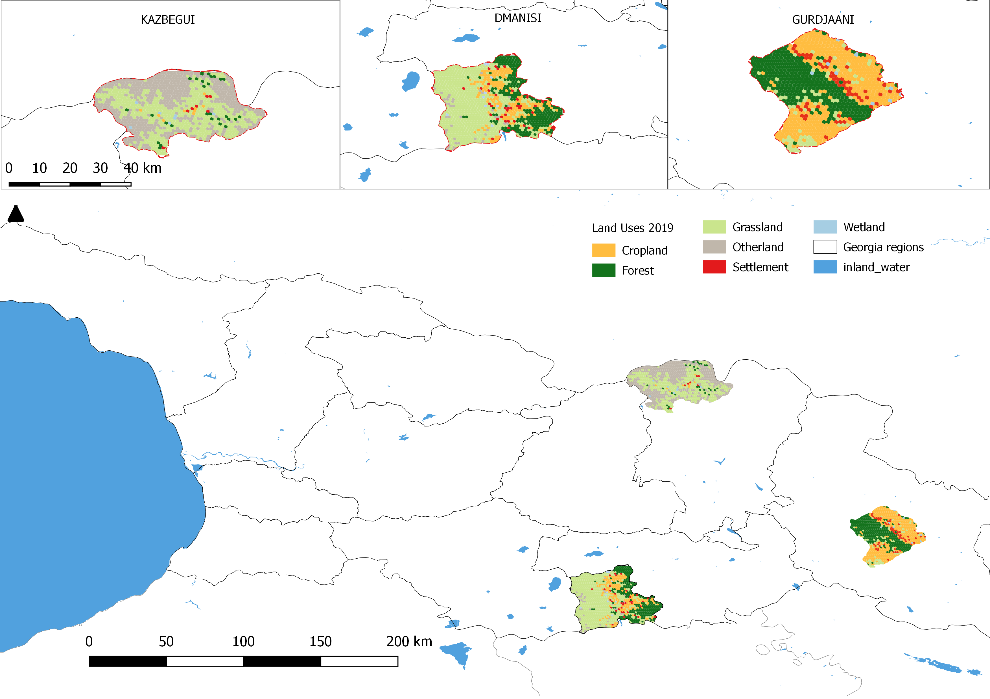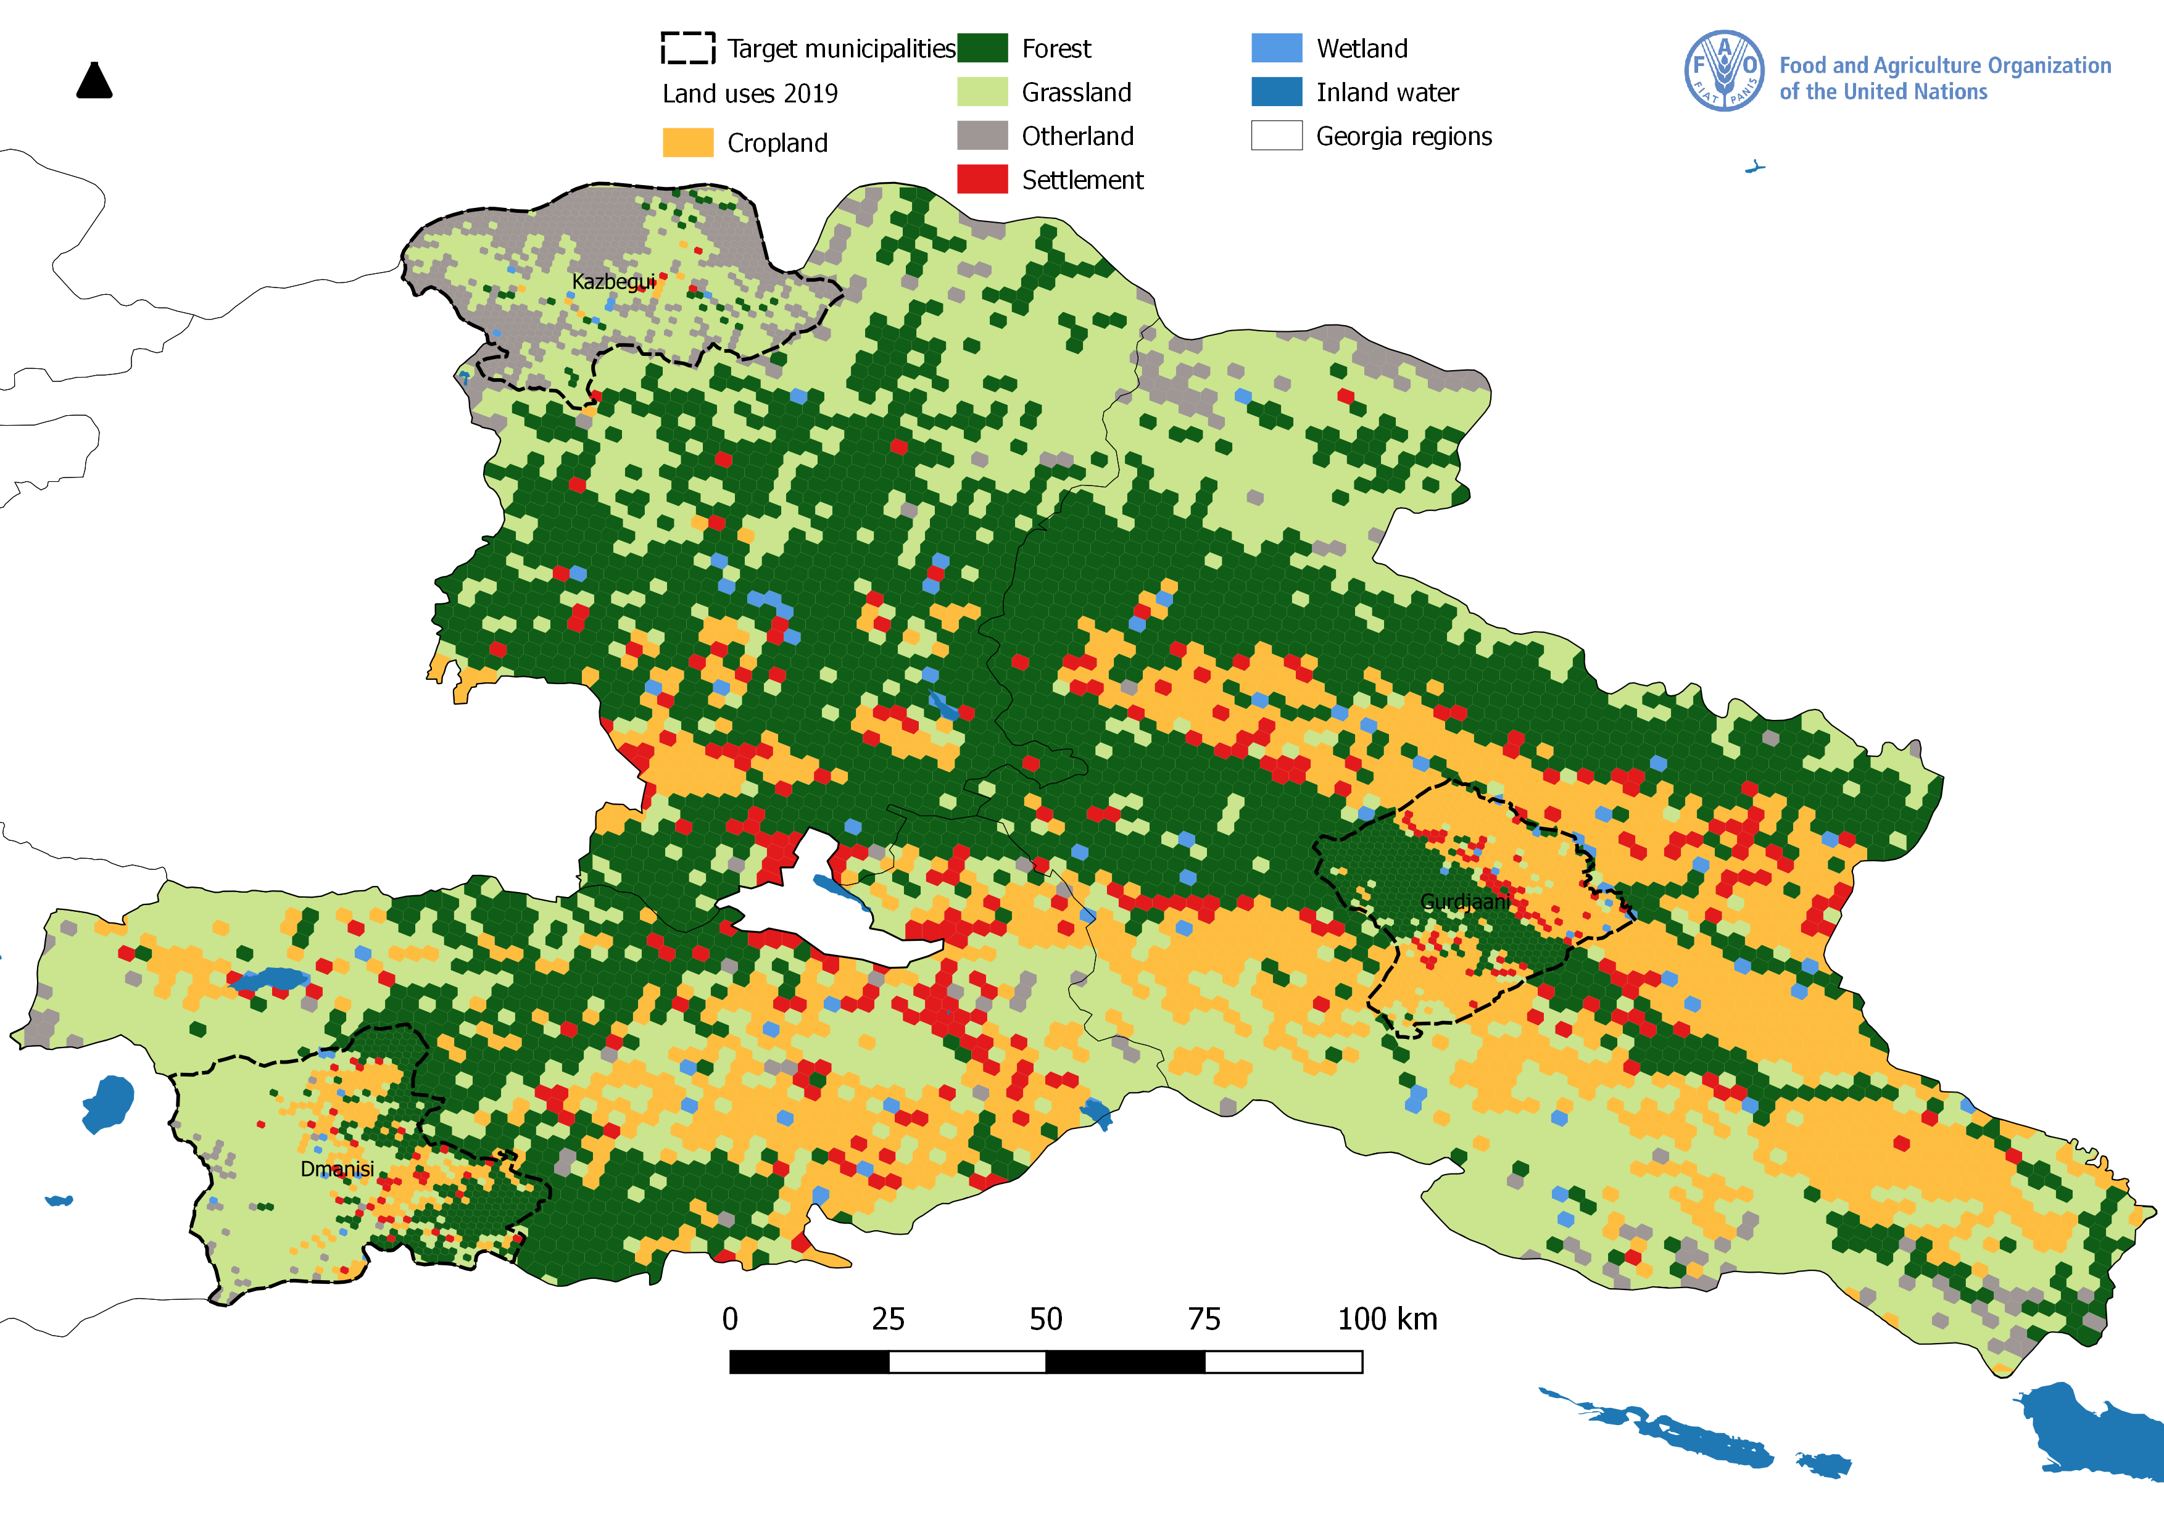
The target sites for restoration activities have been selected based on the extensive stakeholder consultations (details in Stakeholder section) and summarized in Table 1.

Table 1. Target sites for the restoration activities.

Region | Municipality | Village name | Number of sites | Primary land use | Area, ha (total 747 ha)
Mtskheta-Mtianeti | Kazbegi | Sno | 3 | Communal Grazing (cows) | 207
Kvemo Kartli | Dmanisi | Ganakhleba | 1 | Communal Grazing (cows) | 254
Kakheti Region | Gurjaani | Naniani | 2 | Communal Grazing (50 cows) and Seasonal grazing (280 cows + sheep, goats, horses) | 110
Kakheti Region | Gurjaani | Melaani | 1 | Communal Grazing (cows, Sheep, goats, horses) & Forestry | 176

Socio-economic analysis of the target municipalities

Full socio-economic analysis is available in Annex M.

Methodology overview
A baseline data collection process was conducted between August and September 2019, using a questionnaire surveying 148 households. The aim of this activity was to collect relevant information on different macro-domains - agronomic, economic, environment, social and government to better understand the livelihoods, socio-economic characteristics, resource management practices, among others, of the project’s potential beneficiaries in three target municipalities.

The questionnaire covers several aspects of people’s livelihoods, including the following: Household, Agricultural production activities, Pastureland access, Weed species and management, Pastureland management practices, Fertilization practices on the pasturelands, Animal production practices, Animal breeding practices, Animal nutrition and health, Utilisation of new and adapted varieties and breeds of animals, Farm inputs, Water access, Soil quality and land degradation on pasturelands, Landscape characteristics, Climate variability, Access to information on weather and climate change adaptation practices, Access to financial services, Community cooperation.

The final sample was selected based on a two-stage sampling strategy. At the first stage, a sample of villages among the three targeted municipalities was selected based on a probability proportional to size (PPS) systematic sampling. All villages that rely on the use of pasturelands in one form or another were used for the selection of the sample. Out of 81 villages, seven were randomly selected based on PPS systematic sampling taking into consideration the number of households per village as the size measure. At the second stage, an equal number of 21 households were selected per village. With 21 households in seven villages, the total sample size was 147 households and considered representative for the population of three target municipalities. Household sampling in the villages was randomized. This sample is considered statistically significant for the total target population of the project (12,239 households). A 95% confidence level, 10% margin of error and a design effect of 1.5 were used as statistical parameters for calculating the sample size.

Results
The majority of the households in the study area are headed by males (90%). Overall, 50% of the households reported to have a household size 4-6 members, and 40% small size HHs (1 member). Generally, there are low levels of education of the household heads, with 45% of the interviewed households having only the secondary education. Only in the 12% of the households, a member had obtained training or education in farming/agriculture.

Because of the land privatization process that started in 1992, most of the households (65%) are smallholders who own land plots of around one ha, with 20% owning less than one ha land. Most of the used pastures are owned by the State, with only one respondent owning the pastureland. HHs mostly used pastures without formal access agreement/lease (90% of the respondents).

The area of pasture used by households varies significantly - from seven to 220 hectares. HHs usually take herds to the marginal lands around the village (village pastures). This is main practice of pastureland use in Georgia for dairy cows left in villages throughout the year. Livestock are herded to the village pasture every morning and return in the evening.

The study showed that the main source of livelihood in the project areas is livestock production (94%), vineyard/vegetable production (74%), and crop farming (34%). In 69% of the cases livestock production is carried out only on farm for own household consumption. 97% of the HHs own cattle, 18% sheep, 28% pigs, and 18% chicken.

The vast majority of the HHs (92%) in the target municipalities are smallholder animal farmers (cattle and sheep). Few of them following semi-nomadic (seven HHs) or transhumant (two HHs) livestock system and three HHs indicated that they possess holding with extensive livestock production on village pastures. From a sample of 140 HHs, 57% own 1-2 cows, 29% owns 3-5 cows, and 14% own more than six cows. Ten or more cows are present in only 11 HHs. Out of 26 HHs which own sheep – 54% own up to 6 sheep and 19, 2 % - 10-25 sheep. Only in three farms, there are 50 sheep, and two farms have 100 and 1000 sheep each.

Significant changes in the livestock sector are observed in the target municipalities during the last 5-10 years, as noted by 78% of the HHs and that is reflected in the decline of livestock number in HHs. Financial issues (45%) and scarcity of the pastures (79%) mainly cause these changes. Less economic benefits from cattle were noted by farmers as well as a reason of changes in livestock production system. Marketing/sale issues is main challenge for 14% of the farmers, which is caused by long distance to markets (Kazbegi municipality) and lack of knowledge/experience in marketing.

HHs do not take any actions to improve or preserve the pasturelands productivity. The only one action implemented corresponds to rotational grazing. Targeted farmers revealed various challenges related to the pastureland productivity. In general, farmers stated the lack of pastures as main problem for livestock development, which is caused by small area of the pastures available nearby, re-forestation of meadows and weeds spreading. Another challenge is related to water accessibility on the pastures. Lack of irrigation water, as well as of drinking water for livestock were mentioned as important problem in 60 cases (40%). Improvement of water accessibility on the pastures is essential according to 60% of the farmers.

All targeted households and pastures used by them were affected by droughts, which were happened twice in the last three years and lasted for three months. Cases of droughts of more than three months duration were also noted. Nevertheless, data collected shows that most respondents have not taken any preparatory/adaptation actions after experiencing such extreme events.

There is little diversity of livestock breeds in the HHs. In 97% of the cases, HHs mentioned that they have local breeds of animals and only in four cases introduced breed. It should be mentioned that when farmers noted local breeds, they refer to those introduced in the Soviet period rather than the old, traditional endemic species that are very rarely found in Georgian villages nowadays. HHs believe that using local breeds is profitable because they are highly adapted to local conditions and they have less confidence regarding new breeds consider that new high productive breeds are less adapted and their maintenance takes a lot of effort.

Livestock vaccination is provided regularly by the MEPA (veterinary department of National Food Agency) and is obligatory for livestock owners. State programs in cooperation with international organizations are implemented by the National Food Agency annually targeted on domestic animals health to meet requirements of EU-Georgia Association Agreement. Information and awareness raising campaigns were also carried out. Consequently, 95% of the HHs vaccinate owned livestock during the last three years. 94% of them acknowledge their access to veterinary services for vaccination of animals which they found to be of good quality. However, decrease of livestock number almost three times in 2016-2017 caused by disease (brucellosis) was declared during the interviews.

HHs cooperation is mainly based on informal mutual neighboring agreement or common decision-making traditional for the rural areas of Georgia. Villagers also help each other by common farming actions, also through the share of knowledge and experience. Only two HHs are members of livestock agricultural cooperatives. Despite the great efforts made by the state and donor organizations in recent years, the development of agricultural cooperatives in Georgia still faces significant challenges. Only 20 cooperatives are acting in Kazbegi, and 16 and 18 cooperatives in Gurjaani and Dmanisi respectively.

Farmers have restricted access to financial resources in targeted municipalities. Most of the respondents (61%) stated that in the last three years, they have needed financial assistance at least once when faced with unexpected expenditures for livestock. External financial support were provided mainly by family members or frends (in 57 cases), but also from banks (in 22 cases) and micro financial organizations (in 20 cases). Farmers do not trust financial institutions and are afraid to apply to banks and especially micro financial organizations becouse of very high interest rate and inadequate terms of loans.

The following issues came out the strongest in the survey:

Pastureland access: access to the pastures appears to be a major constraint for agricultural producers in Georgia. This is especially true for village pastures, area of which are reducing due to the privatization, cultivation or development projects. The legal access to the pastures owned by the State or municipality is restricted and in general, HHs uses pasturelands informally. 71% of households using village pastures are ready to increase the number of animals if more pastureland is available.

Reduced productivity of the pastures: overgrazing, as well as lack of measures are taken to preserve/maintain pastureland and ensure sustainable use, reducing of the land productivity and vegetation cover is observed on pasturelands. Farmers observe different changes in the vegetation on pastures, mostly spreading of weed and declining of herbs species diversity.

Low productivity of livestock breeds: There is restricted diversity of livestock breeds in the HHs. mainly breeds introduced during the soviet period are present. Farmers are less likely to switch on new, high productivity livestock breeds because they are poorly adapted to local conditions. Low productivity of local breeds and in general, decrease of livestock number lead to the shortage of dairy products, especially in Kazbegi.

Water access: Lack of water supply infrastructure on pastures, water shortages and long distance to water sources causes insufficient water supply to meet livestock needs. In 55% of the cases there is insufficient water for livestock and in 18, 3% livestock needs are meet only a little. Lack of water access on the pasturelands is especially highlighted by the farmers from Gurjaani municipality.

Special Education / Trainings in Agriculture: There is a significant gap in the education of farmers in terms of agriculture. Lack of special knowledge in livestock farming, as well as sustainable management of pastures significantly restricts further development of livestock sector and leads to the deterioration of pasturelands.

Access to financial resources: HHs involved in the livestock farming very restrict access to the financial resources that limits their capacities significantly. Main challenges are related to the high interest rate of the banks and micro financial institutions, as well as unfavorable terms of loans offered by them. There is a lack of bank products designed for agriculture sector, especially for small HHs. Existing State subsidies and support offered by different financial institutions are non–profitable and are not foreseeing interests of farmers. Farmers in all target villages highlighted importance of flexible and cheap financial services for the small farmers and availability of profitable agricultural loans that allows them to develop livestock farming.

Financial issues and scarcity of the pastures lead to the significant changes in the livestock sector in the target municipalities during the last 5-10 years, as noted by 78% of the HHs. Decline of the livestock number is observed in all three municipalities.
Restricted access to the pasturelands, lack of financial resources and special education cause that HHs are mostly oriented to the on-farm consumption production, rather to expand their production system and produce agriculture products for selling.

Rangeland health assessment the target municipalities

Rangeland health assessment has been conducted during the PPG phase (through FAO co-financing) through stakeholder consultations and field surveys using the Participatory Assessment of Land Degradation and Sustainable Land Management in Grasslands and Pastoral Systems (PRAGA). In all, five sites were chosen for field assessments by the workshop participants, with four being communal pastures and one being a former communal pasture that is informally being used by only three community members as it is far from the village and the reduction in livestock numbers have made the trip too far for those with smaller herds.

Annexes N-1 and N-2 provide a report with the results of the assessment and field data, which includes the following:
- Summary of the results (% ground cover, presence of soil crusting, sward height, palatable species, seed formation, slope, evidence of erosion, presence of bush encroachment, dominant grass species recorded, secondary grass species recorded)
- LDN indicators (land cover, land productivity, and SOC) based on field observations
- Conclusions and recommendations for technologies and approaches
- Sampling sheet for PRAGA survey
- Photos of the sites

PRAGA baseline assessment will be used for project monitoring (output indicator as per Results Matrix) and as a basis for selection of technologies and approaches.

Land degradation assessment in the target municipalities

Land degradation assessment has been conducted during the PPG phase through stakeholder consultations and field surveys using rapid Land Degradation Assessment in Drylands (LADA) methodological approach. The assessment was done through a simplified LADA QM (Questionnaire for mapping) and was used for characterizing the sites selected. The assessment was done only for one land use system as sites selected include only one land cover and land use system - grassland/pastureland. The objective of the assessment was to collect information on land degradation processes, drivers, existing and potential SLM practices in three target municipalities. Key findings for each site with detailed information on the processes of land degradation, drivers, and causes can be found in Annex O.

1.3. Barriers

A number of barriers remain that contribute to pasture deterioration and land degradation including: 1) gaps in the legal framework, 2) institutional weakness of the relevant State agencies, 3) lack of scientific information and data on the actual conditions of the land, 4) unclear land tenure and management issues, 5) absence of delineated borders and registry, 6) inadequate incentives, 7) lack of skills and knowledge on sustainable use of pasturelands and related financial risks.

Weak legal framework
At present, there is no specific policy, strategy or laws dedicated to pasture management. The issues of protection and use of pasturelands are scattered within nine different laws (for example, in the laws on the "Protected Areas System" and "Law on Soil Conservation, Restoration and Improvement of its Productivity"). The legislation has gaps and in some cases, the laws contain contradictions regarding ownership of pastures. The existing legislation does not include fundamental provisions on sustainable pasture management.

Institutional weakness
At present, despite understanding of the existing challenges, there is no specific institutional framework and administrative structure for pasture management and there are no national programs, plans or regulations to promote the introduction and implementation of sustainable pastureland management practices. Likewise, there are no significant national budget allocations to this. There are no institutions or mechanisms linking the pasture ownership (under MESD) agencies with actual pasture users (communities). These two are vertically disconnected. The regional administrations are not involved in pasture management. Moreover, there is no horizontal coordination between MEPA and MESD either, while both are involved in the aspects of pastureland management. Furthermore, there is no monitoring system to ensure sustainable use and management of pastures by the lessees.

Limited data for decision-making
There is no scientific national data on:
- LDN national data indicators:
- Land cover. The national data exists based to Collect Earth Assessment carried out during PPG for only three Municipalities in the East of the country.
- Soil carbon. SOC data in the country is mostly old, coming from soil surveys conducted in the 2nd half of 20th century. These data are not digitized or referenced and is therefore of limited use for assessing current soil conditions. SOC data from new surveys comes in relatively small amounts and has a coverage limited to certain project sites.
- qualitative conditions of pastures, including the extent and severity of land degradation; pasture conditions are not studied;
- Information how different livestock management systems affect soil fertility and pasture productivity. This lack of knowledge is a barrier to securing private or donor funding to new technologies and practices

No inventory, no information about actual condition of land, no registered and delineated borders
Since the dissolution of specialized central governmental agency - State Department of Land Management in 2004, the nationwide overall land inventory has never been fully conducted. Only about 20% of pastures are registered. Pasture rent agreement are short term and inconsistent. In general, the pastures were rented without any proof attached about actual soil conditions. The status and condition of soil/pasture at the time when the lease initiated was not known. Therefore, there is no monitoring system to ensure control of the sustainable use and management of pastures by the renters. In 2018, the leasing of pastures was stopped until the state decision is made on this issue. The State pastures are currently used by the population without permits or monitoring.

Lack of awareness
The government recognizes the importance of the SLM and the challenges due to the land degradation on pastures of Georgia. However, in general there is lack of information, skills, capacities and experience in SLM at the relevant State institutions at the central, regional and local level. There is general lack of awareness among farmers about the potential positive impact of the sustainable pasture management and associated long-term benefits resulting from increased productivity of the land and livestock. Access to the expertise is limited. The local communities have no access to knowledge materials on alternative practice and their benefits.

Inadequate incentives and/or financial risk
Over the short term, it is in the interest of small farmers to continue the current practices and technologies. To adopt alternative practices and technologies requires an investment in terms of time and money, and many small farmers are not able to make this investment. This is linked also to the perceived risk. The Government currently does not have the resources to broadly promote the adoption of the new technologies.

High perceived risk of new technologies and practices.
The small farmers predominantly believe that the best way to minimize risk is to maximize the number of livestock. Further, small farmers are generally risk averse; hence, they are slow and reluctant to adopt new technologies or practices believing that they result in higher investment with low results. This is also coupled with the absence of real efforts to scale-out and/or introduce improved technologies on pasture management. There is a lack of pilot sites where evidences of the benefits of SLM/LDN on pasture management can be demonstrated. SLM/LDN scaling up strategies will encourage farmers/land users to adopt improved practices.

1.4. The baseline scenario and any associated baseline projects.

The Government is committed to addressing livestock sector challenges through a holistic approach that addresses food security, economic competitiveness, land reform, and sustainable land management. The approach focuses on reversing land degradation and sustainably increasing land productivity and efficiency. The GoG is in the process of developing the next phase of Agriculture and Rural Development Strategy of Georgia (2021-2027). The existing Strategy for Agricultural Development in Georgia (2015-2020) along with the associated action plan provides the basis for setting the priorities, timeline, and financing for the agriculture sector work in Georgia. The new Strategy is under elaboration (with support from FAO) and will be adopted along with its action plan before the GEF project implementation starts. The Action Plan of the allocates funds to the rational use of State-owned pasturelands in the mountaneous regions (dedicated State program) and to restore and improve soil fertility (study of the Georgia land fund). In addition, The National Strategy for Agricultural Extension in Georgia 2018-2020 provides dedicated financing for Government extension services technical support.

The Government has provisions for the soil organic carbon monitoring system. Scientific-Research Centre of Agriculture (under MEPA) is responsible for obtaining soil information by executing topsoil inventory according to the methodology adopted by JRC (LUCAS Topsoil Survey). It covers a minimum 20,000 ha per year and results in maps, including soil organic carbon stock map for those territories. The system, along with work carried out by FAO’s GSP to produce harmonized digital soil map (PPG process co-financed by FAO) will serve as infrastructure for SOC indicator of the LDN decision-making system as well as monitoring the success of field activities.

In line with the existing Policy (2015-2020) priorities, and in order to help address the challenges faced by the livestock sector, a national working group to identify and resolve livestock related issues was established. The group the working group is made of the representatives of MEPA, Ministry of Regional Development and Infrastructure of Georgia, The National Agency of State Property, Scientific-Research Centre of Agriculture in. While the working group meets on an ad-hoc basis, does not have a program, targets or a dedicated budget, it will serve as a baseline for the coordination mechanism planned under Component 1.

Georgia’s extension network consists of the Information-Consultation Centers (ICC) at municipal and regional levels. These centers consist of local municipality employees and provide extension services to farmers (technical advice and laboratory analysis). However, the support is typically ad-hoc and of limited quality. The centers will act as infrastructure for capacity building support on land degradation issues and outreach to the farmers in target municipalities and scaling out.

Currently, the Georgian Farmers Association unites 3,600 farmers in Georgia and provides (i) linkages to service providers and sources of funding, (ii) markets and technical support, (iii) consultation on policy issues and representation of members’ interests, (iv) defense of smallholder farmers’ rights, (v) participation in policymaking, and (vi) advocacy of fair access to markets and resources.

Georgia participated in the UNCCD and the Global Mechanism the LDN Target Setting Program (TSP). The TSP manifested with the release of the following targets:

- Integrate LDN principles into national policies, strategies and planning documents;
- About 1500 ha of degraded forests will be afforested, about 7500 ha will be reforested and 60% of forests will be managed sustainably;
- Protected areas coverage will be increased up to 12 %
- Degraded land will be rehabilitated. Note: this target includes pasturelands
- Irrigation and drainage system will be improved

In line with the UNCCD 3/COP12 decision and priorities of the GoG, the summary of the project baseline data is presented in Table 2, below.

Table 2. Project baseline landscape indicators

Category | LDN |  |  | Land degradation | Erosion | Grassland health |  |  |  | Ecosystem parameters
Indicator | Land cover distribution by provinces, ha | Land productivity | SOC | LD status | Disturbance, % of area, type of erosion | Average ground cover (%) | Biomass quantity status | Palatability (dominant and secondary species recorded) | Regeneration capacity (high/ moderate/ low) | Biome, ecoregion, elevation, slope, aspect, tree count, etc.)
Source | Collect Earth | Collect Earth and PRAGA | SOC digital map | LADA | Collect Earth, PRAGA, LADA | PRAGA (field result) |  |  |  | Collect Earth
Region | X | X | X |  | X |  |  |  |  | X
Municipality | X | X | TBC during implementation |  |  |  |  |  |  | X
Target landscape /sites | X | X | TBC during implementation | X | X | X | X | X | X
Location of full inventory | Annex P and full database | Full database | Work in progress | Annex O and Annexes O1-2-3 with field data | Annex N and Annex O and Collect Earth full database | Annex N1 and N-2 |  |  |  | Collect Earth full database

The TSP has mobilized consultations with a wide group of national stakeholders and provided an opportunity to leverage and coordinate among different State bodies on land management issues identified opportunities to align the national policies and development plans to mainstream LDN principles. TSP will serve as a strong technical baseline for the project, which will support the national efforts to implement LDN targets (#1 and 4) through restoration and sustainable management of the degraded pasturelands.

The Municipalities in Georgia are the managers of the communal pastures entrusted to them by the Ministry of Economy and Sustainable Development (MESD). The they are in full control over the planning and use of the pastures. Each municipality is allocated with a budget which is distributed to municipal priorities. Furthermore, for priorities identified by the municipal council, various state funds might be available through various institutions such as the Ministry of regional development and infrastructure. Their contribution is expected in the form of personnel for implementation and monitoring of pilot activities, communication with and awareness raising of the concerned population, as well as in the and in the form of lobbying with the central government institutions and the Parliament.

In addition, there are currently several internationally supported projects, listed below.

The main baseline project is entitled “FAO support to Georgian agricultural sector under ENPARD III”. This is a FAO-led initiative funded by the European Union with the amount of US$14.7 million (2018-2022). ENPARD III contributes to the reduction of rural poverty of the targeted rural population because of improved and development oriented policies, as well as improved agricultural services and investments accessible for farmers, allowing for an increased competitiveness and employment creation within the agriculture sector. The project will have two main outcomes, namely: (i) The MEPA and other relevant institutions will have improved capacity, management practices and technical knowledge to sustainably enhance policies, which foster and support the development of value chains and the sustainable competitiveness of agriculture , and (ii) Farmers, cooperatives and other rural SMAEs entrepreneurs, workers and rural households will be included on equitable terms in sustainable food value chains through improved access to finance, inputs and services, leading to increased competitiveness of the agriculture sector.

The project will cooperate and make synergies with the work in the municipalities under ENPARD output 2.1 “Documented economic improvement of the target population (individual farmers, cooperatives, SMEs) as a result of equitable agricultural investment support” and Output 2.2. “The targeted population benefits from the improved provision of agricultural services as a result of increased municipal-level investments of public interest”. ENPARD has begun its implementation in 2019. FAO has announced a grant competition for farmers, cooperatives and SMEs in Georgia to award five value chain actors in 14 municipalities. Beef and dairy are key priorities in eight of the 14 municipalities. The closure of the grant award application deadline coincides with the start of the implementation of the GEF project. Proper coordination arrangements will be put in place during the initial stages of project implementation. Total co-financing from ENPARD III is US$ 5,100,000

The project will establish close cooperation with the FAO-led initiative “Technical Assistance for Establishment of the National Animal Identification, Registration and Traceability System” (NAITS), financed by SDC, ADA and FAO, at a total value of US$5.5 million (2017-2021). The NAITS aims to improve productivity and competitiveness of the livestock sector through improved animal health, reduced food risks and facilitated access to regional and international markets. The project has three main outcomes: (i) The Georgian NFA operates a fully functional and sustainable National Animal Identification, Registration and Traceability System; (ii) the NAITS stakeholders properly use and comply with the new electronic system and (iii) The authorities in Georgia, Armenia and Azerbaijan increase regional cooperation in the livestock sector.

The project synergies include its nationwide implementation, which includes the targeted municipalities, pastures, and mountain pastures, which are considered as important part of the animal movement controls. Georgia’s livestock industry is largely based on use of the national pasturelands and is one of the main agricultural sectors and agricultural export generators. As such it receives significant attention by the government and assistance providers in the country. The project activities include identification and registration of animal holdings (including pastures) and control of animal movements to and from holdings, as well as monitoring of animal health. The two projects have closely aligned agendas as the pasture policies to be introduced by the GEF project will have significant impact on the registration of pasture holdings within the NAITS. In-turn the data made available by the NAITS will enable establishment of animal loads per pasture which are essential for appropriate pasture use and enable livestock producers to both improve the overall animal health situation and to maximize their productivity. Total co-financing from the NAITS project is US$ 5,100,000

GIZ Programme on Management of natural resources and safeguarding of ecosystem services for sustainable rural development in the South Caucasus (ECOserve) will support Georgia in developing sustainable pastureland management practices and scaling up successful approaches in order to achieve LDN. Linkages will the GEF project will be provided through the following work contributing to Components 1, 2, and 3: 1) Development of a method for assessing pasture conditions and soil erosion risks based on remote sensing and ground-truthing at municipality level, 2) Assessment of pasture conditions and soil erosion risks for entire Tusheti, 3) Assessment of pasture conditions and soil erosion risks for Sagarejo municipality, 4) Development of an integrated pasture management plan for Tusheti Protected Areas (Tusheti National Park and Tusheti Protected Landscape), 5) Demonstration of sustainable pasture management on summer pastures in Tusheti, 6) Capacity building of suitable partners to collect, store and analyse pasture and soil erosion risk data, 7) Initiating a pasture policy working group with the aim to prepare a State Programme for Sustainable Pasture Management.

CENN is implementing three relevant projects under the baseline. “Promoting Sustainable Forest Management for Climate Resilient Rural Development in Georgia (SFMRD)” (2018 – 2022), is implemented with financial assistance provided by the Austrian Development Cooperation (ADC). The SFMRD project contributes to the awareness raising of rural populations, especially youth and women initiative groups. This is accomplished via an annual environmental youth competition, the Niko Ketshkhoveli school award, and its supporting webpage forestry.ge. The GEF project results and knowledge materials will be advertised on the portal and some of the challenges for the youth competition will be based on the GEF project priorities with co-financing of US$118.000.

EU-funded project “Embrace Tsalka” (2018 - 2022) targets reducing rural poverty and improving living conditions in Tsalka Municipality, addressing economic, social and environmental concerns by improving agricultural competitiveness, promoting sustainable management of natural resources, and building climate-resilient rural economies and communities. Based on Tsalka Local development strategy agriculture, and more precisely cattle farming is a priority direction of municipality. The municipality possess vast areas of subalpine pasturelands, which has good potential if it is managed properly. The project will establish close cooperation and make synergies with GEF project with the following work: Capacity building and awareness raising activities for farmers and other stakeholders on sustainable pasture management, animal health, and production of safe agricultural/animal products etc. Special attention will be given to Tsalka’s neighbor municipality Dmanisi - a GEF target. Project will work on advocacy at regional and national levels in order to prioritize pasture management issues in the country with co-financing of US$102,000.

CENN also organizes Green Camps for youth form different regions of Georgia (2018 - 2022) with the aim to raise awareness of young generation about environmental protection, sustainable development, science and technology and creating new opportunities for future leaders. Classes are conducted on sustainable land management, SDGs, climate change, sustainable management of forest resources, sustainable waste management and circular economy, water, sanitation and hygiene (WaSH) issues, natural disaster risks and mitigation measures. ToTs will be conducted for the local coordinators and other stakeholders to support the capacity building at local level. Upon completion the participants join the Green Camp Alumni Network and get access to future opportunities within the organization’s youth initiatives. Representatives from GEF target municipalities (Kazbegi, Dmanisi, Gurjaani) will be able to participate in the Green Camps with allocated co-financing of US$130.000.

Dairy Modernization and Market Access: Adaptation Component (DiMMAdapt) project financed by the Adaptation Fund and implemented by IFAD/MEPA (US$4.6 million) targets dairy modernization and market access to enhance the resilience to climate change of vulnerable dairy producers through creation of an enabling environment developed through training and capacity building, implementation of a pasture management plan and introduction of climate-smart technology demonstrations and alternative livelihood diversification. The project tackles the the negative impact of the current pasture usage through management practices on animal productivity with the objective to descrease their vulnerability to the effects of climate change.
The project works on climate resilience and dairy production (markets) through promoting climate-proofing pastoral ecosystem services, focusing at cattle registry and GHG offsetting, and supporting the climate resilience of market vulnerable smallholders, looking among others on energy-saving, climate-smart pilots. The two projects complement each other geographically and thematically. The GEF project will be implemented in the Eastern part of Georgia, while the AF project will target Western part. Complementarities between GEF project looking at biophysical solutions targeting land degradation neutrality and the focus of the IFAD project at climate resilience and markets are strong assets for both projects.

Baseline contribution from REC Caucasus will come in a form of give projects. First, EU-funded project “Increasing LAs capacities in coordination between national and local levels of government to enhance their contribution to establishment of Vashlovani Biosphere Reserve in Kakheti region as model for inclusive and sustainable growth at local level”. The overall objective of the action is to improve living conditions and quality of life of local communities in Kakheti region through inclusive and sustainable growth. The project addresses deforestation, biodiversity loss, land degradation, and desertification challenges of the region. The specific objective of the proposed action is fostering sustainable land use practices, defining new ways of understanding and demonstrating rotational grazing and holistic approach to grassland management in Kakheti region (2019‐2021) co‐financing secured: US$250,000.

Second baseline is “UNESCO biosphere reserve establishment in the climate‐vulnerable regions of Tusheti, Kakheti region – working towards the nomination”, funded under the International Climate Initiative of the German Federal Ministry for the Environment, Nature Conservation, Building and Nuclear Safety through GIZ and Michael Succow Foundation. The project focuses on application of several measures for ecosystem based approaches to climate change adaptation, sustainable pasture management and integrated land use planning in Kakheti region. The project helps local governments in the region to achieve transitional changes to more climate‐resilient, sustainable pasture management and green agriculture by providing them with essential information, tools, technical support and knowledge. (2019‐2021) co‐financing secured: US$150,000.

Third baseline project is “Development of Draft River Basin Management Plans for Alazani/Iori and Khrami /Debeda River Basins in Georgia”. It addresses existing challenges in both development and implementation of efficient management of water resources. It specifically supports Georgia to move towards the approximation to EU acquis in the field of water management with a focus on EU Water Framework Directive (WFD). As part of River Basin Management planning process, elaboration of GIS maps on land use, data gap analysis, update data on drivers, pressures, impacts, conceptual model linking pressures to impacts, computer modelling/simulations of river pollution from point and/or non‐point sources for the Kvemo Kartli, Mtskheta Mtianeti and Katkheti regions are envisaged. (2020‐2021) co‐financing secured: US$100,000.

Fourth baseline project titled “Upscaling Land Restoration Measures to Prevent Land Erosion and to Maintain the Fertility of 650 ha Agricultural Land in Vulnerable Municipalities of Kakheti Region”. The project aims at securing the productivity of about 650 ha of agricultural lands (arable land and permanent cropland) and to reduce land degradation caused by wind erosion through contribution to reestablishment and rehabilitation of 25 km of windbreak system in vulnerable municipalities of Kakheti region(Sagarejo and Gurjaani municipalities) and Carbon sequestration of 117 t CO2 eq. The proposed pilot measures will demonstrate local farmers as well as regional and national policy makers the economic and ecological importance of windbreaks and encourage them to expand the restoration of windbreaks to the other parts of municipalities. (2019‐2020) co‐financing secured: US$150,000.

Last baseline project from REC Caucasus is IFAD-financed project “Regulatory Impact Assessment (RIA) of the Draft Law on Soil Protection” objective of which is to support MEPA to create evidence‐based justification for the draft law on Soil Protection and to insure that final draft of the new legal instrument is as efficient and effective as possible before its public disclosure and start of formal review process. (2019‐2020) co‐financing secured: US$50,000.

In addition, the project will coordinate with the activities and will build on the lessons-learned from the GEF-funded project “Generating Economic and Environmental Benefits from Sustainable Land Management for Vulnerable Rural Communities of Georgia” (GEF ID: 9730) and the “Enhancing Resilience of Agricultural Sector in Georgia (ERASIG)” (GEF ID 5147) project. The project will also draw on lessons-learned from the “Sustainable Agriculture in Adjara” project financed by the Government of the Adjara Autonomous Republic as well as the EU-funded “Sustainable Management of Pastures in Georgia to Demonstrate Climate Change Mitigation and Adaptation Benefits and Dividends for Local Communities” project. The latter two projects focused on the strengthening of extension services, introduced SLM to farmers, and carried out pilot activities on rehabilitation of pastures and will serve as a technical foundation for the scaling out of the pastureland technologies and approaches. These projects are not considered as co-financing.

The baseline scenario thus includes a number of important elements to build upon and to implement the LDN targets. However, under the business-as-usual scenario, the pasturelands will continue to be unmanaged, under maintained and underinvested; the gaps in the policy and institutional framework that enables sustainable pasturelands management will remain, the farmers will practice inefficient pastureland management approaches, leading to further land degradation, loss of economic returns and biodiversity, and decreased carbon stocks. Incremental GEF funding is required to pave the way for Georgia to implement LDN targets in a timely, coherent, and consistent way to ensure the scaling up.

1.5. The proposed alternative scenario with a brief description of expected outcomes and components of the project and the project’s Theory of Change.

1.5.1. Project strategy and Theory of Change
The project will follow the proposed Theory of Change (Figure 1).

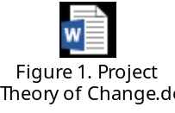

The project will support the national efforts to implement LDN targets of Georgia through restoration and sustainable management of degraded pasturelands (National Targets 1 and 4) working at the landscape level. The project will set a framework for the LDN targets implementation in the three target Municipalities in East Georgia for upscaling at national level in line with SDG Target 15.3. It follows the “Scientific Conceptual Framework for Land Degradation Neutrality” guidelines and takes a phased approach:

Phase A: Vision and system characterization
First, the country has selected three target municipalties based on the priorities of the LDN TSP, and the target landscapes (based on stakeholder prioritization). The target municipalities and landscapes have been characatrerized by key bio-physical and socio-economic parameters (see part 1.2. Area of intervention and Table 2. Project baseline landscape indicators).

Phase B: Setting the baseline
The LDN baseline is the land-based natural capital as measured by three voluntary LDN indicators (land cover change (LCC), land productivity, SOC) and additional national indicator for grassland health (based on PRAGA methodology). Each of these indicators assesses a different aspect relevant to LDN: LCC detects the human actions that drive land degradation and its reversal; land prodctivity reflects the impacts of those drivers on plant production as a measure of ecosystem function; and change in SOC stocks, which responds more slowly, indicates the change in productive capacity. Asessment of the grassland health is further provided through a combination of participatory mapping of target landscapes (consultation with local representatives and land users) and field studies (plot surveys and field-based indicators). Table 2. provides a summary of the project baseline landscape indicators.

Phase C: Establishing mechanism for neutrality
Achieving LDN requires land managers to monitor land use decisions that may impact the neutrality, and estimate their likely cumulative impacts, so that these can be counterbalanced by reversing land degradation on the same land type, elsewhere. While Georgia does not have established land use planning processes, the project will develop pasturereland management plans in target municipalities (Component 2) and manage counter-balancing at the level stipulated in the plans. To ensure that counterbalancing measures do not diminish the wellbeing of land users, a comprehensive socio-economic baseline analysis has been conducted in three target municipalities (See section 1.2. Area of intervention). The aim of the study was to collect relevant information on different macro-domains - agronomic, economic, environment, social and government to better understand the livelihoods, socio-economic characteristics, resource management practices, among others, of the project’s potential beneficiaries in three target municipalities. Clear boundaries of pastures are essential to prevent conflicts and avoid illegal changes of land use (e.g. from pasture to arable land). The status and condition of pastureland is important for leasing purposes. A detailed inventory (qualitative and quantitative) will be developed in three target municipalities (Compoentn 2).

Phase D: LDN planning and implementation
To ensure technical coherence of the framework, the land degradation status, causes and effects of land degradation were identified for the target landscape (see Annex O1-3). Building on the stakeholder-driven rapid LADA and PRAGA assessments, the project applies a participatory process for design and implementation by including land users and relevant representetives of local government and extension. The project will strengthen the enabling environment for LDN, land-use planning processes, and security of tenure rights in Georgia with the specific focus on pasturelands. It will be followed by development of a LDN Decision Support System (DSS) using the proposed hierarchy of responses (avoid>reduce>reverse) based on the status of land degradation and using three LDN voluntary indicators (land cover, land productivity, and SOC) that will be piloted in the three target municipalities (Component 1).

This phase also involves balancing of the anticipated losses from impacts of pastureland use decisions through restoration of degraded pasturelands (land use of the same type), thus achieving LDN on the ground on pasturelands in the three target municipalities generating associated GEBs related to land restored and under SLM (Component 2). The counterbalanding of the LDN will be done at the same scale as land use planning process that will be established in the three target municipalities. This will be followed by scaling up the select approaches within three target municipalities using the land use plans and targeted capacity building programs and targeted awareness raising campaigns (Component 3).

Phase E: Monitoring neutrality
The final phase will include monitoring of the three LDN indicators, additional national indicators for rangeland health, GEBs and socio-economic benefits. Local knowledge and continuous learning will be applied to validate/interpret the data, and anticipate/adjust/create new steps – closing the LDN loop (Component 4).

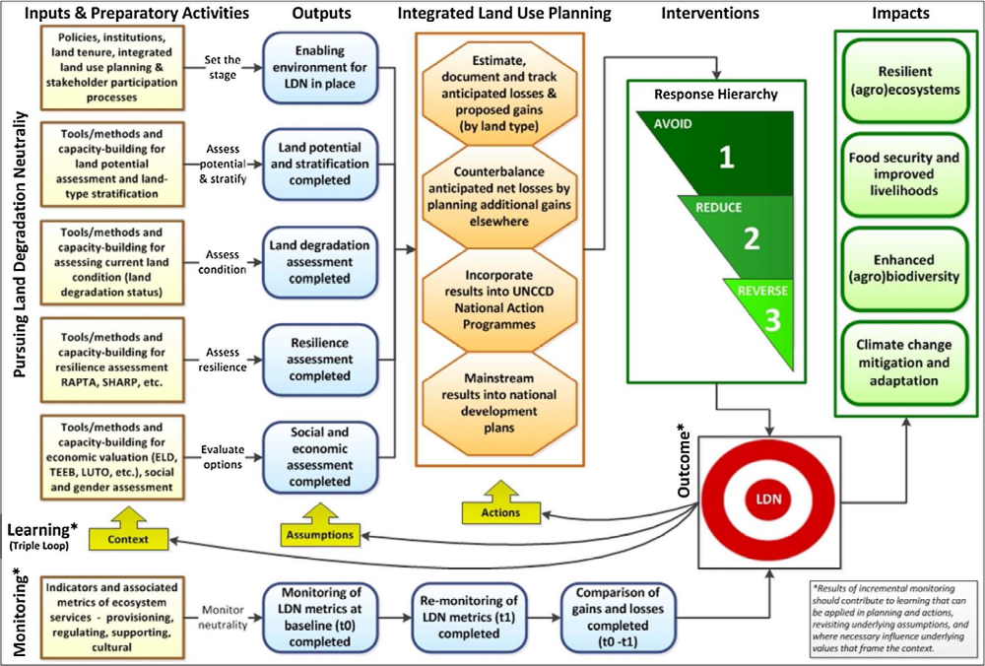
Figure 2. Theory of Change for Land Degradation Neutrality (LDN).
1.5.2. Project Objectives, Outcomes and Outputs
The project objective is to support the national efforts to implement LDN targets of Georgia through restoration and sustainable management of the degraded pasturelands (National Targets 1 and 4). It will be achieved through three Components with related outcomes and ouputs:

Component 1. Strengthening the regulatory and institutional framework for sustainable management of pasturelands in Georgia

Under Component 1, the proposed project will facilitate the development of the State vision / policy and laws for pasture management following SLM principles and will ensure establishment of the required institutional framework for pasture management.

Outcome 1.1: Enhanced policy and institutional frameworks for LDN with the focus on the implementation of SLM principles on pasturelands

Output 1.1.1: A national pastureland management policy contributing to implementation of LDN principles, designed and agreed with key stakeholders
This output will develop a policy that will set the principles of sustainable pastureland management. Reflecting the socio-economic analysis conducted during the PPG, the policy principles will include the following:
- Provide definitions of Pastoral resources (grasslands, pastureland, hay-making areas, steppes, seasonal resources, such as grazed forests)
- Outline the quantitative and qualitative conditions of pasturelands
- Promote land tenure security (regardless of the type of ownership) based on delineated and registered pastures, also as an an important precondition for the enforcement of the regulatory mechanisms, including sustainable use and management of pastures, pasture leases, etc. The customary tenure arrangements will to be clarified (including rights and obligations) as vast majority of communal pastures (and state) in Georgia are used by residents informally. This will be closely linked to communication to the community members (during awareness raising campaigns, including on the VGGT – done in Component 3);
- Outline ecosystem services of various types of pastures;
- Provide an overview of the national and sub-national institutional set-up for work on pasturelands
- Develop guidelines on participatory development of community-based pasture (grazing) plans, focused on prevention of soil degradation and maintainance of biodiversity;
- A mechanism to transfer sustainable pasture management technologies to livestock keepers and community leaders. The technologies may include introduction of erosion-resisting grass species, introduction of bushes and trees to the pastures, wider use of electric fencing, supplementing diets for the livestock to reduce dependence on the pastures etc.

The work will include the following:
- Establishment of a national inter-sectoral multi-level LDN Working group
- Enhancement of a national pasture platform integrating LDN principles
- Dissemination of national pastureland policy document for wider public review and facilitation of at national and local levels for governmental approval

The policy should be supported by technical tools/information and capacity needs and opportunities. Therefore, Output 1.1.1 will be closely linked to the work being done under Components 2 and 3. This policy will be closely lined with the Agricultrue and Rural Developmetn Strategy of Georgia (2021-2027) that is currently being drafted.

Output 1.1.2: Pastureland management law and supplementary sub-laws drafted
Based on the policy recommendations, presenting the overal State vision of the management of pastures, the GoG through Output 1.1.2 will draft a Law on Pastureland. The law will govern pastureland management and monitoring issues to ensure their sustainable use. It will provide compliance and monitoring tools for pastures exploitation including organizational-methodological schemes (for grazing, assessment of pastures condition, plot rotation rules, or mechanisms of monitoring, control etc.). The law on pasturelands will:
- Set definitions of pastureland and its various types (permanent, seasonal, semi-natural, high-biodiversity, environmentally sensitive grasslands, etc.);
- introduce monitoring of grasslands that have high environmental value;
- ban plowing of environmentally sensitive grasslands or introducing triggering corrective action if the natural pastureland is converted into intensive annually-sown pastures;
- define eligibility criteria for support payments to the farmers;
- clarify pastureland tenure issues:
- clearly determined rights and obligations of the parties, i.e. observance of the exploitation rules, obligation of taking trainings;
- direct renting of pastures to targeted groups (municipality community, agrarian cooperatives and other legal entities);
- in the case of pastureland auction, to differentiate pastureland rental conditions according to their quality. The quality should be assessed according to their altitude, fertility of land, grass productivity, nutritious value of the grass and through availability of the relevant infrastructure (road, water);
- pastureland lease agreement shall incorporate the exploitation conditions in compliance with the current standards and rules).
- Develop guidelines on calculating recommended loads on the pastures (e.g. livestock units per hectar), taking into account local ecosystems and seasonality;
- Set livestock production rules in/near particularly environmentally sensitive places such as protected areas (e.g. biosphere reserves) and riparian zones;
- Develop national AnGR Management Strategy for grazing livestock in line with the Global Plan of Action for AnGR to ensure efficient use of pastures.

The work will include the following:
- Identification of needs for new legislation and/or revisions of existing legislation based on agreed national pastureland policy and pastureland management law drafted
- Regulatory Impact Assessment (RIA) + of draft law
- Pastureland management law presented to the national stakeholder platform
- Stakeholder consultations of draft pastureland law (with RIA) for wider review and arrangement of regional public hearing meetings and submission of final draft law to the Government for further formal governmental review procedure
- Establishment of the Land Management Agency responsible for the pastureland management

Outputs 1.1.1 and 1.1.2 will be closely coordinated with GEF project implemented by IFAD “Enhancing Resilience of Agricultural Sector in Georgia (ERASIG)” and build on results of the GEF project implemented by UNDP “Sustainable Management of Pastures in Georgia to Demonstrate Climate Change Mitigation and Adaptation Benefits and Dividends for Local Communities”.

Output 1.1.3: Multi-stakeholder coordination mechanism on pastureland management created at national level
The regulatory structures provided by MEPA and MESD need to be aligned and integrated in the Output 1.1.3. This horizontal coordination mechanism - an inter-agency multi-stakeholder coordination group for an inclusive national dialogue on pastureland management - will complement vertical coordination mechanisms among various administrative levels of central, regional and local government and actual users of pasturelands. The coordination mechanism work will include the stakeholders listed in Annex I2.

The work will include the following:
- A national pastureland policy integrating LDN principles drafted in participatory manner through series of roundtables, workshops, discussions under the national multi-stakeholder platform
- National Pastureland/LDN stakeholder consultation to discuss and agree on of the national pastureland management policy

Output 1.1.4: Multi-stakeholder pasture management groups are established in the three target municipalities
Output 1.1.4 will facilitate establishment of multi-stakeholder pasture management groups in the form of Pasture Users Unions - community-based groups working on pasture management, which can play an essential role in preventing pasture degradation by advocating at the local and national level for more favorable rules and implementing sustainable pasture management approaches in its area. These groups will be key players in deciding and receiving the capacity building work carried done under Component 3.

The work will include the following:
- Establishment of pasture management groups at municipal level in communities integrating LDN principles in the three target municipalities
- Development of a coordination mechanism between the croppers, food processors and livestock keepers to ensure wise use of resources (e.g. use of post-harvest residues for feeding) and prevent damage of crops by the aniamls
Output 1.1.5. Decision Support System (DSS) for LDN integrated and tested

The work will include the following:
- Identification/validation metrics for Land Cover (based on Collect Earth-PPG work)
- Identification/ validation metrics for Soil Organic Carbon
- Identification/calibration metrics for Land Productivity
- Piloting of DSS for 3 LDN indicators and integration into existing processes (based on LADA-PPG work)
- Integration and mapping land cover, land productivity, and Soil Organic Carbon for SOC monitoring
- Faciltate access of stakeholders to the labs for checking quality of the soils
Component 2: Demonstration of sustainable pastureland management practices and scaling up successful approaches

Component 2 interventions will be designed according to land type (and tenure) and involve a variety of appropriate approaches to avoid, reduce, and reserve land degradation. The three target municipalities represent national priorities according to the sub-national assessments of hot spots (identified through LDN TSP). Measures will also be applied to manage the trade offs. The TPP will continue serving as guidance also during the PPG when the details on the project sites and project activities are elaborated. Component 2 activities will be closely linked to the capacity building carried out under Component 3.

Outcome 2.1: LDN target # 4 is implemented via SLM practices on degraded pasturelands by local land users with the support of the coordination mechanism

Output 2.1.1: A detailed inventory and multi-factor assessments of pastures are conducted in the three target municipalities
In order to carry out field demonstration activities, the project will develop an inventory of pastures and pastoral resources in the selected project sites (Output 2.1.1). This will include both spatial and temporal considerations of the resources. Based on thise pastoralure inventory, strategic pasture management plans comprising urgent measures on implement SLM/LDN approaches and practices in pastureland will be developed (Output 2.1.2) and validated with local stakeholders in the three target municipalities. The project will also seek to enhance the coordination mechanism between decision makers and farmers considering the needs of vulnerable groups (women, youth and minority groups) – based on Gender Action Plan (Annex Q).

The planning process will be carried out at 2 levels: strategic and operational. On one hand, the strategic planning will contribute to achieving a sustainable long-term fit of the various farm business models linked to the plans, taking into consideration the physical, social and financial environments under which the businesses are operating. In this case, strategic planning will be done at the municipal level, which will include different approaches and techniques for the diverse land tenure systems and economic realities that exist within the municipality.

On the other hand, operational plans will be developed at the plot level and will introduce concepts like rotational, strategic grazing, pasture recovery times, application of animal impact, monitoring of indicator species, mobile fencing and watering, in addition to basic planning calendars for improved breeding, sales and disease management. These will be developed based on the results of the PRAGA baseline study and with the participation of the farmers, relevant agricultural cooperatives, and locally-based technical advisors. The implementation of these approaches will serve both to restore degraded areas, improve ecosystem services and to prevent or avoid further land degradation. The specific steps will include: (i) mapping of the pastureland (physical inventory count of pastures according to the municipalities and identify the total area of pastures according to the categories – based on Collect Earth PPG results – Annex P); (ii) surveying farm technical and financial parameters and providing recommendations based on the PPG socio-economic analysis – Annex M; (iii) identifying degraded areas (type of ownership and the specifications that are essential for monitoring during the further exploitation of pastures) – absed on PPG LADA results – Annex O1-3; (iv) identifying basic infrastructure barriers; (v) assessing the soil and biodiversity condition of grasslands at paddock level and native forests that provide protection, shelter and shade, including pastureland characterization to various sub-levels (e.g. hay-making, summer/winter pastures, etc.) – based on PPG PRAGA results – Annex N1-2; (vi) participatory assessment of constraints and opportunities, and; (vii) verification of the available/suitable technologies, practices and measures to be tested. 30 percent of selected farms will be women-headed. The suggested possible technologies and practices are the following: pastureland rotations strictly aligned with grassland recovery times, pasture/grazing management plans (maps+calendars) with clear short/long-term objectives for each landscape section, improved distribution of livestock manures in landscape to increase soil fertility, increase biomass retention on pastures to improve soil quality and reduce erosion, water harvesting works and the use of intense, targeted grazing to reduce the costs of weed control.

Impact of sustainable intensification in livestock production on livestock production will be assessed (presuming that increasing the share of concentrates in the livestock diets as well as a wider use of crop leftovers, food processing by-products and silage would reduce dependence on the pastures)

The work will include the following:
- Inventory system/methodology with parameters (quantitative, qualitative) is agreed through the coordination mechanism and developed in at least one municipality based on Collect Earth
- Nationally appropriate pasture grazing capacity methodology developed, tested and promoted, with transparent, well documented analysis of operational costs of proposed livestock production system.

Output 2.1.1 will build on the results of the project “Sustainable Management of Pastures in Georgia to Demonstrate Climate Change Mitigation and Adaptation Benefits and Dividends for Local Communities” on rehabilitation of pastures and introduction of SLM/LDN practices.

Output 2.1.2: Pasture management plans (strategic and operational) are developed in participatory manner and implemented in the three target municipalities
The Output 2.1.2 will build on the lessons learned from the GEF project supported by UNDP project “Sustainable Management of Pastures in Georgia to Demonstrate Climate Change Mitigation and Adaptation Benefits and Dividends for Local Communities”.

During the PIF formulation, three municipalities have been selected as potential beneficiaries of the project: Kazbegi, Gurjaani and Dmanisi and confirmed during the PPG. In addition, the project will assist the country to identify the areas for implementation of the Bonn Challenge commitment.

The work will include the following:
- Elaboration of State-owned pastureland management plans (strategic and operational) in participatory manner for three target municipalities (in total 20,000 ha)
- Implementation of sustainable participatory pasture management practices (grazing management, weed control, breeding program with local stock, fertilization, terracing, gully prevention, mobile livestock water points, water harvesting, mobile fencing, mobile shade structures, etc.) (in total 747 ha)
- Pastureland management municipal group discussions and community consultations

Techniques and practices to be introduced during the implementation phase on the selected 747 ha will include the following:
- Directed grazing: also referred to as ‘rotational grazing’, it described the use of domestic grazing animals as tools to complete a variety of task, including suppressing weed growth, reducing biomass in fireprone areas, improving soil fertility and nutrient cycling, increasing pasture or forest biodiversity and to maintain historic landscapes to name a few. It often requires a change in how we see domestic animals and the roles they play within the landscape. Materials for this approach include but are not limited to fencing (electric/wire), mobile livestock watering equipment, water storage and distribution materials, mobile shade structures for livestock, predator deterents (dogs, fencing/housing, noise-makers), plus other equipment to support the shepherds manage the flocks (GPS, mobile veterinary kits, holding pens, portable milking stations, etc).
- Weed Control: following grazing applications, manual or mechanical weed control measure should be taken to maintain pasture productivity. These could necessitate the purchase of specialised machinery (tractors, brushcutters, tractor implements), manual tools, specialed clothing and gear and other supporting materials.
- Pasture fertility works and direct seeding: although the improved grazing rotations will more effectively distribute manure and urine across the pasture surface and these deposits can be concentrated to certain sites through shade and water placement, there will most likely be key areas which have been poorly managed and are in need of restoration works. This could include soil preparation works (ripping, ploughing, raking), seeding with local or improved pasture species, fertilizer and soil amendment applications, irrigation, etc. Of special interest are direct seeders which maintain pasture cover, yet introduce crop or forage species into the pasture space with minimal impact.
- Earthworks and water harvesting: if done properly, focused earthworks and water harvesting structures can greatly improve water capture, retention and distribution through the grazing space. They often require heavy machinery, water distribution and storage infrastructure and fencing if animals are to be excluded from the area. These works can and most likely should include roadwork to improve access and movement of goods.
- Creation of wetlands and other diverse landscape areas as pasture support components: the increasing frequency of droughts was of vital concern to those interviewed for the HH surveys. Pasturelands cannot always provide adequate forage in times of drought, and backup measures should be incorporated into the grazing landscape. This requires certain areas, often marginal lands or boundaries, be planted with deep rooting shrubs and trees that can be cut as green feed in time of emergency. Trees can also be used as windbreaks, to create calm, sheltered areas for lambing or calving, woodlots, wildlife corridors, etc. They bring deep soil nutrients to the pasture surface and if place horizontally across a slope they reduce soil erosion and slippage. Wetlands should also identified in the planning process and be grazed as individual units. Their recharge areas should maintain more biomass than their surroundings so as to improve moisture capture and retention. This excess biomass can then be intensely grazed during drought times, as it will often be the only green material available.

The lessons learned and costs of the application and use of these techniques will be a vital component of the State-owned pastureland management plans (strategic and operational) that are to be developed for total 20,000ha of municipal lands.

The project will promote the ”neutrality” within the project sites. Through participatory assessment and evaluation of the different land uses and systems, an agreed division and analysis of the ecological state of each area of the landscape can be reached and plans can be discussed to conserve those are deemed healthy, and improve those areas showing degradation. Involving communities in this “neutrality” discussion also allows them to visualize and understand how ecosystem services flow through the different land tenure systems, and how this consequently leads to the need for a holistic approach to landscape issues.

To support this participatory analysis, the PPG baseline work conducted through LADA and PRAGA can be revisited in order to add some structured data and figures to the debate. The LADA assessment during the PPG focused on identifying hot and bright spots and areas with various stages/status of land degradation and design interventions to counterbalance LD with participation of local communities. The PRAGA field assessment collected data from 95 plots distributed in the 3 selected pilot sites are associated with GPS coordinates so that they can be revisited and the field conditions compared with those taken as a baseline. These initial assessments together with the participatory feedback mechanisms will serve as monitoring tools to assess the impact in achieving LDN. The implementation of the land resource planning general concepts and particularly “Pasture management planning” will support the integrated landscape management and the implementation of LDN concepts.

Output 2.1.3: Business models to encourage investments in pastureland management to implement SLM and achieve LDN are elaborated in 3 target municipalities
The results of the socio-economic assessment carried out during the PPG, reveiled sustainable access to finance for livestock/pastoral resource development is one of the main obstacles for pastureland management. Pasture-based business models developed under Output 2.1.3 will estimate production costs scenarios under the Pasture Management Plans (Output 2.1.2) and compare them with surrounding areas to demonstrate in clear economic terms the benefits that SLM provides when closely linked with financial planning. The models will also explore administrative, marketing, value-adding and logistical issues that must be overcome to achieve financial sustainability.

Global research has demonstrated that the return on investments in improved rangeland and pastureland management can be significant, leading to clear social, economic and environmental benefits. However, making this case becomes difficult when applied at micro, farm or community-based levels. Therefore, these models will provide a roadmap with clear financial grounding and analysis to encourage investments in improved pastureland management and achieving LDN through SLM practices. This will target to increase 1) internal national support through public and private sector entities (at least 3 different types of enterprise) and 2) external donor funds supporting smallholder farmers to scale up best practices and adoption of self-reliant approaches for LDN transformative project. The majority of farmers and pastoralists in Georgia lack access to lending resources due to restrictive and often unclear land tenure and lack of access to affordable credit. The project will therefore promote economic models and case-studies, as well as collaboration with micro-financing organizations to improve access to credits for farmers and pastoralists who wish to adapt components of the project developed business models.

The work will include the following:
- Development of 5 differing business models for pasturelands under different land tenure systems in 3 target municipalities mainstreaming LDN principles based on the cost-benefit analysis
- Livestock value chain strengthening in three target regions
- Development of at least one bankable project for the LDN fund
- A pilot solar-powered water well on a remote pasture to demonstrate potential RoI from the pastures
Component 3: Capacity building of the key stakeholders on sustainable management of pasturelands and achieving land degradation neutrality

Outcome 3.1: National and local stakeholders are empowered and have capacity to implement SLM practices in pasturelands

Output 3.1.1: National Capacity building program focused on the application of the SLM/LDN in pastureland management with gender mainstreaming consideration elaborated
Building on the results of the socio-economic assessment, a Capacity Needs Assessment will be carried out during the first 3 months of project implementation to determine the capacity development needs at the relevant State institutions and among farmers. This assessment will provide a basis to design and a capacity building program (Output 3.1.1) to be implemented with project resources. The capacity building program will focus on the application of the SLM/LDN. It is expected that as a result at least 600 farmers/farm employees/cooperatives will be trained in the application of the SLM/LDN technologies and practices on pastures covering 20,000 ha of land (number of direct beneficiaries to be determined at project inception). An integrated pasture management plan/strategy will be developed for each community in consultation with all stakeholders. Additionally, the smallholders will be educated on balancing the livestock diets, that would increase productivity, decrease GHG emission intensity and decrease dependence on the pastures (avoid overgrazing and land degradation). The project will contribute to revival of old, traditional breeds, which arte well adapted to the local environmental conditions (also, products from the local breeds can command a higher price, especially in touristic areas).

The first step will be to prepare the training material. At least 3 farms/cooperatives will then receive on-the-job and informal classroom training on the improved approaches to pastureland management employing the FAO-developed approach of Farmer Field Schools for small-scale livestock producers. This will enable the farmers to implement the SLM strategies (in Output 2.1.1). At least 30% percent of trainees will be women.

The work will include the following:
- Capacity Needs Assessment at the national, regional, and local levels
- Farmer trainings via ICC/extension (at least 30% of participants are women) in three target municipalities
- Farmer Field Schools on sustainable intensification of production by making the livestock feeding diets more efficient and climate-friendly, which would lead to decreased load on the pastures
- Farmer Field Schools on creation and management of silvopastoral systems (considering expansion of goat production) on the currently degraded pastures (bringing the forest to the pasture, not livestock to the forest)
- The livestock keepers will be educated on choosing right AnGR for the local environment and the importance of right breeds will be demonstrated by providing the parent stock and applying the passing on the gift approach
- Training of Trainers in 3 target municipalities (through Extension, FFS)
- Group organizations (field demonstrations/farmers meetings/exhibitions/competitions/ field days, etc.) in three target municipalities
- Training for investment access to the farmers (FAO Rural Invest of others)

Output 3.1.2: Knowledge materials on SLM and LDN are developed and disseminated to a wide range of relevant stakeholders
In order to support activities under Output 3.1.1, the project will develop a set of manuals and media products to be used by extension specialists and producers. These informational materials will capture and describe the improved practices, measures and technologies. Under Outputs 2.1.2, the project, through its consultative and research-action approach, will have developed an affordable package of measures, practices and technologies that have been, tested, refined and implemented over 20,000 hectares under diverse socio-economic and ecological conditions. Under Output 3.1.2 this will be transformed into a set of products to be used by extension agencies in target municipalities and other municipalities in the country (through co-financing). Extension specialists will be trained through a Trainer of Trainers (ToT) approach to disseminate knowledge about newly learnt approaches to other municipalities (through co-financing).

The work will include the following:
- Preparation of knowledge brochures, manuals for pastureland management
- Preparation of knowledge brochures, manuals on sustainable intensification and use of traditional local breeds

Output 3.1.3: Training provided to national and local decision makers, workers of governmental extension services, women groups and farmers
Training and capacity building activities (Output 3.1.3) will be based on the approach developed by FAO and will address the identified gaps and needs for meeting the UNCCD requirements set out in the LDN principles, with specific focus on pastureland rehabilitation and sustainable management and targeted at young professionals and farmers. FAO has considerable experience in developing and reinforcing countries’ technical and institutional capacities, particularly considering institutional needs, as well as in promoting and facilitating dialogue, consultation and consensus processes with multiple stakeholders. FAO recognized capacity development as a catalytic core functions to achieve its strategic results, is implementing a comprehensive corporate strategy and has developed cutting-edge normative and practical methodologies on human, institutional and systemic CD approaches to guide its member countries. Practical tools and methods include how to assess capacities, design appropriate CD interventions and track capacity results jointly with stakeholders. This approach has been proven successful in several GEF projects implemented by FAO.

The State agencies (MEPA, MESD, NASLM (under establishment)) supporting sustainable pastureland management will develop their capacities to support implementation of SLM on pasturelands including: interagency coordination, monitoring, analysis, communications, technical assistance, resource mobilization, social and economic evaluation. The output will build on the results of the project “Sustainable Agriculture in Adjara”.

The work under this output will also include two study tours abroad on SLM/LDN to visit the successful examples of pastureland management in the similar environemntal conditions (Turkey). The Government of Turkey and FAO will provide co-financing to conduct study tours on sustainable pasture management for the Georgian technical specialists involved in pastureland management. Turkey manages its pastureland by two Government institutions according to the their type - General Directorate of Plan Production (steppe pastures) and General Directorate of Forestry (forest pastures). General Directorate of Plan Production of Turkey will be the technical lead for the trainings.

The work will include the following:
- Technical workshops and knowledge sharing activities on LDN oriented sustainable pastureland management
- International technical study tours (two) for examining the best SLM applications related to LDN on pasturelands (co-funded by Turkey)

Output 3.1.4: Knowledge-sharing with other municipalities, regions and countries and dissemination of verifiable data and tested methodologies
Output 3.1.4 will include an awareness raising campaign to support communication and replication of the successful approaches to pastureland management. Output 3.1.4 will target wider audience at national level. The activity will include a broad awareness-raising program with active engagement of media to increase public awareness on issues related to sustainable pastureland management and the land degradation neutrality in Georgia. The process will engage various stakeholder groups including local communities, women, youth and minority groups. This output will complement Output 3.1.1. and Output 3.1.2 on elaboration of a capacity development program and provision of knowledge materials on the application of the SLM/LDN to reach sustainable results at scale.

The work will include the following:
- Media campaigns on sustainable pasture management
- Promotion of animal sourced foods, produced on sustainably manged pastures
Component 4: Effective Knowledge Management through RBM, monitoring and evaluation

Outcome 4.1: Project implementation based on RBM and lessons learned/good practices documented and disseminated

Output 4.1.1: RBM system of the project promoted adaptive management through capturing key results of the project activities and peer-to-peer training

The project will implement novel approaches to the simultaneous improvement of productivity, adaptation to and mitigation of climate change. It is thus of critical importance to ensure strong linkages with teams carrying out similar work (project listed as technical baseline projects – UNDP, IFAD and others) and a proactive dissemination of results through MEPA, CENN, and REC Caucasus and FAO Global Agenda for Sustainable Livestock (GASL), the Livestock Environmental Assessment and Performance (LEAP) Partnership, and Pastoralist Hub.

Activities under this output will include the presentation of the results at UNCCD. Furthermore, the project will facilitate the study tours through FAO and the Government of Turkey to connect with peers from other countries in the region.

Output 4.1.2: A Gender-Sensitive Project Monitoring & Evaluation Plan and a relevant system are in place
Under this output, a database tool will be developed to allow monitoring and evaluation of project outcomes, outputs and activities in compliance with GEF and FAO standards, including the GEF tracking tools. The system is backed by regular reporting to the Executive committee to ensure transparency and tinely information flow. Progress will be evaluated in monthly meetings of the project team and six-monthly meetings of the executive committee to be able to assess problems and adapt the course of action to achieve the planned results, if necessary. At inception, a grievance mechanism will be defined, a focal point designated and communicated to the stakeholders to ensure that people affected by the project can file a complaints, in accordance with FAO operational procedures.

Output 4.1.3: Communication Strategy and KM strategy are developed and implemented
The project will prepare a communication and outreach plan, followed by knowledge and communication products in the area of SLM practices that can be applied to achieve LDN at sub-national and national level in Turkey. A national LDN guideline will also be published that describes how LDN should be measured at different scales and how gains and losses could be balanced from the landscape and up to the national scale.

Output 4.1.4: Project Mid-term review and Final Evaluation are conducted
A mid-term evaluation will be carried out with field visits to selected sites and consultation with local stakeholders and national project partners. A final evaluation will also be conducted and will include review of project reports, web-based information, and field visits to selected project sites, with recommendations for ensuring sustainability of Project outcomes and the LDN system.

1.6. Alignment with GEF focal area and/or Impact Program strategies.

The project will contribute to the Land Degradation focal area objective one to Support on-the-ground implementation of SLM activities to achieve LDN and its priority LD-1-1 Maintain or improve flow of agro-ecosystem services to sustain food production and livelihoods through Sustainable Land Management and LD-1-4 on Reduce pressures on natural resources from competing land uses and increase resilience in the wider landscape. This will be achieved through Project Component 2 on Demonstration of sustainable pastureland management practices and scaling up successful approaches – in the LDN TSP priority Municipalities of Kazbegi, Gurjaani, Dmanisi. The project will also contribute to GEF LD objective 2 on Creating and enabling environment to support voluntary LDN target implementation and its priority LD-2-5 on Create enabling environments to support scaling up and mainstreaming of SLM and LDN through Component 1 on Strengthening the regulatory and institutional framework for sustainable management of pasturelands in Georgia.

1.7. Incremental/additional cost reasoning and expected contributions from the baseline, the GEFTF, LDCF, SCCF, and co-financing.

The proposed project will build on baseline activities discussed in baseline section above. Under component 1, the project seeks to strengthen the regulatory and institutional framework to implement sustainable land management on pasturelands. GEF incremental financing will cover the costs of lawyers and other technical staff to draft the laws/legislation, will cover ; and the design of a vertical coordination mechanism between various administrative levels, and staff time for the development of the pasture management groups on the ground and consultants for the development of the LDN Decision Support System.

Under component 2, GEF incremental financing will be used to demonstrate pastureland restoration activities on the group (at least 747) and cover 20,000 ha under sustainable land management practices through pastureland management plans. Staff time using GEF financing will be required for the development of at least three business plans in the target municipalities. These activities will be up scaled using co-financing. The project will support planning activities (inventory and participatory management plans) that will lead to the development of business models and further investments (including household investments) in new technologies and approaches.

Under Component 3, the GEF incremental financing will support activities related to the needs assessment, the preparation of training and awareness raising materials, and to organize meetings and travel for the capacity building program. GEF incremental financing will cover the costs of three public hearings for the pastureland law and 17 workshops for the pastureland policy for Component 1; technical trainings on the LDN for the Land Agency that will be established by MEPA in 2020; pasture management plans application (achieved through component 2), and training on investment access for farmers, extension, ToT, value chains strengthening.

Finally, under compent 4 GEF incremental cost will support the project inception workshops in the capital and in municipalities, project compeletion workshop, and project related monitoring and evaluation.

1.8. Global environmental benefits (GEFTF) and/or adaptation benefits (LDCF/SCCF).

The project will provide global environmental benefits in the form of the following benefits:

- Effective Land Degradation Neutrality system in place
- Healthy, productive pasturelands (747 ha restored and 20,000 ha under SLM)
- Increased CO2 sequestration in pasturelands

1.9. Innovativeness, sustainability, potential for scaling up and capacity development.

The proposed project will promote innovative measures (community based management, modern pasture management approaches and technologies, promoting an integrated landscape approach) for the conservation and management of selected areas of Georgia in order to (i) combat existing threats and barriers, (ii) support cooperation and collaboration among existing stakeholders, and (iii) increase the capacity and supporting services provided by the targeted ecosystems. The main innovation in the project is in its focus – on tackling land degradation and neutrality in the pasturelands of Georgia. Pasturelands represent 25% of total land in the country and serve as the main source of rural livelihoods. The focus is strategic to tackle the root causes of degradation and achieve neutrality. The strategic focus on pastureland will allow to mobilize additional national and international resources. Lastly, the project logframe was based on the LDN TPP to allow for alignment with the UNCCD guidance.

The scaling-up of the implemented SLM practices on degraded pasturelands will be facilitated, foremost, through the design of a National Policy for Sustainable Management of Pasturelands, the formulation of laws on pastureland management and the establishment of multi-stakeholder pasture management groups. The scale up of the the implemented pastureland restoration will be scaled up through the upcoming Agriculture Policy (2021-2017) where the pastureland restoration targets are expected to be defined and implemented through the action plan. The GoG provided indicative co-financing for pastureland restoration in the amount of US$4 million. In the second place, a Knowledge Management System, established under Component 4, for knowledge sharing will also contribute to scale-up project results, as well as their sustainability.

This initiative is the first of its kind in Georgia and is also linked to the global pilot project on LDN coordinated by the UNCCD. As such, it will generate new and innovative approaches to pastureland planning based on testing and implementation in the three target municipalities. The experiences are expected to be replicable across Georgia through activities of REC Caucasus and CENN and opportunities for scaling up best practices will also be explored in the context of Georgia’s sharing of experiences with other countries and the UNCCD.

1.10. Summary of changes in alignment with the project design with the original PIF

Changes from the PIF are shown directly in the GEF Portal

1.b Project Map and Geo-Coordinates.
Please describe the project sites and provide geo-referenced information and map where the project interventions will take place.
Project intervention location | Latitude | Longitude
Kazbegi | N 42° 39' 27'' | E 44° 38' 43''
Gurjaani | N 41° 45' 0'' | E 45° 48' 0''
Dmanisi | N 41° 19' 12'' | E 44° 12' 0''

Geo-referenced information was taken from the GeoNames geographical database

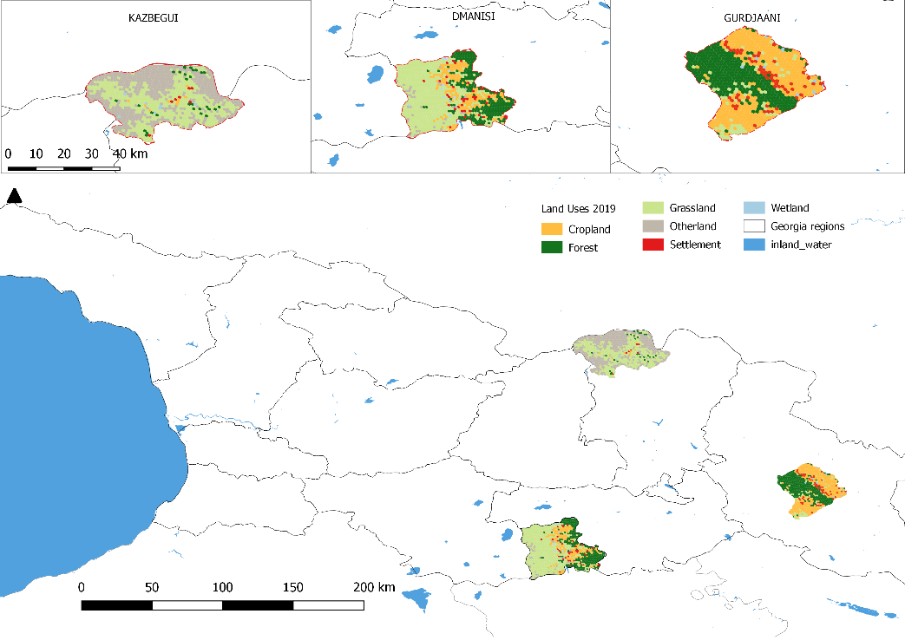

2. Stakeholders.
Please provide the Stakeholder Engagement Plan or equivalent mapping/assessment. (Type response here; if available, upload document or provide link) In addition, provide a summary on how stakeholders will be consulted in project execution, the means and timing of engagement, how information will be disseminated, and an explanation of any resource requirements throughout the project/program cycle to ensure proper and meaningful stakeholder engagement. Please identify disadvantaged or vulnerable groups/individuals that may be affected by the project for appropriate consideration in the stakeholder engagement plan and in the risk matrix or environmental and social management plan.

Select what role civil society will play in the project:
Consulted only;
Member of Advisory Body; contractor;
Co-financier;
Member of project steering committee or equivalent decision-making body;
Executor or co-executor;
Other (Please explain)

The project will work with a wide range of stakehodler, from international, central government, to sub-national and local levels. The main stakeholders and their roles are summarized in Table 3.

Table 3. The main project stakeholders

Stakeholder (group) | Mandate (or activities) | Potential role in Project
Ministry of Environmental Protection and Agriculture (MEPA). | Responsible for the strategic development of agriculture including all aspects related to the livestock sector and pastures, including policy and provision of technical support to stakeholders. As pastures are considered agricultural lands, MEPA’s responsibility covers livestock in general, including pastures and transhumance herds. | Overall project coordination.  Provide technical and logistical support  Identification of demonstration sites  Will benefit from capacity building activities.  Part of coordination unit/working group at horizontal level
Information-Consultation Centers at municipal and regional levels (ICCs, RICCs) | Serve the role of the extension service - employees at municipal level, in addition to Coordination Units at regional level with 4-6 employees in each unit. The services provide ad-hoc technical advice. Popularization and introduction of modern methods and technologies of animal care; Consultation of interested persons for rational use of pasturlands. ICCs and RICCs report on the daily basis to the central administration (MEPA) with regards to the services provided on issues such as livestock and plants. | Coordination of the activity in the pilot municipalities;  Channels for replication in other municipalities  Will benefit from capacity building activities.
Ministry of Regional Development and Infrastructure (MRDI) | In terms of agricultural development and pastures management, MRDI ensures provision of needed infrastructure to farmers. MRDI is also involved in the process of strengthening policies and laws on transferring implementation of services from central to municipal level. | Participation in the developing policy and legislation;  Part of coordination unit/working group at horizontal level
Local government of the selected municipalities | Municipalities are in charge of issuing pastures lease contracts to shepherds on their pastures. Local authorities are also aiming at acquiring state land in order to improve their revenues also to improve management of pasturelands.. | Participation in the coordination/working group at vertical level;  Will benefit from capacity building activities.
Scientific-research Centre of Agriculture (SRCA) | Preservation of animal and plant agro biodiversity, reconstruction of the breed selection stations, supporting animals artificial insemination process and breeding activities, developing seed/planting material standardization and certification system, introducing new technologies, providing extension services to farm workers, conducting risk assessment in food safety, veterinary and plant protection, providing support to the development of biologically clean agriculture etc. SRCA is responsible for soil information on national level and carries out the soil inventory to assess the fertility of soils, evaluate risk factors for improvement of degraded soil structure and fertility.  It is dedicated to generating and adapting knowledge and technologies to contribute to the sustainable development of the agricultural sector and the country, considering state policies, social inclusion and market and consumer demands. | SRCA will play a key role in the scientific and technical back-up of the project
National Food Agency (Veterinary Department) | Veterinary Department is responsible for maintaining and controlling epizootic situation in the country; carries out the risk assessment of epizootic conditions, the registration of veterinary preparations. Prevention and localization of diseases. animal identification and registration; Veterinary services for business operators; Ensures diagnosis of animal diseases within the competence; Supervision over the migration of animals (including seasonal pastures); Supervision over the collection, utilization and destruction of biological waste (except dangerous and medical waste). | Participation in the developing policy and legislation;  Part of coordination unit/working group at horizontal level.
Agriculture Projects’ Management Agency | Implementing several agricultural projects including in livestock sector | Part of working group
Georgian Farmers Association | Currently, the organization unites 3,600 farmers in Georgia. links to service providers and sources of funding, markets and technical support; consultation on policy issues and representation of members’ interests; defense of smallholder farmers’ rights; participation in policy making; and advocacy of fair access to markets and resources. | Participation in the developing policy and legislation;  Part of working group
Association of shepherds | The association has limited representation (only 60 members). It tries to promote a policy dialogue related to grazing issues in the country. | Participation in the developing policy and legislation;  Part of coordination unit/ working group
Ministry of Economy and Sustainable Development (MESD) | MESD has an important role in the supporting pastureland management through its role in overseeing land management policies in general and the process of privatization of state owned lands and their registration. | Participation in the developing policy and legislation;  Part of coordination unit/ working group
Farmers, agro cooperatives | Farmers are the main stakeholders involved in land management and in livestock management. | Farmers will benefit from support and capacity building;  Targeted farmers will be responsible for transforming land management systems and adopting SLM/LDN.

Stakeholder Engagement Plan is provided in Annex I2. It costists of the consultations that have taken place in project formulation (1) and consultations that will take place during implementation (2). PPG team photos from field visits and consultations are provided below:

LOCATION: Kazbegi, Mtsheta-Mtianeti region
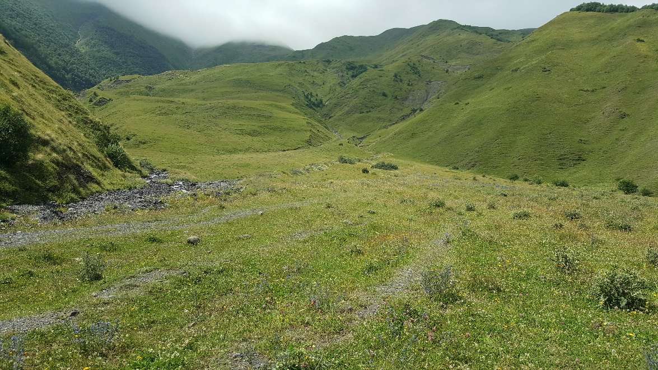
Picture 1. Pastureland of village Sno

LOCATION: Gurjaani, Kakheti region
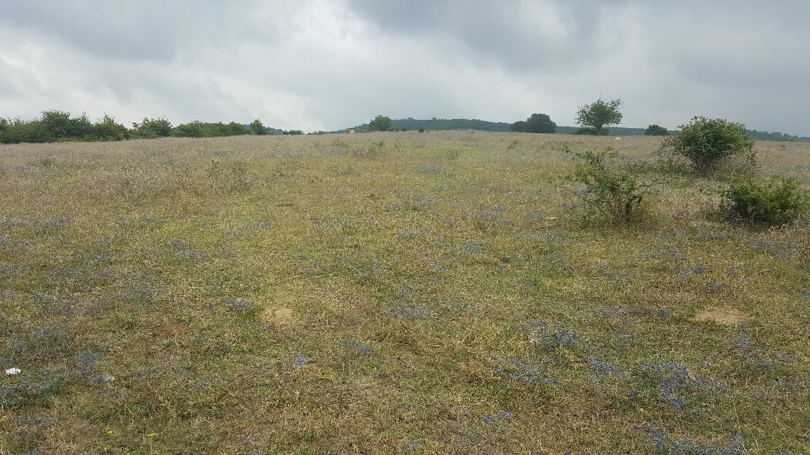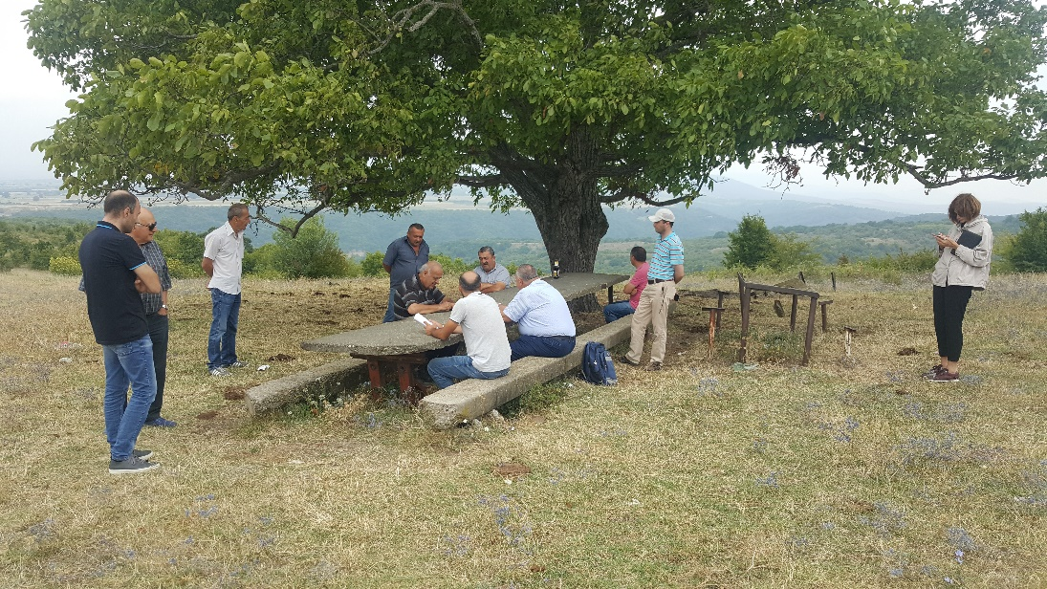
Pictures 2-3. Pastureland of village Naniani

LOCATION: Dmanisi, Kvemo Kartli region
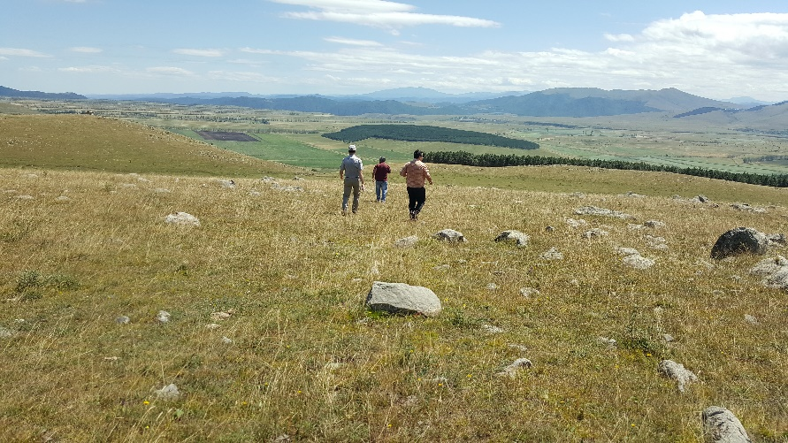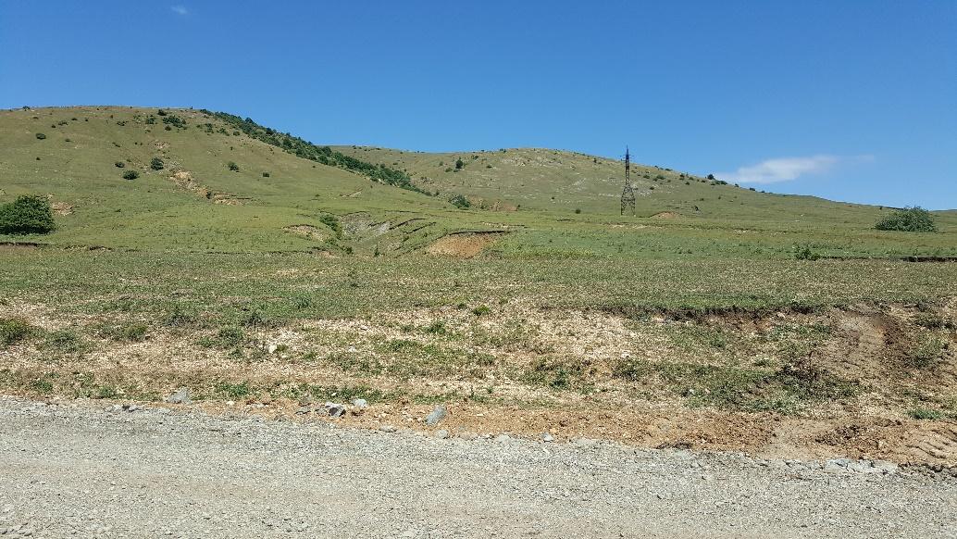
Pictures 4-5. Pastureland of village Sarkineti

3. Gender Equality and Women's Empowerment.
Provide the gender analysis or equivalent socio-economic assessment. If available, provide document in annex and/or provide link.
Widespread and unprecedented rapid degradation of land threatens food production, water availability, biodiversity and energy security worldwide. Land degradation contributes to climate change, deepens poverty and induces displacement and migration, while those forces in turn worsen land degradation. When land is degraded and usable land becomes scarce, women are uniquely and differentially affected given their substantial role in agriculture and food production, greater vulnerability to poverty, and typically weaker legal protections and social status. Women constitute the majority of farmers in many of the regions most severely affected by desertification, land degradation and drought. While they often serve as environmental stewards, women tend to be excluded from conservation and management of land, lack access to agricultural extension services and institutional credit and encounter barriers to participation in development, planning and policymaking processes. Unlike men, women often have less access to information, resources and legal rights to land, natural and productive resources. Unequal power relations and gender-based discrimination in legal and customary systems in many societies deny women even user rights to plant trees, control soil degradation and enhance soil fertility. Gender-responsive LDN projects and programmes strategically contribute to the achievement of LDN and address the needs of the most vulnerable groups, such as small farmers, rural communities and indigenous peoples, with a dedicated focus on women.

The project considers gender mainstreaming as central to its successful achievement because of the reasons put forward above and in key international agreements relating to land degradation and gender equality (see below).

This Project Gender Action Plan (GAP) is informed by relevant international and national frameworks and policies related to the environment and gender equality as set out below, and is designed to meet the mandatory requirements of the new GEF Policy on Gender Equality (2017). This GEF policy aims to ensure equal opportunities for women and men to participate in, contribute to, and benefit from GEF-financed activities in support of the GEF’s efforts to achieve global environment benefits. Principles include requirements that stakeholder engagement and analysis be conducted in an inclusive and gender responsive manner, so that the rights of women and men and the different knowledge, needs, roles and interests of women and men are recognized and addressed. In addition, GEF-financed activities must be conducted, designed and implemented in an inclusive manner so that women’s participation and voice are, regardless of their background, age, race, ethnicity or religion, reflected in decision-making, and that consultations with women’s organizations, including Indigenous women and local women’s groups, are supported. Furthermore, a gender-responsive approach must be applied throughout the identification, design, implementation, monitoring and evaluation of the project.

This GAP aims to ensure the Project meets these GEF requirements, specifically with regard to the GEF project and programme cycle i.e. “In Program Framework Documents (PFDs) and Project Identification Forms (PIFs) submitted for Work Program entry or CEO Approval, Agencies provide indicative information on Gender considerations relevant to the proposed activity, and any measures to address these, including the process to collect sex-disaggregated data and information on Gender.” The PIF has already touched on gender considerations and the Project PFD advances the integration of gender in the dedicated section as required, but also in other sections on “risk” and “stakeholder engagement. In addition, the Project GAP sets out operational details such as responsibilities and budget estimates. To summarize, the GEF Policy on Gender Equality also requires Agencies to provide the following at or prior to CEO Endorsement/ Approval:

Gender Analysis or equivalent socio-economic assessment that identifies and describes any gender differences, gender differentiated impacts and risks, and opportunities to address Gender Gaps and promote the Empowerment of Women that may be relevant to the proposed activity. Project response: yes, done.

any corresponding gender-responsive measures to address differences, identified impacts and risks, and opportunities through a gender action plan or equivalent and (c) if gender-responsive measures have been identified, the results framework or logical framework include actions, Gender-Sensitive Indicators and sex-disaggregated targets. Project response: see Project results framework and GAP below, containing all these measures.

The FAO is the principal Agency and the GAP also contributes to the objectives of its Policy on Gender (2013) as in Table 1 below.

Table 4. Project contribution to objectives of FAO Policy on Gender (2013)
1. Women participate equally with men as decision-makers in rural institutions and in shaping laws, policies and programmes. | National level: Project will build on sub-national consultations to inform these laws, policies and programmes.  Sub-national level: Project is not directly engaged in Pasture Users’ Union (PUU) governance and will not therefore be involved in promoting women’s equal participation in them directly.
2. Women and men have equal access to and control over decent employment and income, land and other productive resources. | Women’s and men’s more equal access to pastureland is a key goal of the Project
3. Women and men have equal access to goods and services for agricultural development, and to markets. | Project support to strategic/ operational pasture management plans as well as inclusive business models that prioritize clean technologies, gender-sensitive services and infrastructure will promote more equal access to pasture lands and related economic incentives.
4. Women’s work burden is reduced by 20 percent through improved technologies, services and infrastructure. | Project will contribute to FAO global goal by supporting pasture management policy, legislation and strategic/ operational plans as well as inclusive business models that prioritize clean technologies, gender-sensitive services and infrastructure that reduce drudgery and save time for women.
5. The share of total agricultural aid committed to projects related to women and gender equality is increased to 30 percent | Project will track contribution of financing related to women and gender equality in Project and report on contribution to global target of 30%.

The GAP is also framed by the FAO Regional Gender Equality Strategy for Europe and Central Asia (2019), which includes a focus on minimizing gender-related risks and safeguarding rural women’s rights in all actions to achieve sustainable and equitable food systems and rural development. It will also be compliant with FAO’s Environmental and Social Management guidelines (2015).

Finally, the project also aims to contribute to the gender policies of the Government of Georgia (GoG see below), The European Union is co-financing Project components 2 and 4, and also has a gender action plan. This includes objectives on equal access to financial services, productive resources including land, trade and entrepreneurship, equal access and control over clean water, energy, transport infrastructure, and equitable engagement in their management, as well as equal rights to participate in and influence decision-making processes on climate and environmental issues.

Key policies and frameworks framing this Project GAP

Sustainable Development Goals (SDGs) of Agenda 2030 (UN, 2015). The main development framework against which countries are held accountable, SDG5 relates to gender equality and women’s empowerment. One of the most relevant targets is Target 5.A calling on countries to “(u)ndertake reforms to give women equal rights to economic resources, as well as access to ownership and control over land and other forms of property, financial services, inheritance and natural resources, in accordance with national laws”. Project response: Project will promote women’s equitable access to pastures as well as related economic incentives and services through policy/ regulatory reform, pasture management plans and inclusive business models for LDN and SLM.

Convention on the Elimination of all Forms of Discrimination Against Women (CEDAW, 1979). This is the UN convention focussed on gender equality and women’s empowerment, and sets out requirements for States in all areas of life. Georgia became a signatory in 1994. The Committee has noted progress in many areas but with regard to rural women called for the government to ensure that rural women have adequate access to economic opportunities and equal opportunities to participate in in decisions relating to the agricultural sector. It also sets out the concept of temporary special measures to tackle gender inequalities e.g. quotas. Project response: Project has already started consulting women and men through a household survey that will include women and women headed households in its sample, as well as asks questions about intrahousehold decision-making so as to better target Project services. The project will see additional consultations at the sub-national level including about the Project’s GAP. The Project implementation phase will ensure a participatory approach to developing laws and policy related to pastures, including women and women heads of household. Although largely male-dominated, women do need access to quality pastures and related inputs conducive to LDN targets, as heads of household (including if males migrate or die) and the Project will also explore entry points for women’s economic empowerment in related environmental services or alternative livelihoods.

United Nations Convention to Combat Desertification (UNCCD, 1994). The UNCCD, the main Multilateral Environmental Agreement (MEA) on land degradation, has a Gender Action Plan (UNCCD, 2017). Its relevant objectives for this Project are to: (i) enhance women’s role as agents of change by addressing the gender inequalities they face (ii) build the capacities of women and girls to access the resources they need to improve their livelihoods, manage land sustainably and become resilient to drought (iii) develop a baseline on gender-related issues in land degradation and desertification, and monitor, report and regularly review progress in the implementation and achievement of objectives (iv) mobilize adequate resources to achieve these objectives. Key principles to guide action on the ground are that (i) interventions do not increase women’s burden but decrease it (ii) women not only contribute to, but also benefit from, the interventions. The UNCCD Gender Action Plan emphasizes equal participation in decisions taken during the design, planning, implementation and evaluation of initiatives to implement the UNCCD. Project response: Project including through its GAP addresses all the objectives stated above, and meets all the key principles.

The UNCCD’s land degradation neutrality (LDN) principles apply to this Project and they also highlight the importance of integrating a gender perspective, which are set out in the publication “Scientific Conceptual Framework for Land Degradation Neutrality. A report of the Science-Policy Interface” (UNCCD, 2017). Broadly speaking, they touch on the importance of ensuring gender differences and inequalities between women and men are addressed for LDN. Project response: Project including through its GAP will ensure that gender dimensions of LDN principles inform all policy/ regulatory development as well as sub-national planning.

United Nations (UNFCCC, 1992). This MEA is also key given the carbon mitigation dimensions of the Project, and the most relevant priority areas of its Gender Action Plan (2018) for this Project are: Priority area A.1 “Through … workshops, technical assistance, etc., enhance the capacity of Parties and stakeholders to develop gender-responsive policies, plans and programmes on adaptation, mitigation, capacity-building, technology and finance” AND Priority area B.4 “… formal and non-formal education and training programmes focused on climate change at all levels, targeting women and youth in particular at the national, regional and local levels”. Project response: Project including through its GAP builds capacity of women and men at national and sub-national levels in gender-responsive policies on SLM/ LDN with mitigation/ adaptation benefits, as well as through national/ sub-national policies that integrate gender dimensions. Project will confirm the municipalities using criteria including contribution to the LDN targets, ensure social impact in particular vulnerable groups and women.

Voluntary Guidelines on the Responsible Governance of Tenure of Land, Fisheries and Forests in the Context of National Food Security (VGGT). FAO. 2012. These are particularly relevant given the Project’s focus on sustainable pasture management, and confirms that States should ensure that women and girls have equal tenure rights and access to land, independent of their civil and marital status. The VGGT call for States to “monitor the outcome of allocation programmes, including the gender-differentiated impacts on food security and poverty eradication as well as their impacts on social, economic and environmental objectives, and introduce corrective measures as required” – this is very relevant to the Project’s intended support to national and sub-national policy, regulations and incentives for pasture access and management. Project response: Project will ensure that all policy, regulatory and programming related to land including pastureland is informed by the VGGT.

GEF-7 Land Degradation Focal Area Strategy. This confirms “gender roles have impacts on both farming and livelihood systems, but the contribution of women smallholder farmers often goes unrecognized. Women farmers often have less access to land, decision making processes, labor, credit, information, technology, and extension”. The strategy commits to mainstreaming gender "by including 1) practical gender needs – improving the conditions of women through access to resources, services and opportunities, and 2) strategic gender interests – empowering women to take decisions and be better represented in various decision making bodies.” Project response: Project will meet practical gender needs through operational pasture management plans targeting poor women heads of household as well as ensuring that all operational and strategic pasture management plans, as well as sustainable business models, take into account women’s and men’s different needs and priorities with regard to access to resources, services and opportunities. In terms of strategic gender interests, the Project targets women for capacity development and awareness raising in SLM/ LDN at national and sub-national levels, so that they are better positioned to contribute to decisions. The Project is not working on PUU membership directly and will not be tackling therefore the gender imbalance in their membership, where women are in a minority. However, it will explore opportunities to directly target women PUU members with incentives, hence increasing their status and voice in PUUs.

Government of Georgia

The Government of Georgia (GoG) has demonstrated committment to supporting gender equality and women’s empowerment through the ratification of various international instruments such as CEDAW, and progressively invested in insitutions mandated to advance gender equality. Today, the main policy instrument for gender equality is the Law of Georgia and this operationalized through the a National Action Plan : the last one was 2014-2016. The Inter-Agency Task Force on Gender Equality, Violence against Women and Domestic Violence was established in 2017 as a gender equality and human rights mechanism, and at the municipal level, Gender Equality Councils were established.

Gender dimensions have also been integrated into various environmental and climate action plans. For example, the National Biodiversity Strategy and Action Plan of Georgia 2014 – 2020 has an indicator of Number of NGOs, including women’s organizations and other stakeholders (especially representatives of local communities taking into account the gender balance), participating in public consultations on development projects and natural resource management plans, and women are to be targeted with awraeness raising on biodiversity. Further, Georgia’s first Intended Nationally Determined Contribution Submission to the UNFCCC in 2017 confirmed the importance of “a gender- and human rights-sensitive approach in adaptation planning capacity building, prioritizing the most vulnerable sectors and regions in order to reduce social inequality and the gap between women and men rights.” It also refers to a gender-sensitive Nationally Appropriate Mitigation Action (NAMA) for sustainable energy in rural areas. The NAMA on “Efficient use of biomass for equitable, climate proof and sustainable rural development” (under development) use and up-scaling of Solar Water Heaters, Fuel Efficient Wood Stoves and Energy Efficient Insulation, all of which potentially empower women given their roles in rural society. The report of “National Target Setting to Achieve Land Degradation Neutrality” (GoG, 2018) refers to including women in awareness raising, alhtough does not state the linkages between gender inequality and land degradation.

In Georgia, as in many countries, there is generally held to be a gap between generally supportive government policy and on-the-ground implementation. The Project foresees, in Component 1, a review of legislation with a gender lens, which will build on this preliminary review and especially focus on the relevant national and sub-national levels.

Analysis of gender roles in the Project context

Pastures in Georgia provide food for livestock, medicinal and culinary herbs and support recreation and tourism, and women in Georgia are active in these areas. A recent Gender Assessment by FAO in 2018 identifies some prevailing gender roles, gaps and opportunities at the national level in agriculture and in the livestock sector. These are summarized below.

- The social status of women in rural areas remains low and gender stereotypes persist. This implies a rigid division of gender roles and decision-making within the household that negatively affects women´s economic opportunities. Gender inequalities and gender stereotypes are perceived as somehow natural or acceptable. Agricultural work (as helpers and not as managers) along with domestic and care work are believed to be women’s primary responsibilities, and their time and workload are underestimated. Women heads of household are especially impacted by time poverty. It also has an impact on overall agricultural productivity and rural development. Project implications: women have too little time and too many care responsibilities to contibute their full potential in pasture management. Project opportunities: target women with access to time- and drudgery- saving technologies, including women heads of household- Create opportunities for women’s decision-making in shaping national policy/ legislation, as well as community/ household decisions related to pasture management. Target women and men with gender sensitization.

- There is a significant gender pay gap, and women are overrepresented as unpaid workers. Because of the perception of women as helpers or contributing family members, they are more likely to be involved in unpaid and informal work, and the gender pay gaps in agriculture, forestry and fisheries are significant. The “invisible” nature of their work means that their roles relating to pasture management are underestimated. Women generally devote more time to livestock than men, although women are involved in milking and milk processing while men are mostly in charge of cattle maintenance (cattle feeding and cleaning) and pasturing. Moreover, 46.5% of women owned large cattle compared to 53.5% men, only slightly less. They are considered knowledgeable in livestock health. These roles may be different in women headed households. Project implications: at the local level, women’s role in livestock and pasture management may be underestimated with the risk that they are left out of relevant capacity development and decisions. Lack of time and inputs (see below) may deter women from seeking alternative income generating opportunities or employment that could reduce/ help communities cope with land use stress in pasture lands (e.g. as paravets). Project opportunities: pasture management plans and business models at the municipal and plot levels to explicitly target women with economic incentives, including women heads of household. Identify and draw on women’s often unique and traditional knowledge of biodiversity related to pasture management and LDN.

- There is a gender gap in technical and professional expertise on agriculture and rural development. Men are more represented in higher managerial positions and in technical subjects such as agriculture, engineering and construction, where very few women are represented. Project implications: fewer women in MEPA in senior/ technical positions may contribute to the challenge of making gender-responsive provisions in policy and law. And at the sub-national level fewer female extension workers and service providers may make it more challenging for women to access gender-responsive services in pasture and livestock management. Project opportunities: actively aim for women as well as men service providers and trainers throughout the Project.

- Women´s access to new technologies, machinery and agricultural inputs is lower compared to that of men. In family farming, men are usually involved in agricultural activities that require technology and machinery, and women are mostly involved in manual and labor-intensive work but have less access to labor-saving technologies partly because of the widespread stereotype that machinery is a “man’s thing”. The same is true in accessing irrigation, pesticides, fertilizers and other agricultural inputs. Because men are regarded as decision-makers and those responsible for dealing with providers, women experience de facto barriers in accessing these resources. Project implications: women’s time, drudgery and lack of access to inputs burden holds them back from engaging in profitable pasture management. Project opportunities: pasture management plans and business models at the municipal and plot levels to explicitly target women with access to inputs, including women heads of household.

- Women have limited access to ownership of land and other property. The lack of land registration limits women’s access to governmental subsidies, credit and grant schemes that operate in the regions because of lack of collateral. Funding schemes in rural areas are less accessible for women except when women are the targets. Project implications: women, including women heads of households, have less access to pastures for subsistence or income generation, and less voice in their management. Project opportunities: pasture management plans and business models at the municipal and plot levels to explicitly target women with access to inputs, economic incentives and quality pasture, including women heads of household.

- Poor rural infrastructure, limited access to transport and modern energy supplies have a direct impact on women’s time use in particular. This exacerbates their challenges in participating in pasture management and related income generation. Project opportunities:pasture management plans and business models at the municipal and plot levels to explicitly target women with access to gender-responsive infrastructure, including women heads of household.

Despite these findings, it seems that there may be opportunities for joint decision-making in some parts of Georgia. For example, a gender assessment for a GEF-supported project on land degradation found that both men and women emphasized the importance of sharing opinions and ideas regarding agricultural activities and felt that rural family life should be based on mutual decisions made by men and women together. This highlights the need to dig deeper to determine the space for women’s decision-making within the Project scope.

Whether or not women are directly involved in pasture management, depending on prevailing gender norms, they are key actors in the dairy sector and have primary responsibility for household nutrition; they therefore have an important stake in sustainable pasture management. Poor quality, unsustainable pastures have both commercial and health implications: they translate into poor quality milk that may not meet EU regulations and into sub-optimal nutrition benefits for the household. The Project will therefore set a 30% target of women/ women heads of household for membership of PUUs established, which can include women dairy and livestock entrepreneurs.

FAO and project partners are aware that gender roles, just like environmental issues, are very context- specific and can change over time. The Project therefore plans to validate/ strengthen the above analysis during implementation. Opportunities to do so and check opportunities are given below.

Thirdly, the main baseline project, “FAO support to Georgian agricultural sector under ENPARD III, involves a grant competition for farmers, cooperatives and SMEs in Georgia to award 5 value chain actors in 14 municipalities. Beef and dairy are the priorities in eight of the 14 municipalities. The grant winners will be analyzed to identify opportunities to expand gender equality and women’s empowerment related to this Project and in line with the ENPARD output related to economic improvement of the population as a result of equitable agricultural investment. More broadly, the Project will seek to draw on its experiences and the knowledge of its national gender officer. The project carried out a mapping of the social structure at community level through Focus Group Discussions with men and women, which provided the basis for actions plans for equal particpation in project actions. Once the Project municipalities and communities are finalized, ENPARD III mappings/ action plans in the same/ nearby areas will be reviewed so as to deepen this preliminary gender analysis. The ENPARD III project also offers up to 60% matching grants for value chains in which women are more active, and the concept will be applied to the inclusive business model being developed by this Project i.e. the inclusive business model will include special measures for women heads of household and women.

Rapid assessment of relevant institutions to engage in Project implementation

The table below gives at-a-glance information on key stakeholders to be engaged in support of the Project Gender Action Plan. Most institutions have yet to develop a gender strategy/ appoint a gender focal point, and the Project

Table 5. key stakeholders to be engaged in support of the Project Gender Action Plan

 | Documents related to gender equality | Gender focal points/consultants
Ministry of Environmental Protection and Agriculture (MEPA) | No documents currently identified, such as gender equality strategy, or gender action plan.  The ministry is a member of 2 government Task Force groups of:  Inter-agency Commission on Gender Equality, Violence Against Women and Domestic Violence;  Gender Equality Council of the Parliament of Georgia. | Khatia Tsilosani (Deputy Minister)  Other staff members, who are involved in the gender task force meetings/activities:  Nato Macharashvili  Ketevan Kapanadze  Natia Nikolaishvili  There is no separate position in the ministry for a gender focal point.
Information-Consultation Centers at municipal and regional levels: Gurjaani | No documents related to gender equality currently identified. | There is no focal point/consultant.
Information-Consultation Centers at municipal and regional levels: Dmanisi | No documents related to gender equality currently identified. | There is no focal point/consultant.
Information-Consultation Centers at municipal and regional levels: Kazbegi | No documents related to gender equality currently identified. | There is no focal point/consultant.
Ministry of Regional Development and Infrastructure (MRDI) | There is no document such as a gender action plan or gender equality strategy. The work of gender focal point is framed by National Strategy for the Protection of Human Rights in Georgia 2014-2020 and Human Rights Action Plan for 2018-2020 (with special emphasis on gender equality). | Magda Mamukashvili (Department for Relations with Regions and Local Self-government Agencies; Responsible person for gender related issues).
Local government of the selected municipalities: Gender Equality Council of Kazbegi Municipality  Local government of the selected municipalities: City Hall of Municipality | Gender Equality Action Plan for 2018-2019. | The council consists of 8 members (4 women, 4 men).  Contact person: Tamar Odishvili (Kazbegi Municipality Assembly staff head). She became gender consultant in 2014.  There is no separate position in the Assembly for gender consultant/gender focal point.  Responsible person on gender equality issues: Lia Kushashvili
Local government of the selected municipalities: Gender Equality Council of Gurjaani Municipality  Local government of the selected municipalities: City Hall of Municipality  Municipal service - Women's rooms | Gender Equality Action Plan 2018-2019. | The council consists of 17 members.  Contact person: Mariam Sirbilashvili. (551153660)  Responsible person on gender equality issues: Elza Paposhvili  Women's rooms coordinator: Izolda Tergiashvili
Local government of the selected municipalities: Gender Equality Council of Dmanisi Municipality  Local government of the selected municipalities: City Hall of Municipality  Municipal service - Women's rooms | Gender equality strategy and gender action plan for 2018. | The council consists of 12 members. (9 women, 3 men).  Contact person: Sophio Aslamazashvili.  Responsible person on gender equality issues: Ketevan Martiashvili  Women's rooms coordinator: Ketevan Martiashvili
Scientific-research Centre of Agriculture (SRCA) + | There is no gender related documents, such as strategy, or action plan in the Centre. | The Center does not have a gender focal point.
National Food Agency (Veterinary Department) + | No documents related to gender equality. | No focal point on gender issues.

Synergies with/ learning from other projects

Finally, the Project will continue to seek opportunities to learn from/ seek synergies with other projects in regard to gender and women’s empowerment. For example, an IFAD investment that is starting up targets women Pasture User Association members with grants to impove pastures, setting a target of 30% beneficiaries to be women heads of household. This Project will similarly set a target for women heads of household to comprise 30% of beneficiaries of operational (plot level) pasture management plans and the total number of beneficiaries of economic incentives for pasture improvement. Lessons learned from a project in Kyrgyzstan are also highly relevant; Box 1 presents the main findings as well as project implications.

Box 1: Lessons learned from gender-sensitive pasture management in the Kyrgyz Republic

The main findings from the assessment of the The Livestock and Market Development Program (LMDP) project include the following.
- By recognizing that all residents of a community are members of a Pasture Users’ Union (PUU), the law is positive for women, because women’s ability to use and manage the pastures is not based on their marital status, their ancestry, or where they were born. Project implications: consider integrating this provision into the proposed law on pasture management.
- The LMDP design includes detailed elements specifying how the project will mainstream gender in every aspect of its implementation, including management, programming, and monitoring and evaluation. It assigns specific responsibility for gender to one core staff member. However, there is a gap between the activities envisioned in the design and the capacity of the implementers to specifically address the identified needs. Project implications: assign responsibility for gender to one project staff member, and consider contracting gender experts to carry out some activities.
- After a design adjustment, women’s interests were prioritized in investments and grants that the project provided in support of Community Pasture Management Plans. The incentives are supplemented with other approaches to ensure that women’s interests are represented – including outreach and mobilization, support for women’s capacity development, and quotas for women in decision-making roles. These supplementary activities became critical to ensuring that women’s voices and perspectives are incorporated into the Community Pasture Management Plans. Project implications: consider integrating similar measures.
- Imposing quotas for participation of women in the management committee had mixed results. On the positive side, the targets may have been the main link between the gender policy and project implementation; they are a key performance metric for the project and have motivated implementing staff to pay attention to women in some way. In practice, whether women were meaningfully included depended on other factors, such as the commitment, knowledge, and skill of the field staff person and the understanding that women and men have of the value of women’s participation. Project implications: consider integrating similar measures backed up by gender sensitization of Project staff.
The project illustrates that even where laws and program design are favorable to women, ensuring that women’s interests in pasture management are in fact addressed requires time and resources dedicated to shifting behavior and attitudes of men and women.

Source: adapted from A. Undeland. 2016. Kyrgyz Republic: Women and Community Pasture Management.

Another opportunity is to identify linkages with/ adopt models from the ”Generating Economic and Environmental Benefits from Sustainable Land Management for Vulnerable Rural Communities of Georgia” project implemented by UNEP (GEF ID 9730). Running until 2021, women will benefit from skill development (and improved access to modern technologies and knowledge on land management, which will contribute to increasing both the incomes and social capital of women. The project ensures that consultations among stakeholder groups, capacity-building programs and outreach programs all include an analysis of gender dimensions in order to maximize the participation of and the potential positive impacts for women. Smallholder beneficiaries of pilot projects in municipalities include at least 50% women. The project document for GEF CEO approval also notes that “30% of women are land holders, however majority of women are actively engaged in agricultural activities and are known for adopting more diverse land practices”. This Project will draw on the analysis of gender dimensions to see what lessons can be relevant, especially in the two common regions of Kakheti and Shida Kartli. Similarly, the Project will identify any trainers and content that may be of relevance in the Project context of pasturelands.

Finally, the Project will seek synergies with the major GEF-supported “Sustainable Forest Management Impact Program on Dryland Sustainable Landscapes” Impact Program, which will benefit broadly equal numbers of women and men and includes two countries with similar challenges related to pastures – Mongolia and Kazakhstan. In Kazakhstan, the child project the project will work with local stakeholders to design and implement a capacity building program on sustainable pasture management practices. This will build on efforts from another GEF-financed and FAO-supported project on supporting integrated crop-livestock production systems and empowering rural women - the Central Asian Countries Initiative for Land Management. This Project will also seek relevant lessons and models that could be adapted to the context in Georgia, and also from the child project in Mongolia as it evolves.

Based on the above preliminary gender analysis at this time, the Project has identified the following opportunities to contribute to: (i) closing gender gaps in access to and control over natural resources (ii) improving women’s participation and decision-making and (iii) generating socio-economic benefits or services for women. These areas correspond to those in the GEF PIF template, and potential Project contributions by component are shown in the table below.

Table 6. Project contribution to closing gender gaps, equal decision-making and benefits for women
Closing gender gaps in access to and control over natural resources | Component 1 (ii) gender-responsive national and policy, including temporary special measures as needed  Component 2 (i) engaging women and men in gender-responsive strategic (municipal) and operational (plot level) pasture management plans and (ii) gender-responsive business models and incentives for LDN and SLM, including alternative livelihoods  Component 3 (i) increasing women’s participation in capacity development at the national and sub-national levels
Improving women’s participation and decision-making | General: Consultations with women at project sites to identify context-specific barriers and opportunities, as well as validation of this GAP with relevant gender in SLM/LDN in pasture management stakeholders in Georgia  Component 1 (i) engaging women as well as men in developing national and sub-national policy, legislation and programming for LDN and SLM in pastures  Component 2 (i) engaging women and men in gender-responsive strategic (municipal) and operational (plot level) pasture management plans and (ii) gender-responsive business models and incentives for LDN and SLM, including alternative livelihoods  Component 3 (i) increasing women’s participation in capacity development at the national and sub-national levels  Component 4 (i) a gender-sensitive Monitoring and Evaluation plan  Component 4 (i) a gender-sensitive Monitoring and Evaluation plan
Generating socio-economic benefits or services for women | Component 2 (i) engaging women and men in gender-responsive strategic (municipal) and operational (plot level) pasture management plans and (ii) gender-responsive business models and incentives for LDN and SLM, including alternative livelihoods.

Does the project expect to include any gender-responsive measures to address gender gaps or promote gender equality and women’s empowerment? (yes /no) If yes, please explain and upload/annex Gender Action Plan or equivalent.
If possible, indicate in which results area(s) the project is expected to contribute to gender equality:
closing gender gaps in access to and control over natural resources;
improving women’s participation and decision making; and or
generating socio-economic benefits or services for women.
Does the project's results framework or logical framework include gender-sensitive indicators? (yes /no)

Gender Action Plan is provided in Annex Q.

4. Private Sector Engagement.
Elaborate on the private sector’s engagement in the project, if any.
The socio-economic analysis based on the statistical sampling of the household survey (PPG) revealed that the vast majority of the HHs (92%) in the target municipalities are smallholder animal farmers (cattle and sheep). Few of them following semi or transhumant livestock system and three HHs indicated that they holding with extensive livestock production on village pastures. The study showed that the main source of livelihood in the project areas is livestock production (94%), vineyard/vegetable production (74%), and crop farming (34%).
HHs cooperation is mainly based on informal mutual neighbouring agreement or common decision-making traditional for the rural areas of Georgia. Villagers also help each other by common farming actions, also through the share of knowledge and experience. Only two HHs are members of livestock agricultural cooperatives. Despite the great efforts made by the state and donor organizations in recent years, the development of agricultural cooperatives in Georgia still faces significant challenges. Only 20 cooperatives are acting in Kazbegi, and 16 and 18 cooperatives in Gurjaani and Dmanisi respectively.

Farmers have restricted access to the financial resources in targeted municipalities. Most of the respondents (61%) stated that in the last three years, they have needed financial assistance at least once when faced with unexpected expenditures for livestock. External financial support were provided mainly by family members or friends (in 57 cases), but also from banks (in 22 cases) and micro financial organizations (in 20 cases). Farmers do not trust financial institutions and are afraid to apply to banks and especially micro financial organizations because of very high interest rate and inadequate terms of loans.

To encourage private investments in pasture management (via implementing SLM and achieving LDN) business models will be elaborated for three pilot municipalities of Kazbegi, Gurjaani and Dmanisi (Output 2.1.3). The capacities of the stakeholders from the private sector involved in agricultural activities and production and sales of agricultural products will be increased via trainings, consultation, workshops and provision of knowledge materials on SLM. A set of user-friendly manuals and informational products will be prepared on sustainable pasture management practices, measures and technologies to be used by local farmers, agricultural cooperatives and women entrepreneurs etc. (Output 3.1.2 and Output 3.1.3).

Engagement of private sector will ensure sustainability the project results and support replication of successful SLM approaches in other regions of Georgia. Private sector involvement (namely small-holder farmers) in the selected landscapes will be sought and encouraged to improve yields, add value to their agricultural products and link the producers to markets. To achieve sustainable land management, it will also be important to create stable revenues from agricultural products and to introduce sustainable supply chains for meat, wool and dairy.

5. Risks.
Risk management is a structured, methodical approach to identifying and managing risks for the achievement of project objectives.The risk management plan will allows stakeholders to manage risks by specifying and monitoring mitigation actions throughout implementation. Part A of this section focuses on external risks to the project and Part B on the identified environmental and social risks from the project.

Section A: Risks to the project
In the section below, elaborate on indicated risks to the project, including climate change, potential social and environmental risks that might prevent the project objectives from being achieved, and, if possible, the proposed measures that address these risks at the time of project implementation.
Risk | Level | Management Strategy
Lack of commitment from MEPA to develop and approve some of the policy recommendations within the scope of the Project | Low | Establish close and strong cooperation with the MEPA, communicating the project information to relevant decision-makers on regular basis, maintaining a continuous constructive dialogue and to ensure MEPA ownership of the Project’s results
Insufficient absorption capacity of the MEPA staff to use fully and benefit from the policy development support provided by the project | Medium | Elaboration of a detailed work plan of the project coupled with the agendas of the MEPA activities and consideration of an adequate timing to ensure MEPA participation
Lack of coordination or integration of the actions of the ministries | Medium | Develop effective working contacts and method for active communication and networking with the ministries; Engaging in the activities of the Inter-Agency Coordination Council for Rural Development (IACCRD) chaired by the MEPA
Limited capacities of the implementing partner/s to manage the investment | Medium | The Project will revise the selection of implementing partners prior to distribution of activities among them; identifying other potential implementing partners from the pool of potential candidates in the country
Lack of government commitment to ensure agricultural land registration | Medium | The World Bank piloted a land registration program in order to redefine and test the policies and procedures for registration of agricultural land to allow the majority of existing land ownership rights to be registered. The GoG is committed to include agricultural land registration among the top priorities in the upcoming revision of the Agricultural Policy (starting 2020) which is under consideration at the stage of PIF formulation. There are discussions of the potential Phase-2 of the World Bank project.
Climate change | Medium | The project will closely collaborate with DIMMA project fuded by the Adaptation Fund to address climate vulnerability conciderations on pasturelands

Section B: Environmental and Social risks from the project – ESM Plan
This section is based on the risk matrix obtained during risk screening in the concept note (in FPMIS) and based on further update and revision by the PTF under the responsibility of the LTO.


6. Institutional Arrangements and Coordination.

6.a Institutional arrangements for project implementation.

MEPA will have the overall executing and technical responsibility for the project, with FAO providing oversight as GEF Agency as described below. REC C aucasus will act as the lead executing agency and will be responsible for the day-to-day management of project results entrusted to it in full compliance with all terms and conditions of the Operational Partnership Agreement signed with FAO. As OP of the project REC C aucasus is responsible and accountable to FAO for the timely implementation of the agreed project results, operational oversight of implementation activities, timely reporting, and for effective use of GEF resources for the intended purposes and in line with FAO and GEF policy requirements.

The project organization structure is as follows:

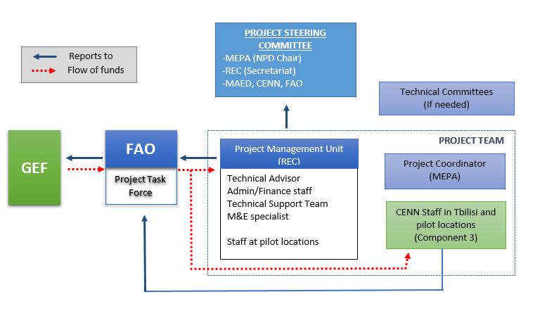

The government will designate a National Project Director (NPD). Located in MEPA the NPD will be be responsible for coordinating the activities with all the national bodies related to the different project components, as well as with the project partners. He will also be responsible for supervising and guiding the Project Coordinator (see below) on the government policies and priorities. The NPD (or designated person from lead national institution) will chair the Project Steering Committee which will be the main governing body of the project. The PSC will approve Annual Work Plans and Budgets on an yearly basis and will provide strategic guidance to the Project Management Team and to all executing partners. The PSC will be comprised of representatives from MEPA, MAED, REC Caucasus, CENN, and FAO. The members of the PSC will each assure the role of a Focal Point for the project in their respective agencies. Hence, the project will have a Focal Point in each concerned institution. As Focal Points in their agency, the concerned PSC members will: (i) technically oversee activities in their sector; (ii) ensure a fluid two-way exchange of information and knowledge between their agency and the project; (iii) facilitate coordination and links between the project activities and the work plan of their agency; and (iv) facilitate the provision of co-financing to the project.

The Project Coordinator (see below) will be the Secretary to the PSC. The PSC will meet at least twice per year to ensure: i) Oversight and assurance of technical quality of outputs; ii) Close linkages between the project and other ongoing projects and programmes relevant to the project; iii) Timely availability and effectiveness of co-financing support; iv) Sustainability of key project outcomes, including up-scaling and replication; v) Effective coordination of government partner work under this project; vi) Approval of the six-monthly Project Progress and Financial Reports, the Annual Work Plan and Budget; vii) Making by consensus, management decisions when guidance is required by the National Project Coordinator of the PMU.

A Project Management Unit (PMU) will be co-funded by the GEF and FAO and will be established within MEPA and REC. The main functions of the PMU, following the guidance of the Project Steering Committee, are to ensure overall efficient management, coordination, implementation and monitoring of the project through the effective implementation of the annual work plans and budgets (AWP/Bs). The PMU will be composed of a Project Coordinator (PC) who will work part-time for the project lifetime. The PC will be co-funded entirely by FAO and located in MEPA. In addition, the PMU will include Administrative staff, finance officer, and M&E specialist.

The Project Coordinator (PC) will be in charge of daily implementation, management, administration and technical supervision of the project, on behalf of the Operational partner and within the framework delineated by the PSC. S/he will be responsible, among others, for:
- coordination with relevant initiatives;
- ensuring a high level of collaboration among participating institutions and organizations at the national and local levels;
- ensuring compliance with all OPA provisions during the implementation, including on timely reporting and financial management;
- coordination and close monitoring of the implementation of project activities;
- tracking the project’s progress and ensuring timely delivery of inputs and outputs;
- providing technical support and assessing the outputs of the project national consultantshired with GEF funds, as well as the products generated in the implementation of the project,;
- approve and manage requests for provision of financial resources using provided format in OPA annexes;
- monitoring financial resources and accounting to ensure accuracy and reliability of financial reports;
- ensuring timely preparation and submission of requests for funds, financial and progress reports to FAO as per OPA reporting requirements;
- maintaining documentation and evidence that describes the proper and prudent use of project resources as per OPA provisions, including making available this supporting documentation to FAO and designated auditors when requested;
- implementing and managing the project’s monitoring and communications plans;
- organizing project workshops and meetings to monitor progress and preparing the Annual Budget and Work Plan;
- submitting the six-monthly Project Progress Reports (PPRs) with the AWP/B to the PSC and FAO;
- preparing the first draft of the Project Implementation Review (PIR);
- supporting the organization of the mid-term and final evaluations in close coordination with the FAO Budget Holder and the FAO Independent Office of Evaluation (OED);
- submitting the OP six-monthly technical and financial reports to FAO and facilitate the information exchange between the OP and FAO, if needed;
- inform the PSC and FAO of any delays and difficulties as they arise during the implementation to ensure timely corrective measure and support.

A part-time Finance Assistant will be hired with GEF funds and will be seated in REC. The Assistant will be responsible for the financial management, contract and day-to-day operations of the project activities implemented by the project. S/he will be responsible for procurement and financial actions as well as their monitoring, documentation and preparation of financial reports. S/he will be responsible for the timely delivery of inputs needed to produce results.

A full time Administrative Assistant will provide direct interpretation services when needed for day-today operations of the project and in project meetings, workshops and other events related to project. Provide other support to PIU such as preparing/typing documents and meeting arrangements. S/he will provide other support to PMU such as preparing/typing documents and meeting arrangements.

A part-time Translator will be hired with project funds and placed at the PMU in REC. Translator/secretary will closely work with the Project Coordination Unit, under direct supervision of PC. Translator/secretary will be responsible for direct translation services to the project team on a daily basis, for project related documents such as progress reports, work plans, terms of references and other materials and correspondence, project meetings, workshops and other events related to project.

The Food and Agriculture Organization (FAO) will be the GEF Implementing Agency (IA) for the Project, providing project cycle management and support services as established in the GEF Policy. As the GEF IA, FAO holds overall accountability and responsibility to the GEF for delivery of the results. In the IA role, FAO will utilize the GEF fees to deploy four different actors within the organization to support the project (see Annex K for details):
- the Budget Holder, which is usually the most decentralized FAO office, will provide oversight of day to day project execution;
- the Lead Technical Officer(s), drawn from across FAO will provide oversight/support to the projects technical work in coordination with government representatives participating in the Project Steering Committee;
- PC for the duration of the project;
- the Funding Liasion Officer(s) within FAO will monitor and support the project cycle to ensure that the project is being carried out and reporting done in accordance with agreed standards and requirements.
FAO responsibilities, as GEF agency, will include:
  - Administrate funds from GEF in accordance with the rules and procedures of FAO;
  - Oversee project implementation in accordance with the project document, work plans, budgets, agreements with co-financiers, Operational Partners Agreement(s)and other rules and procedures of FAO;
  - Provide technical guidance to ensure that appropriate technical quality is applied to all activities concerned;
  - Conduct at least one supervision mission per year; and
  - Reporting to the GEF Secretariat and Evaluation Office, through the annual Project Implementation Review, the Mid Term Review, the Terminal Evaluation and the Project Closure Report on project progress;
  - Financial reporting to the GEF Trustee.

6.b Coordination with other relevant GEF-financed projects and other initiatives.

MEPA and FAO will be directly responsible for the project coordination. FAO will ensure coordination and synergies with the activities of international partners and their initiatives, whereas MEPA will be in charge of the coordination of the project activities with the national partners and their initiatives at local, regional and central levels.
The proposed project will be part of a series of activities supporting rural areas in addressing challenges related to the natural resource management, land degradation and impact of the climate change. MEPA will ensure close coordination with these activities, including the following:
Project “Generating Economic and Environmental Benefits from Sustainable Land Management for Vulnerable Rural Communities of Georgia” (GEF CEO Approved on 26-Jan-2018) is a USD 1,452,968 GEF initiative, led by UNEP, and has a duration of 3 years (GEF ID: 9730). The project aims to develop and strengthen sustainable land management (SLM/LDN) practices and build capacity at municipal scale for their application for the protection of natural capital in Georgia. This objective will be carried out through three components, as follows:

Components 1: Creating an enabling environment at municipal scale for achieving Land Degradation Neutrality (LDN) country voluntary target. This first component will map land degradation trends and establish an LDN local baseline. Moreover, it will establish local multi-stakeholder groups, develop LDN target setting programs along with LDN local transformative projects/programmes of actions. Lastly, it will develop integrated land use plans for pilot municipalities

Components 2: Pilot implementation of measures avoiding degradation, intensifying sustainable land management practices and land rehabilitation to improve ecosystem functions and services. Component 2 will identify local measures to prevent changes in the characteristic of soil, wind erosion, salinization and loss of natural fertility of soil. Secondly, it will sequester 15,500 t CO2-eq through restoration of 10,000 ha of degraded land. Subsequently, the capacity of communities and farmers on SLM/LDN will be improved. Fourthly, required changes will be defined by local farmers/ farmers’ associations once current agriculture practices are assessed. Ultimately, this component will promote market access mechanisms.

Components 3: Knowledge management and capacity building. Component 3 will capture and disseminate best practices for SLM/LDN, create a web based national SLM/LDN knowledge management hub, conduct awareness-raising campaigns on SLM/LDN planning and implementation, develop compelling cases for economic benefits derived from SLM/LDN, and provide trainings to decision makers.

UN Joint Programme for Gender Equality in Georgia (The second phase of the programme was launched in 2015 and will continue through 2020.)

7. Consistency with National Priorities.

Describe the consistency of the project with national strategies and plans or reports and assessments under relevant conventions from below:

The proposed project will support government efforts to achieve LDN and as co-benefits will facilitate improvement of grassland biodiversity and carbon capture. In this regard, the project is aligned with the following national priorities:

National Target Setting to achieve Land Degradation Neutrality
The project will support implementation of one of the five National Targets, namely Target 1 “”Integrate LDN principles into national policies, strategies, and planning documentation” and Target 4 “Degraded land will be rehabilitated”. Currently, Georgia has no accurate national data on three LDN indicators: land cover, land productivity, and carbon stocks above and below ground. The data provided by LDN TSP was assigned for setting baseline situation. The project will use FAO’s tools to develop data on land cover and land productivity (Output 2.1.1).

Carbon stocks above and below ground: The national assessment using global defaults is now being carried out and the map will be ready at the end of 2019. Assessments done for the LDN indicator on carbon stocks above and below ground shows that changing land cover type causes decreasing amount of carbon.

As an example of SOC (soil organic carbon) in the country: Dedoplistskaro municipality was selected as one of the priority regions Second National Communication (NC-2) to the UNFCCC for which in-depth assessments were conducted given significant threat of desertification in this area. NC-2 showed that the depth of humus in agricultural lands (which was highly productive in the past) is being significantly decreased as a result of growing wind erosion. As an example, the humus content in Shiraki soils has decreased from 7.5% in 1983 to 3.2% in 2006, resulting in land fertility to be almost halved.

Second National Action Program to Combat Desertification (29/Dec/2014)
The proposed project will support the implementation of the following objectives:

Operational objective 2, on creating a policy framework for provision of favorable legal and institutional environment for decisions-making-to combat desertification/ land degradation and minimizing the negative effects of the drought. The project will support these efforts by developing National Policy of Georgia for Sustainable Management of Pastures, by drafting relevant law and sub-laws and developing institutional mechanisms for pasture management (Output 1.1.1, Output 1.1.2, Output 1.1.3, and Output 1.1.4).

Operational objective 3, regarding science, technology and knowledge, aims to carry out a national monitoring and vulnerability assessment on biophysical and socio-economic trends, to create databases on the basis of the most reliable data of biophysical, social and economic trends, as well as putting in place knowledge sharing systems. The proposed project will carry out an assessment of pastures in Georgia using FAO tools (Output 2.1.1)

Operational objective 4 concerning capacity building will assess and renew national capacity building needs for the purpose of Global Environmental protection. The proposed project will build capacity at the national and local level for pasture management, provide knowledge materials and tools and mechanisms for scaling up and replication of the successful results of the project( Output 3.1.1, Output 3.1.2, Output 3.1.3, Output 3.1.4)

National Biodiversity Strategy and Action Plan of Georgia (NBSAP) 2014 – 2020
The proposed project is aligned with the following targets of NBSAP (2014-2020) adopted by Government Decree on 8 May 2014:

National Target B.1. By 2020, negative factors directly affecting threatened natural habitats have been significantly reduced through the sustainable management of at least 60% of these habitats, including at least 60% of forests, 80% of wetlands and 70% of grasslands (Output 2.1.2, Output 2.1.3).
National Target B.4. By 2020, the management of agricultural ecosystems and natural grasslands is improved (Output 2.1.2, Output 2.1.3).

UNFCCC
The Climate Change National Adaptation Plan for Georgia’s Agriculture Sector (2017) identified vulnerability of certain pastures throughout the country. The areas included in the study showed that pastures are highly vulnerable to the impacts of climate change. Application of the SLM practices will evaluate and reduce the vulnerability of the pastures to the climate change impact and ensure climate responsive management of these pasturelands in the target municipalities of the project (Output 2.1.1, Output 2.1.2, and Output 2.1.3)

Bonn Challenge
Georgia has committed to restoring 0.01 million hectares by 2030.

8. Knowledge Management.
Elaborate the “Knowledge Management Approach” for the project, including a budget, key deliverables and a timeline, and explain how it will contribute to the project’s overall impact. Please also describe how the project is incorporating lessons learned from previous interventions in the same context.
The proposed project will develop a set of manuals and media products that describe the improved practices, measures and technologies, for use by extension workers and producers (Output 3.1.2). These products will document lessons learnt, share validated technical options developed under Outcome 2. In addition, Output 3.1.2 will strengthen existing local networks for sharing lessons with national, regional and international partners.

The activities implemented under component 4 - Effective Knowledge Management (KM) through Result Based Management (RBM), Monitoring and Evaluation - will result in (Outcome 4.1) elaboration of Knowledge Management System for sharing project results and replicating tested methodologies in other municipalities and regions across the country. KM system will contribute to scale-up and replicate using various types of knowledge products produced including thematic case studies, evaluation and learning reports and briefs; strategic papers, educational and informational materials in printed and digital forms.

In order to achieve this outcome the following will be delivered and/or implemented by the project team: Result Based Management (RBM) system of the project will promote adaptive management through capturing key results of the project activities (Output 4.1.1); a Gender-Sensitive Project Monitoring & Evaluation Plan and a relevant system will be developed (Output 4.1.2); Project Mid-term review and Final Evaluation will be conducted (Output 4.1.3); A Communication Strategy and A Knowledge Management Strategy (supported with annual work plans) will be developed and implemented for information and knowledge-sharing with other regions and dissemination and replication of verified data and tested methodologies (Output 4.1.4).

The project’s broad participation process, involving relevant policy making, research, extension and education institutions, will ensure that knowledge is shared efficiently within the country. MEPA will be an important partner for lesson sharing and knowledge management. Internationally, FAO’s relevant platforms (Mountain Partnership, Pastoralist Hub, Global Agenda for Sustainable Livestock, and others) will be used for lessons sharing.

Deliverable | Timeline
Deliverable | Year 1 |  |  |  | Year 2 |  |  |  | Year 3
Deliverable | I | II | III | IV | I | II | III | IV | I | II | III | IV
Knowledge material on SLM
- Inventory/Multi-factor assessment of pastures |  |  | X | X | X
- Analysis of pasture grazing capacity |  |  |  |  | X | X | X | X
- Capacity building for Pasture management plans |  |  |  |  |  | X | X | X
- Preparation of brochures/manuals for pastureland management |  |  |  |  | X | X | X | X | X | X
- Preparation of brochures/manuals on sustainable intensification of local breeds |  |  |  |  | X | X | X | X | X | X
- Manuals on business plan development/bankable projects |  |  |  |  |  | X | X | X
National Capacity building program
- Capacity needs assessment |  | X | X | X
- Farmer training via ICC/Estension |  |  |  |  | X | X | X | X | X | X | X
- Farmer field schools (FFS) on sustainable intensification of production; on management of silvopastoral systems |  |  |  |  | X | X | X | X | X | X | X
- Training on improving animal genetic resources/choice of breed |  |  |  |  | X | X | X | X | X | X | X
- Group organizations field days (farmer meetings, competitions, etc) |  |  |  |  |  |  |  |  |  | X | X
- Training for investment access (FAO Rural Invest or others) |  |  |  |  | X | X | X | X
- Technical workshop and knowledge sharing |  |  |  |  |  |  | X
- Technical study tours (co-funded by Turkey) |  |  |  |  | X |  |  |  | X
Awareness raising
- Communications Strategy development |  | X
- Media campaigns (at a minimum 1 update on FAO website once every quarter) |  |  | X | X | X | X | X | X | X | X | X | X
- Promotion of animal sourced foods produced on sustainably managed pastures |  |  |  |  |  |  |  |  |  | X | X
- Sharing of project results at UNCCD |  |  |  |  |  |  |  | X | X
- Sharing of results at Global Agenda for Sustainable Livestock, LEAP Partnership, and Pastoralist Hub |  |  |  |  | X |  |  |  |  | X | X

9. Monitoring and Evaluation.
Describe the budgeted M & E plan including a timeline of planned Monitoring and Evaluation Activities, expected dates of submission of Terminal Evaluations and any Mid-Term Reviews, a budget, and roles and responsibilities. In addition please ensure that arrangements for Stakeholder Engagement and information disclosure are specified here or in the Stakeholder Engagement section of this Project Document.

The monitoring and evaluation of progress in achieving the results and objectives of the project will be based on targets and indicators in the Project Results Framework (Annex A). Project monitoring and the evaluation activities are budgeted at USD 189,880 (see Monitoring & Evaluation Summary, pg.58). Monitoring and evaluation activities will follow FAO and GEF policies and guidelines for monitoring and evaluation. The monitoring and evaluation system will also facilitate learning and replication of the project’s results and lessons in relation to the integrated management of natural resources.

Oversight and monitoring responsibilities

The monitoring and evaluation roles and responsibilities specifically described in the Monitoring and Evaluation table (see Table 5 below) will be undertaken through: (i) day-to-day monitoring and project progress supervision missions (PIU); (ii) technical monitoring of indicators to measure a reduction in land degradation (PIU and LTU in coordination with partners); and (iii) monitoring and supervision missions (FAO).

At the beginning of the implementation of the GEF project, the PIU will establish a system to monitor the project’s progress. Participatory mechanisms and methodologies to support the monitoring and evaluation of performance indicators and outputs will be developed. During the project inception workshop, the tasks of monitoring and evaluation will include: (i) presentation and explanation (if needed) of the project’s Results Framework with all project stakeholders; (ii) review of monitoring and evaluation indicators and their baselines; (iii) preparation of draft clauses that will be required for inclusion in consultant contracts, to ensure compliance with the monitoring and evaluation reporting functions (if applicable); and (iv) clarification of the division of monitoring and evaluation tasks among the different stakeholders in the project. The M&E and Communications Expert will prepare a draft monitoring and evaluation matrix that will be discussed and agreed upon by all stakeholders during the inception workshop. The M&E matrix will be a management tool for the PC and the Project Partners to: i) six-monthly monitor the achievement of output indicators; ii) annually monitor the achievement of outcome indicators; iii) clearly define responsibilities and verification means; iv) select a method to process the indicators and data.

The M&E Plan will be prepared by the M&E and Communication Specialist together with local communities in the three first months of the PY1 and validated with the PSC. The M&E Plan will be based on the M&E summary table and the M&E Matrix and will include: i) the updated results framework, with clear indicators per year; ii) updated baseline, if needed, and selected tools for data collection (including sample definition); iii) narrative of the monitoring strategy, including roles and responsibilities for data collection and processing, reporting flows, monitoring matrix, and brief analysis of who, when and how will each indicator be measured. Responsibility of project activities may or may not coincide with data collection responsibility; iv) updated implementation arrangements, if needed; v) inclusion of data collection and monitoring strategy to be included in the final evaluation; vi) calendar of evaluation workshops, including self-evaluation techniques.

The day-to-day monitoring of the project’s implementation will be the responsibility of the PC and will be driven by the preparation and implementation of an AWP/B followed up through six-monthly PPRs. The preparation of the AWP/B and six-monthly PPRs will represent the product of a unified planning process between main project stakeholders. As tools for results-based management (RBM), the AWP/B will identify the actions proposed for the coming project year and provide the necessary details on output and outcome targets to be achieved, and the PPRs will report on the monitoring of the implementation of actions and the achievement of output and outcome targets. Specific inputs to the AWP/B and the PPRs will be prepared based on participatory planning and progress review with all stakeholders and coordinated and facilitated through project planning and progress review workshops. These contributions will be consolidated by the PC in the draft AWP/B and the PPRs.

An annual project progress review and planning meeting should be held with the participation of the project partners to finalize the AWP/B and the PPRs. Once finalized, the AWP/B and the PPRs will be submitted to the FAO LTO for technical clearance, and to the Project Steering Committee for revision and approval. The AWP/B will be developed in a manner consistent with the Project Results Framework to ensure adequate fulfillment and monitoring of project outputs and outcomes.

Following the approval of the Project, the PY1 AWP/B will be adjusted (either reduced or expanded in time) to synchronize it with the annual reporting calendar. In subsequent years, the AWP/Bs will follow an annual preparation and reporting cycle.

Reporting schedule
Specific reports that will be prepared under the monitoring and evaluation program are: (i) Project inception report; (ii) Annual Work Plan and Budget (AWP/B); (iii) Project Progress Reports (PPRs); (iv) Annual Project Implementation Review (PIR); (v) Technical reports; (vi) Co-financing reports; and (vii) Terminal Report. In addition, the GEF-7 Core Indicator Worksheet will be completed and will be used to compare progress of Project Core Indicator 4: “Area of landscapes under improved practices”, as well as Project Core Indicator 11: “Number of direct beneficiaries disaggregated by gender as co-benefit of GEF investment” with the baseline established during the preparation of the project

Project Inception Report. After FAO internal approval of the project, an inception workshop will be held. Immediately after the workshop, the PC and REC Caucasus will prepare a project inception report in consultation with the FAO Representation in Georgia and other project partners. The report will include a narrative on the institutional roles and responsibilities and coordinating action of project partners, progress to date on project establishment and start-up activities and an update of any changed external conditions that may affect project implementation. It will also include a detailed first year AWP/B and the M&E Matrix . The draft inception report will be circulated to, FAO, the PSC and for review and comments before its finalization, no later than three months after project start-up. The report will be cleared by the FAO BH, LTO and the FAO/GEF Coordination Unit. The BH will upload it in FPMIS.

Annual Work Plan and Budget(s) (AWP/Bs). The PC will present a draft AWP/B to the PSC no later than 10 December of each year. The AWP/B should include detailed activities to be implemented by project Outcomes and Outputs and divided into monthly timeframes and targets and milestone dates for Output and Outcome indicators to be achieved during the year. A detailed project budget for the activities to be implemented during the year should also be included together with all monitoring and supervision activities required during the year. The FAO Representation in Georgia will circulate the draft AWP/B to the e and will consolidate and submit FAO comments. The AWP/B will be reviewed by the PSC and the PIU will incorporate any comments. The final AWP/B will be sent to the PSC for approval and to FAO for final no-objection. The BH will upload the AWP/Bs in FPMIS

Project Progress Reports (PPR). The PPRs are used to identify constraints, problems or bottlenecks that impede timely implementation and take appropriate remedial action. PPRs will be prepared based on the systematic monitoring of output and outcome indicators identified in the Project Results Framework (Annex A), AWP/B and M&E Plan. Each semester the Project Coordinator (PC) will prepare a draft PPR, and will collect and consolidate any comments from the FAO PTF. The PC will submit the final PPRs to the FAO Representation in Georgia every six months, prior to 10 June (covering the period between January and June) and before 10 December (covering the period between July and December). The July-December report should be accompanied by the updated AWP/B for the following Project Year (PY) for review and no-objection by the FAO PTF. The Budget Holder has the responsibility to coordinate the preparation and finalization of the PPR, in consultation with the PIU, LTO and the FLO. After LTO, BH and FLO clearance, the FLO will ensure that project progress reports are uploaded in FPMIS in a timely manner.

Annual Project Implementation Review (PIR). The PC, under the supervision of the LTO and BH and in coordination with the national project partners, will prepare a draft annual PIR report covering the period July (the previous year) through June (current year) no later than July 1st every year. The LTO will finalize the PIR and will submit it to the FAO-GEF Coordination Unit for review by July 10th. The FAO-GEF Coordination Unit, the LTO, and the BH will discuss the PIR and the ratings . The LTO is responsible for conducting the final review and providing the technical clearance to the PIR(s). The LTO will submit the final version of the PIR to the FAO-GEF Coordination Unit for final approval. The FAO-GEF Coordination Unit will then submit the PIR(s) to the GEF Secretariat and the GEF Independent Evaluation Office as part of the Annual Monitoring Review of the FAO-GEF portfolio. The PIR will be uploaded to FPMIS by the FAO-GEF Coordination Unit

Technical reports. The technical reports will be prepared as part of the project outputs and will document and disseminate lessons learned. Drafts of all technical reports must be submitted by the Project Coordinator to the PSC and FAO Representation in Georgia, which in turn will be shared with the LTO for review and approval and to the FAO-GEF Coordination Unit for information and comments before finalization and publication. Copies of the technical reports will be distributed to the Liaison Committee and the PSC and other project stakeholders, as appropriate. These reports will be uploaded in FAO FPMIS by the BH.

Co-financing reports. The PC will be responsible for collecting the required information and reporting on in-kind and cash co-financing provided by all the project cofinanciers and eventual other new partners not foreseen in the Project Document. Every year, the PC will submit the report to the FAO Representation in Georgia before July 10th covering the period July (the previous year) through June (current year). This information will be used in the PIRs.

Core Indicators worksheet. In compliance with GEF policies and procedures, at project mid-term and completion, Agencies report achieved results against the core indicators and sub-indicators used at CEO Endorsement/ Approval.

An independent Final Evaluation (FE) will managed by the FAO Office of Evaluation (OED) and be carried out five months prior to the terminal report meeting. The FE will aim to identify the project impacts, sustainability of project outcomes and the degree of achievement of long-term results. The FE will also have the purpose of indicating future actions needed to expand on the existing Project in subsequent phases, mainstream and up-scale its products and practices, and disseminate information to management authorities and institutions with responsibilities in food security, conservation and sustainable use of natural resources, small-scale farmer agricultural production and ecosystem conservation to assure continuity of the processes initiated by the Project. The FE will pay special attention to outcome indicators and will be aligned with the GEF 7 Core Indicators 3,4,6 and 11.

Final Report. Within two months prior to the project’s completion date, the Project Coordinator will submit to the PSC and FAO Representation in Georgia a draft final report. The main purpose of the final report is to give guidance to authorities (ministerial or senior government level) on the policy decisions required for the follow-up of the Project, and to provide the donor with information on how the funds were utilized. Therefore, the terminal report is a concise account of the main products, results, conclusions and recommendations of the Project, without unnecessary background, narrative or technical details. The target readership consists of persons who are not necessarily technical specialists but who need to understand the policy implications of technical findings and needs for ensuring sustainability of project results. Work is assessed, lessons learned are summarized, and recommendations are expressed in terms of their application to the integrated landscape management in the three pilot sites, as well as in practical execution terms. This report will specifically include the findings of the final evaluation. A project evaluation meeting will be held to discuss the draft final report with the PSC before completion by the Project Coordinator and approval by the BH, LTO, and FAO-GEF Coordination Unit

Monitoring and Evaluation summary

Table 7. Summary of the main monitoring and evaluation reports, parties responsible for their publication and time frames.

M&E Activity | Responsible parties | Time frame/  Periodicity | Budget
Inception workshop in Tbilisi | PC; FAO Representation in Georgia (with support from the LTO and FAO-GEF Coordination Unit), REC Caucasus | Within two months of project startup | USD 5,000
Inception workshops in project Municipalities | PC; FAO Representation in Georgia (with support from the LTO and FAO-GEF Coordination Unit), REC Caucasus | Within two months of project startup | USD 3,000
Project Inception Report | REC Caucasus, PC, M&E Expert, FAO Representation in Georgia | Immediately after the workshopds | RECC staff time
Field-based impact monitoring | PC; project partners, local organizations | Continuous | USD 10,000
Supervision visits and rating of progress in PPRs and PIRs | RECC, PC; FAO-GEF Coordination Unit may participate in the visits if needed. | Annual, or as needed | FAO visits will be borne by GEF agency fees  Project Coordination visits shall be borne by the project’s travel budget: USD 12,000
Project Progress Reports (PPRs) | REC Caucasus, PC, FAO Representation in Georgia with stakeholder contributions and other participating institutions | Six-monthly | REC Caucasus and FAO staff time
Project Implementation Review (PIR) | Drafted by the PC, with the supervision of the LTO and BH. Approved and submitted to GEF by the FAO-GEF Coordination Unit | Annual | FAO staff time financed though GEF agency fees.  PIU time covered by the project budget.
Co-financing reports | PC with input from other co-financiers | Annual | PC staff time
Technical reports | PC; FAO (LTO, FAO Representation in Georgia) | As needed | GEF Agency fees
Audits and Spot Checks | FAO Representation in Georgia; FAO-GEF; External consultants Auditors | Annual | Audits: USD 30,000  Spot Checks: USD 25,000
Independent mid-term review | PC and PIU; FAO Representation in Georgia; FAO-GEF; FAO technical staff no participating in project implementation | Midpoint of year 2 of project | USD 15,000
Final Evaluation | External consultant, FAO Independent Evaluation Unit in consultation with the project team, including the FAO-GEF Coordination Unit and others | At least five months before end of project | USD 30,000
Terminal Report | PC; FAO (FAO Representation in Georgia, LTO, FAO-GEF Coordination Unit, Business Development and Resource Mobilization (PSR) Reporting Unit) | Two months prior to the end of the project. | USD 6,880
Total budget |  |  | USD 136,880

10. Benefits
Describe the socioeconomic benefits to be delivered by the project at the national and local levels, as appropriate. How do these benefits translate in supporting the achievement of global environment benefits (GEF Trust Fund) or adaptation benefits (LDCF/SCCF)? Please also explain explain how the project promotes full and productive employment and decent work in rural areas, aiming at the progressive realization of their right to Decent Rural Employment .

Grazing lands in Georgia provide forage for beef cattle, dairy cattle, sheep, goats, horses and other types of domestic livestock, but also carry other important ecosystem functions. Conservation values of these lands are extensive and provide many essential ecosystem services, such as clean water, wildlife habitat, and recreational opportunities. Scenic, cultural, and historic values of these lands provide not only economic benefits, but also quality of life values cherished by many people. The proposed project will provide global environmental and socio-economic benefits in the form of the following benefits:

Environmental/Biophysical
- Effective Land Degradation Neutrality system in place
- Healthy, productive pasturelands (747 ha restored and 20,000 ha under SLM)
- Increased CO2 sequestration in pasturelands

Socio-economic
- Improved livestock value chains
- Improved food & nutritional security
- Improved livelihoods
- Reduced risk (natural disasters, market volatility, access to information and finance)
- Improved access to finance for small scale livestock owners
- Gender equality

PART III: ANNEXES

Annex A1: Project Results Framework

Results chain | Indicators | Baseline | Mid-term target | Final target | Means of verification | Assumptions | Responsible for data collection
 | Objective: Support the national efforts to implement LDN targets of Georgia through restoration and sustainable management of the degraded pasturelands (National Targets 1 and 4)
Component 1: Strengthening the regulatory and institutional framework for sustainable management of pasturelands in Georgia
Outcome 1.1: Enhanced policy and institutional frameworks for LDN with the focus on the implementation of SLM principles on pasturelands | LDN principles integrated in the national legal and policy frameworks with the focus on pasturelands  LDN principles integrated in the national institutional framework with the focus on pasturelands | LDN principles are not yet integrated in the existing national legal and policy frameworks related to agricultural lands (incl. pasturelands)  There is no framework in place to mainstream LDN into sectoral planning and decision-making processes  LDN principles are not yet integrated in the existing national legal and policy frameworks related to agricultural lands (incl. pasturelands)  No monitoring system for the LDN indicators exists at national and/or local levels | LDN priniples are formulated in response of national priorities and context and agreed with stakeholders for further integration into national legal, policy, and institutional frameworks | National legal and policy frameworks for LDN with the focus on the implementation of SLM on pasturelands are developed and presented to the Government  Strengthened national institutional framework with the functional coordination mechanism and LDN DSS  A monitoring system for the LDN indicators in place at national and local levels  Proposal for the MEPA Budgetary Programme for implementation of the recommendations from the cost-benefit analyses submitted for inclusion in the state budget for the following years | Policy documents; Draft legal laws and sub-laws/regulation; Technical reports; State budget document and budgetary reports from varous stakeholders working on the national priorities.  Proposal for the MEPA Budgetary Programme | All assumptions listed for outputs of Component 1 | REC Caucasus, MEPA
Output 1.1.1: A national pastureland management policy contributing to implementation of LDN principles, designed and agreed with key stakeholders | National pastureland management policy document contributing to implementation of LDN priorities  Costed Action Plan for the Strategy for the Agricultural and Rural Development (2021-2027) reflecting the Pastureland priorities developed and addopted  Percentage of budget of Action Plan (AP) for the Strategy for the Agricultural and Rural Development (2021-2027) for implementation of the priorities of national policy for Sustainable Management of Pasturelands (USD) allocated by various sources | Recommendations are available for development of sustainable pasture management national policy  No pastureland management national policy document available  In-kind contributions from municipalities and other stakeholders for pasture managementLimited resources (to be provided during inception period) allocated from central and local budgets for sustainable pastureland management | The pastureland policy is agreed by key stakeholders  10% of allocated budget for pastureland manegment related activites of Actional Plan mobilized by various sources | National pastureland management policy document developed and agreed with all stakehodlers and is used for drafting the legislation with the focus on implementation of LDN principles and closely linked to existing agricultural and other sectoral national policies and strategies  30% of allocated budget for pastureland manegment related activites of Actional Plan mobilized by various sources | National pastureland management policy is reflected into updated Strategies for Agricultural and Rural Development and their Action Plans - all assumed for planning period of 2021-2027  Submited proposal for the MEPA budget and financial reports of the various sources  Approved budget of MEPA for 2023 and financial reports of the various sources | Updated Strategies for Agricultural and Rural Development and their Action Plans are developed by the Government in coordinated and participatory manner | REC Caucasus
Output 1.1.2: Pastureland management law and supplementary sub-laws drafted | Drafts of the pastureland management legislation (law/s and supplementary sub-laws) | No dedicated pastureland management sectoral legislation available | Justification for new pastureland management legislation and/or revisions of existing legislation (based on agreed national pastureland policy outcomes) validated by key stakeholders | Draft pastureland management legal package (incl. pastureland management law, amendments to existing legislation, mandatory explanatory note, regulatory impact assessment and supplementary sub-laws/technical regulations) integrating LDN principles is developed and presented to the Government | Technical reports from validation and stakeholder dialogue and public hearing workshops | There is willingness of pastureland managemnet related line ministries to support and collaborate on new pastureland mangement legislation | REC Caucasus
Output 1.1.3: Multi-stakeholder coordination mechanism on pastureland management created at national level | Number of central and local governmental institutions, professional asssosiations/representatives of local pilot communities ,civil society and non-governmental organizations, academia, businesses, youth and gender groups and experts, involved in the multi-stakeholder coordination mechanism (National Multi-Stakeholder Coordination Platform) on sustainable pastureland management | No pastureland management related coordination multi-stakeholder platform and/or other mechanism exists at national level | Multi-stakeholder coordination mechanism (National Multi-Stakeholder Coordination Platform) structure is agreed with key stakeholders and mechanism established working on regular basis (based on TOR) | Coordiantion mechanism in a form of National Multi-Stakeholder Coordination Platform established and fully functioning with agreed terms of reference, communication channels | Technical workshop and working meeting reports; Terms of references and web-portal for National Multi-Stakeholder Coordination Platform on pastureland management. | There is willingness of pastureland managemnet related key stakeholders to be involved, participate and cooperate | MEPA, REC Caucasus
Output 1.1.4: Multi-stakeholder pasture management groups are established in the three target municipalities | At least one municipal multi-stakeholder group is estableshed in each target municipality  A number of Pasture Users Unions (PUU) for management of s.c. “village pastures” (currently under villagers infromal common use) are facilitated and asssited to be functional, legally organized and registered in all three target municipalities – with at least 30% of women members | No municipal multi-stakeholder groups exist in target municipalities  No PUU exist in target municipalities | Memorandums of Understandings (MoUs) are signed with all three terget municipalities for cooperation on pasture management issues  Survey for organizing PUU to be in charge for s.c. “village pastures” in all three target municipalities | One municipal multi-stakeholder group estableshed and functional in each target municipalities  Based on findings from Survey on opportunities for organizing PUU, at least 1 PUU is facilitated and asssited to be functional, legally organized and registered in each target municipality | Signed MoU’s with municipal authorities; Endorsement documents on establishment of municipal multi-stakeholder groups; Final Lists, Terms of References; Working Plans and Minutes of municipal multi-stakeholder group meetings and, where available, formal documents on creation of PUU | There is willingness of local municipal authorities to cooperate on pastureland managemnet related issues  The conflict risks are low and there is willingness of individual pasture users to be organized in a form of PUU | REC Caucasus
Output 1.1.5: LDN Decision Support System (LDN-DSS) adapted to Georgian conditions, tested and integrated into existing decision-making system | LDN-DSS developed incorporating three LDN indicators, piloted/tested for target municipalities | No LDN-DSS exists at local and/or national levels  Land Cover indicator has been mapped using national data via Collect Earth in three target municipalities at 2x2 km resolution (including 1x1 km resolution), carried out during PPG  Land Productivity indicator has been assessed on pasturelands in three target municipalities via PRAGA methodology  Soil Organic Carbon indicator data harmonization and mapping started during PPG through FAO Global Soil Partnership | LDN-DSS based on three LDN indicators is developed and piloted/tested for each target municipality | LDN-DSS based on three LDN indicators adapted to Georgian conditions, piloted/tested and presented to the Government for integration into decision-making processes  Decision-making framework is developed for integration of LDN into sectoral planning and decision-making processes | Tethnical reports on LDN-DSS adaptation and piloting/testing; LDN-DSS Technical Description, User Guideline and LDN-DSS software | Wilingness of the Government to integrate LDN-DSS in decision-making process | REC Caucasus
Component 2: Demonstration of sustainable pastureland management practices and scaling up successful approaches
Outcome 2.1: LDNtarget # 4 is implemented via SLM practices on degraded pasturelands by local land users with the support of the coordination mechanism | Number of local communities as the main project beneficiaries (number of communities: their population, total ha of land, % share of pastures, and technical features of the pastures) Number of hectares under SLM that meet LDN criteria (20,000 ha)  Number of hectares of land restored (747 ha)  Increased investments in pastureland management for LDN targets scaling up | SLM and restoration on pasturelands is not practiced in three target municipalities  Status of pasturelands degradation is assessed using rapid LADA during PPG and results available in three target municipalities | Methodology for detailed pastureland inventory and multi-factor assessment, methodology and uniform outline for strategic and operational municipal pastureland management plans and draft business models for at least 747 ha of psturelands developed following LDN hyerarchy of responses | At least 20,000 ha under SLM that follow LDN hyerarchy of responses  At least 747 ha of pastureland restored following LDN hyerarchy of responses | PIRs  LADA-regional conducted again at the end of the project | All assumption listed for outputs of Component 2 | REC Caucasus
Output 2.1.1: A detailed inventory and multi-factor assessments of pastures are conducted in the three target municipalities | Pastureland inventory data (quantitative, qualitative) set available on the MEPA environmental data web portal | No detailed inventory and multi-factor assessments of pastures available for national and/or municipal levels | Methodology for detailed pastureland inventory and multi-factor assessment of pastures (quantitative, qualitative) developed and validated with key stakeholders | Pastureland inventories and multi-factor assessments of pastures (quantitative, qualitative) exist for all three target municipalities covering at least 20,000 ha under SLM that follow LDN hyerarchy of responses | Technical reports, MEPA environmntal data web portal | Methodology for detailed pastureland inventory and multi-factor assessment of pastures is developed in participatory manner | REC Caucasus
Output 2.1.2: Pasture management plans (strategic and operational) are developed in participatory manner and implemented in the three target municipalities | Number of strategic and operational land management plans (3 and 3, respectively)  (Population, land area, land under various land cover types according to IPCC, grassland health indicator according to PRAGA methodology, status of degradation according to LADA methodology) | No strategic and operational pastureland management plans exist in target municipalities  At PPG phase three priority pilot areas of village pastures (for Ganakhleba, Melaani and Sno pilot villages) in all target municipalities (in total for 747 ha of pasturelands) have been selected and tested using PRAGA and LADA methodologies with identification of status of degradation | Methodology and uniform outline for strategic and operational municipal pastureland management plans developed and validated with key stakeholders | Strategic and operational municipal pastureland management plans for all three target municipalities (3 and 3, respectively) covering at least 20,000 ha under SLM that follow LDN hyerarchy of responses are developed and presented to municipal and central authorities  Pastureland restoration measures following LDN hyerarchy of responses for selected at PPG phase priority pilot areas (Ganakhleba, Melaani and Sno pilot village pasturelands, in total 747 ha in all target municipalities) are implemented based on findings of strategic and operational municipal pastureland plans and implemented | Technical reports on development of strategic and operational pasture land management plans; Validation workshop reports; Field implementation reports | There is willingness of local stakeholders to be involved in pasturelands strategic and operational participatory planning and to cooperate in implementation of urgent measures on selected degraded pastureland areas | REC Caucasus
Output 2.1.3: Business models to encourage investments in pastureland management to implement SLM and achieve LDN are elaborated in three target municipalities | At least one business model developed for each target municipality | No business models to encourage investments in pastureland management to implement SLM and achieve LDN available in target municipalities for small scale farmers | Draft business models to attract additional investments are developed with local stakeholders | Final versions of three business models developed in all three target municipalities surrounding the priority pilot areas (Ganakhleba, Melaani and Sno pilot village pasturelands) and presented to national governmental and international financial institutions for funding | Technical reports on submission of business models to national governmental and international financial institutions | National governmental and international financial institutions have wilingness to consider and fund submitted business models to encourage investments in pastureland management | REC Caucasus
Component 3: Capacity building of the key stakeholders on sustainable management of pasturelands and achieving land degradation neutrality
Outcome 3.1: Capacity building of the key stakeholders on sustainable management of pasturelands and achieving land degradation neutrality | Direct and indirect beneficiaries with improved knowledge increased awareness on sustainable management of pasturelands |  |  | 600 people from the relevant State agencies and farmers with improved knowledge on sustainable management of pasturelands (30% women)  At least 5 knowledge products (handouts, guidelines, tutorials, publications, brochures) developed on sustainable management of pasturelands  Public awareness raising/educational campaign reaches people 30,000  At least 10 educational and informational events and media outreach activities |  | All assumptions listed for outputs of Component 3 | CENN
Output 3.1.1: National Capacity Focused on the of the SLM/LDN in with gender mainstreaming consideration elaborated | Number of people from the relevant State agencies and extension with improved knowledge on sustainable management of pasturelands involved in the elaboration process of the national capacity building program | workshops have not taken place yet | 10 people involved in elaboration of the National Capacity Building Program on Application of the SLM/LDN (30% women) | 40 people involved in elaboration of the National Capacity Building Program on Application of the SLM/LDN (30% women) | Workshops agenda, minutes of the workshops, list of participants | There is interest from MEPA, Ministry of Economy and Sustainable Development, and other relevant State agencies to develop the capacity building program and participate in the process of elaboration | CENN
Output 3.1.2: Knowledge materials on SLM and LDN are developed and disseminated to a wide range of relevant stakeholders | Knowledge products developed on sustainable management of pasturelands in line with LDN principles (number, type) | No knowledge products available | 1 knowledge product – to be determined at Project Inception meeting | 5 knowledge products - to be determined in the first year of project implementation | Handouts, guidelines, video tutorials, publications, brochures | There is an interest of stakeholder in knowledge materials | CENN
Output 3.1.3: Training provided to national and local decision makers, workers of governmental extension services, women groups and farmers | Number of farmers national and local decision makers, workers of governmental extension services, women groups with improved knowledge on sustainable management of pasturelands  Study tour to Turkey on SLM on pasturelands | Trainings have not taken place yet  No study tour has taken place yet | 300 people trained (30% women) - - to be determined at project inception  1 study tour | 600 people trained (30% women) - to be determined at project inception  2 study tours | Training agenda, training materials, minutes of the workshops, list of participants  Study tour agenda and mission report | There is interest from decision makers, workers of governmental extension services, women groups and farmers to participate in training and study tour | CENN, FAO
Output 3.1.4: Knowledge-sharing with other municipalities, regions and countries and dissemination of verifiable data and tested methodologies | Number of people covered by public awareness and media campaigns  Number of educational and informational events and media outreach activities | Public awareness campagns and education events have not taken place yet | Public awareness raising/educational campaign reaches 10,000 people | Public awareness raising/educational campaign reaches 30,000 people  At least 10 educational and informational events and media outreach activities - to be determined in the first year of project implementation | Electronic and social media, radio, TV channels, local and national newspapers | There is interes from local state and non-state actors and communities to aquire knowledge on SLM/LDN in Pastureland Management | CENN
Component 4: Effective Knowledge Management through RBM, monitoring and evaluation
Outcome 4.1: Project implementation based on RBM and lessons learned/good practices documented and disseminated | M&E system in place  Lessons learned disseminated | No system in place | Implementation of the project based on adaptive rsults based-management | Project delivers expected results and shared lessons learned | GEF core indicator work sheets  PIRs, PPRs  Mid-term review and Final Evaluation | National lead agencies and other stakeholders support M&E processes, and are committed to continuous learning and exchange of knowledge on LDN | REC Caucasus/FAO
Output 4.1.1: RBM system of the project promoted adaptive management through capturing key results of the project activities and peer-to-peer training | M&E system ensuring timely delivery of project benefits and adaptive results-based management | 0 | Timely monitoring of project outcomes, outputs, and activities | Timely monitoring of project outcomes, outputs, and activities | PIRs, PPRs | National lead agencies and other stakeholders support M&E processes, and are committed to continuous learning and exchange of knowledge on LDN | REC Caucasus
Output 4.1.2: A Gender-Sensitive Project Monitoring & Evaluation Plan and a relevant system are in place | Baseline and targets for GEB indicators and co-benefits refined | 0 | Project M&E system delivers expected reports and informs project management | Project M&E system delivers expected reports and informs project management | GEF LD Tracking Tool  PIRs PPRs,  Midterm Review and Final Evaluation | PMU functioning and adequate funding allocated to M&E | REC Caucasus
Output 4.1.3: Communication Strategy and KM strategy are developed and implemented | Number of appearances in local media, MEPA/municipalities and partner websites | To be determmined at project inception | To be determmined at project inception | To be determmined at project inception | Articples in local media, apperance in TV, website and social media statistics | National lead agencies and other stakeholders support M&E processes, and are committed to continuous learning and exchange of knowledge on LDN | REC Caucasus
Output 4.1.4: Project Mid-term review and Final Evaluation are conducted | Mid-term and final evaluation reports | 0 | Mid-project review recommendations implemented | Final evaluation | Evaluation reports (FAO evaluation office) | Adequate funding allocated to evaluations | FAO

Annex A2: Project Budget

The attached Excel file contains
- Results-based budget template for a GEF project
- Guidance notes for the development of a GEF project’s results-based budget


Annex B: Response to Project Reviews
(from GEF Secretariat and GEF Agencies, and Responses to Comments from Council at work program inclusion, and responses to comments from the Convention Secretariat and STAP at PIF).

Source | Comment | Agency responses
GEF Secretiariat | 03/11/2019 UA: At CEO endorsement, a detailed budget breakdown should be provided that clearly shows that co-financing will cover some proposed project outputs such as, but not limited to, international study tours. | Project work plan indicates the activities that will be entirely co-funded
GEF Council | N/A | N/A
STAP | N/A | N/A
UNCCCD Secretariat | N/A | N/A

Annex C: Status of Utilization of Project Preparation Grant (PPG)
(Provide detailed funding amount of the PPG activities financing status in the table below:

PPG activities have been co-fiananced by FAO in the amount of US$30,000

PPG Grant Approved at PIF: 50 000 USD
Project Preparation Activities Implemented | GETF/LDCF/SCCF Amount ($)
Project Preparation Activities Implemented | Budgeted Amount | Amount Spent To date | Amount Committed
Activity 1: Conduct technology feasibility analysis to elaborate Component 2 | 0 | 0 | 0
Activity 2: Conduct LADA and Collect Earth analysis to elaborate Component 2 | 36,000 | 36,000
Activity 3: Baseline data collection using PRAGA methodology | 0 | 0 | 0
Activity 4: Stakeholder consultations | 0 | 0 | 0
Activity 5. Socio-economic analysis and preparation of the gender action plan | 8,500 | 8,500
Activity 6. Information Synthesis, Project Design & Budgeting | 5,500 | 1,424 | 4,275
Total | 50 000 | 45,725 | 4,275
If at CEO Endorsement, the PPG activities have not been completed and there is a balance of unspent fund, Agencies can continue to undertake exclusively preparation activities (including workshops and finalization of baseline, when needed) up to one year of CEO Endorsement/approval date. No later than one year from CEO endorsement/approval date. Agencies should report closing of PPG to Trustee in its Quarterly Report.

Annex D: Calendar of Expected Reflows (if non-grant instrument is used)
Provide a calendar of expected reflows to the GEF/LDCF/SCCF Trust Funds or to your Agency (and/or revolving fund that will be set up)

N/A

Annex E: Project Map(s) and Coordinates
Please attach any additional maps, if needed, to complement those already provided in Part II, Section 1b of this project document.

Project intervention location | Latitude | Longitude
Kazbegi | N 42° 39' 27'' | E 44° 38' 43''
Gurjaani | N 41° 45' 0'' | E 45° 48' 0''
Dmanisi | N 41° 19' 12'' | E 44° 12' 0''

Map 1. Land uses

Map 2. Land use types and subtypes
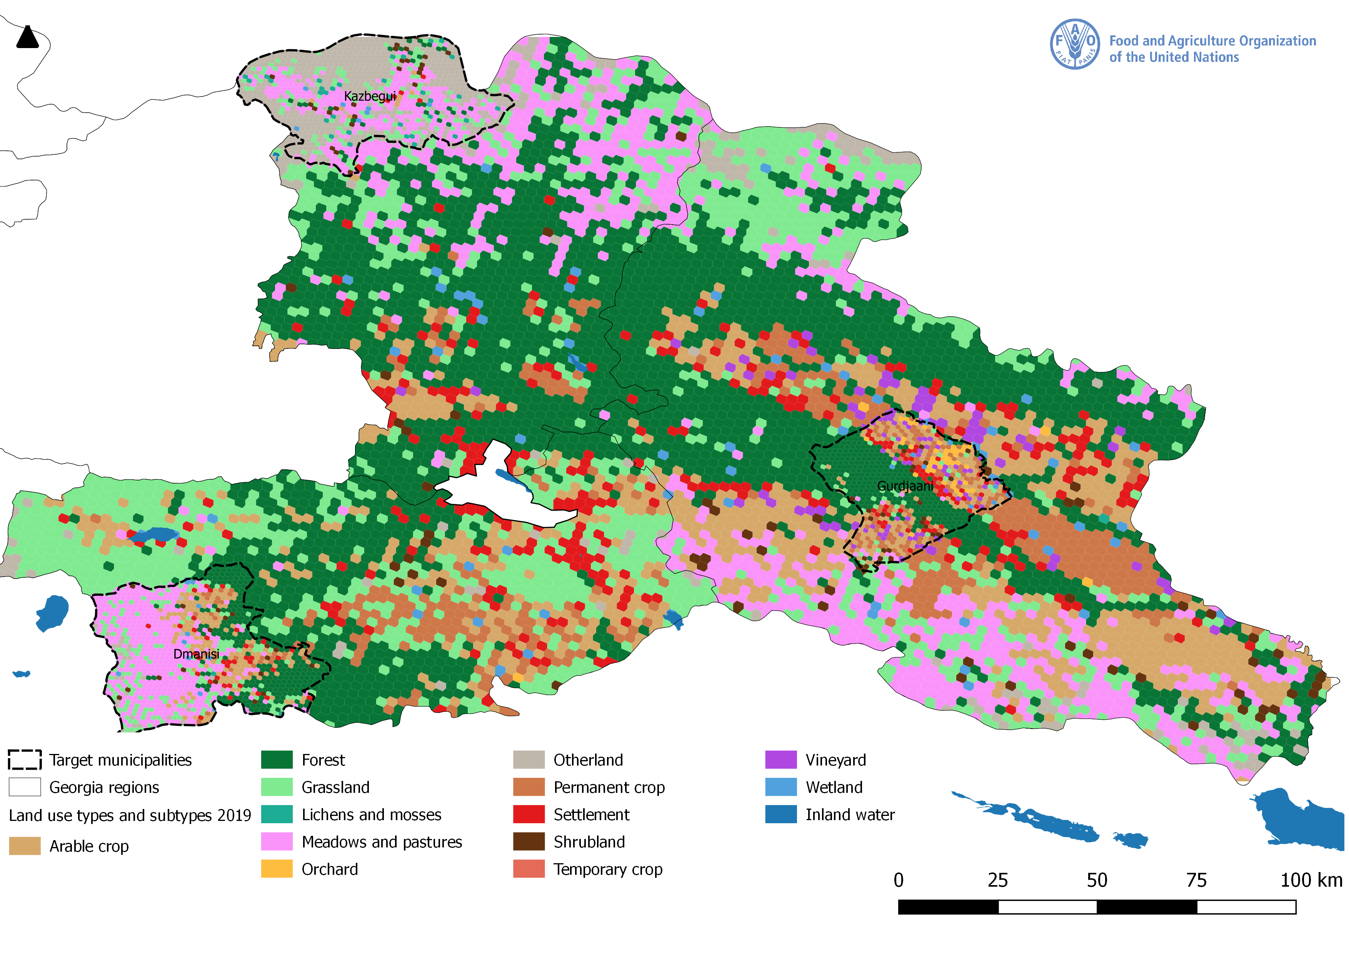

Map 3. Tree cover distribution
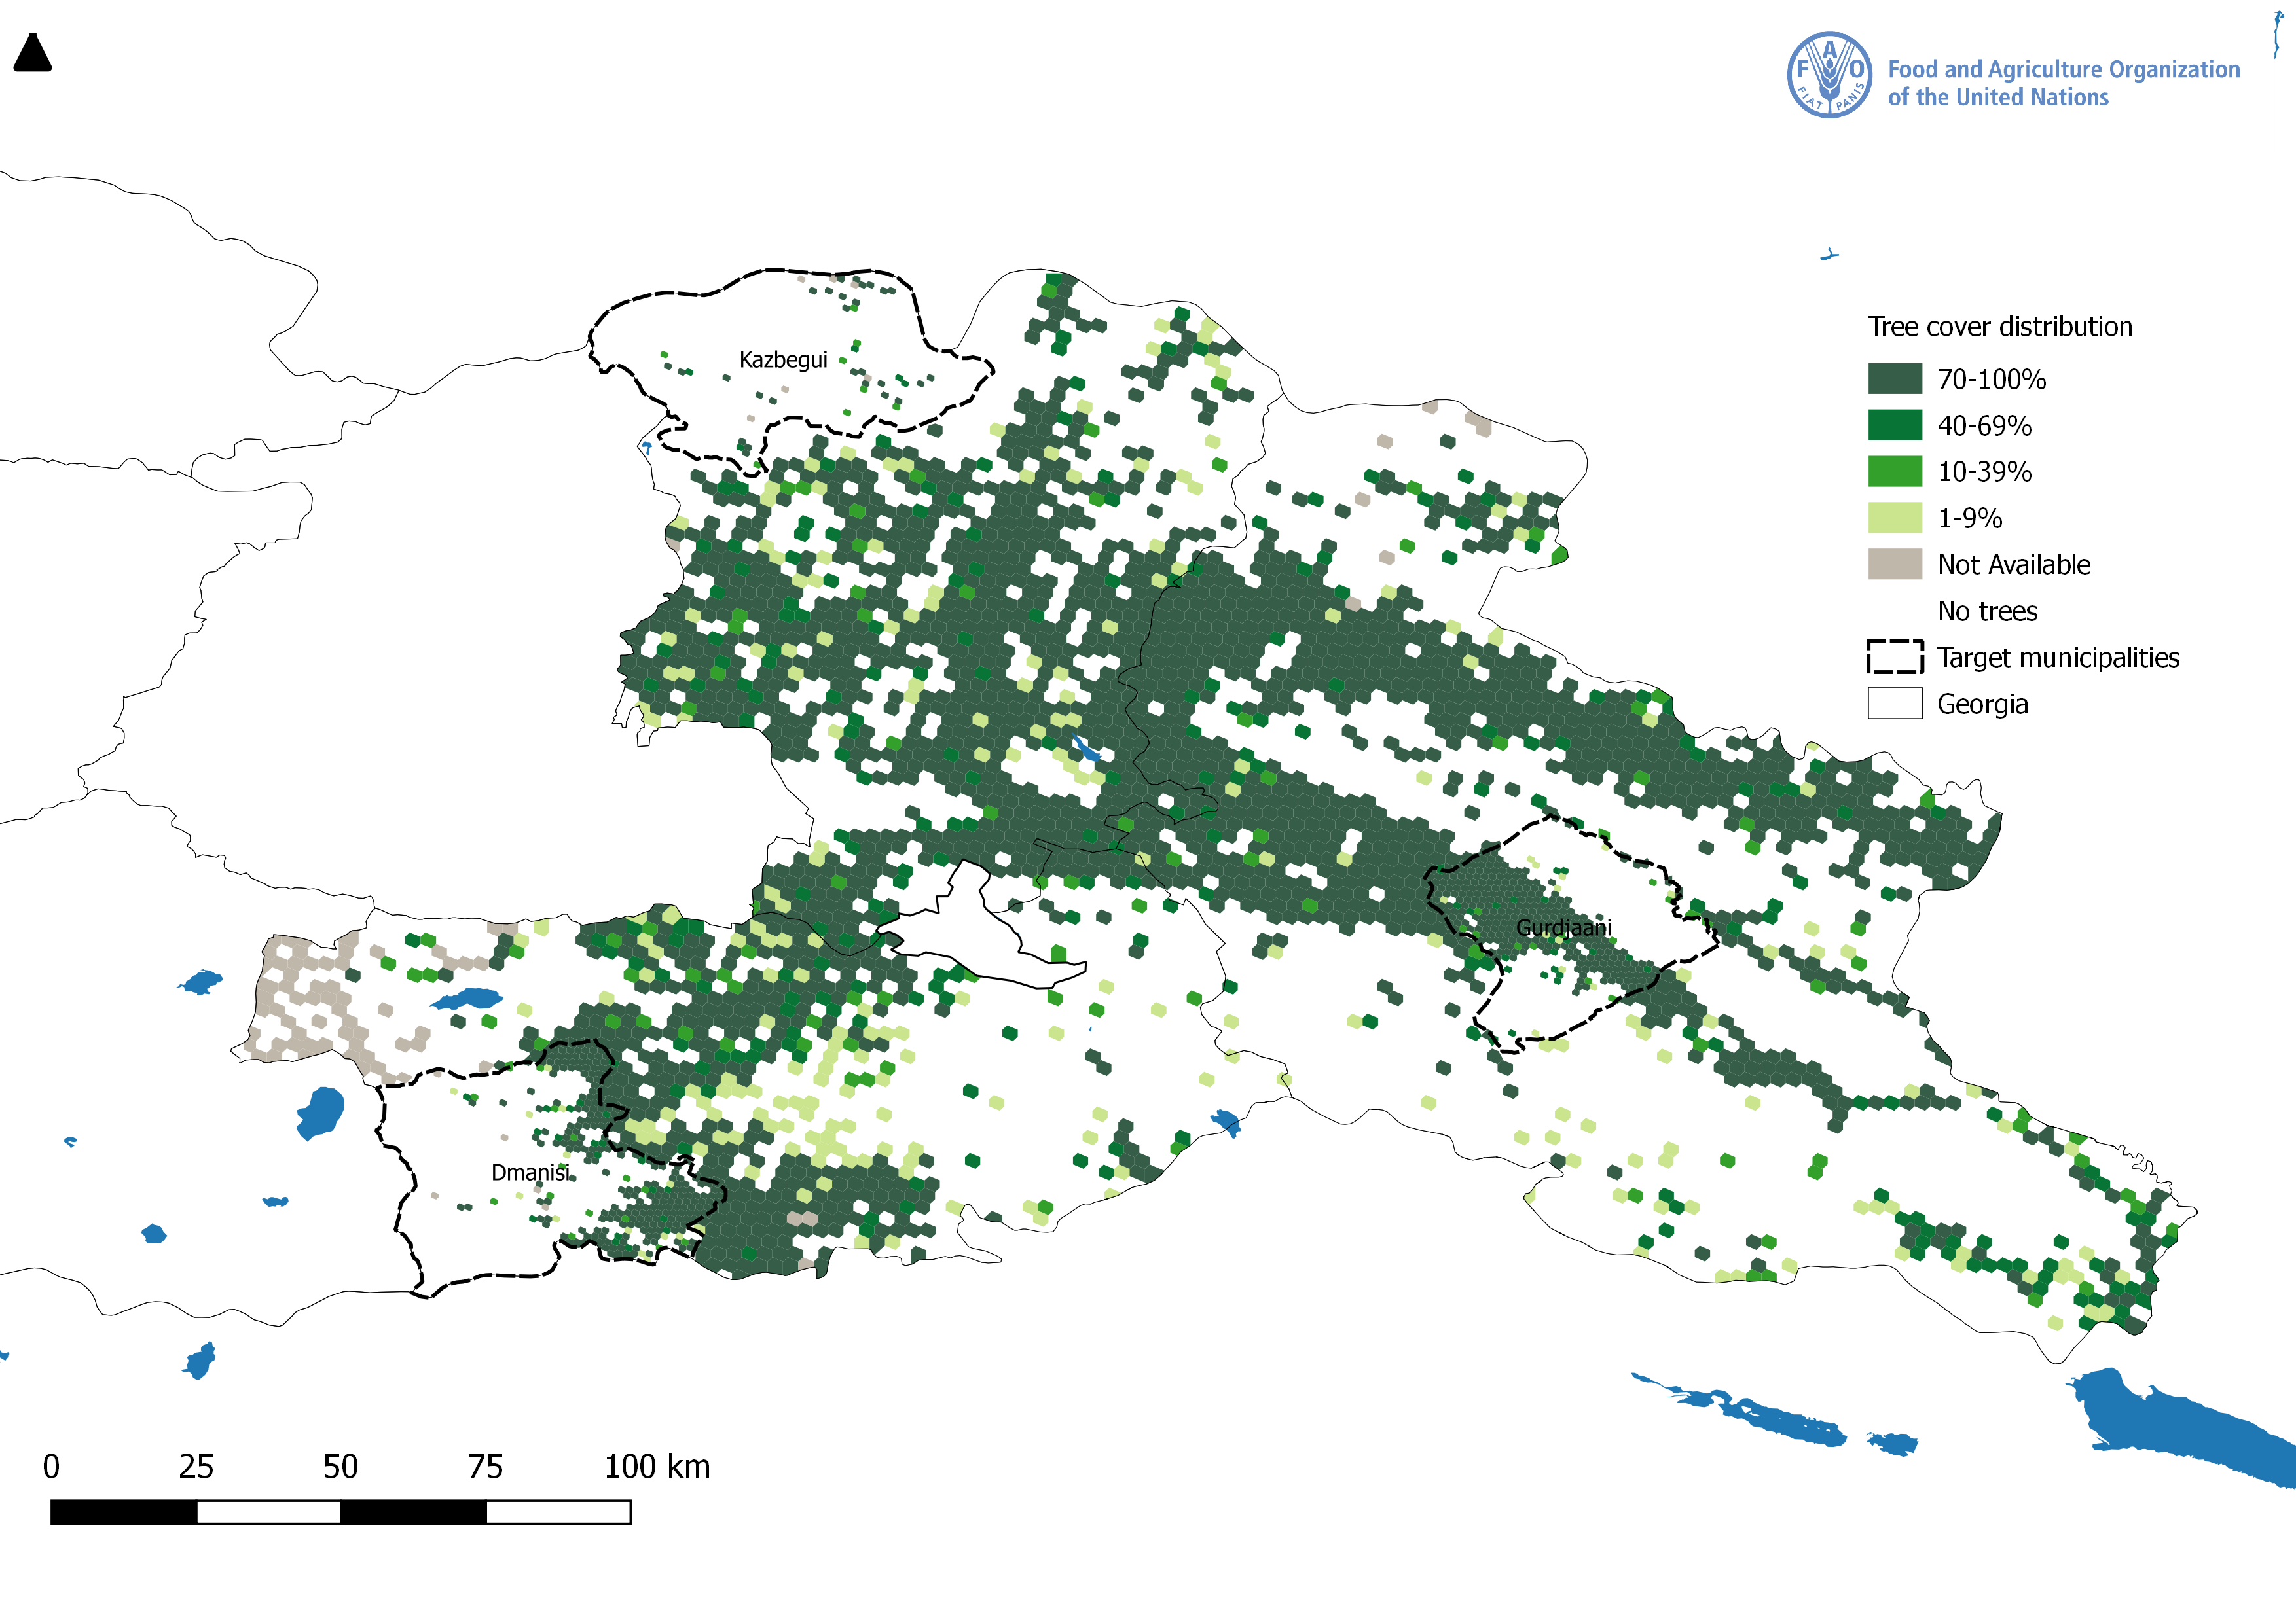

Map 4. Erosion level

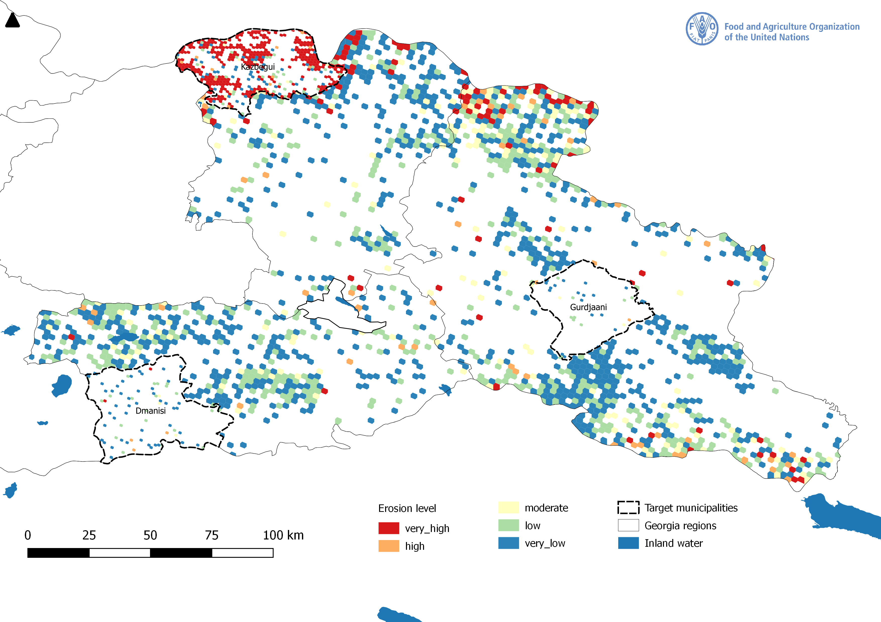

Map 5. Land productivity trend
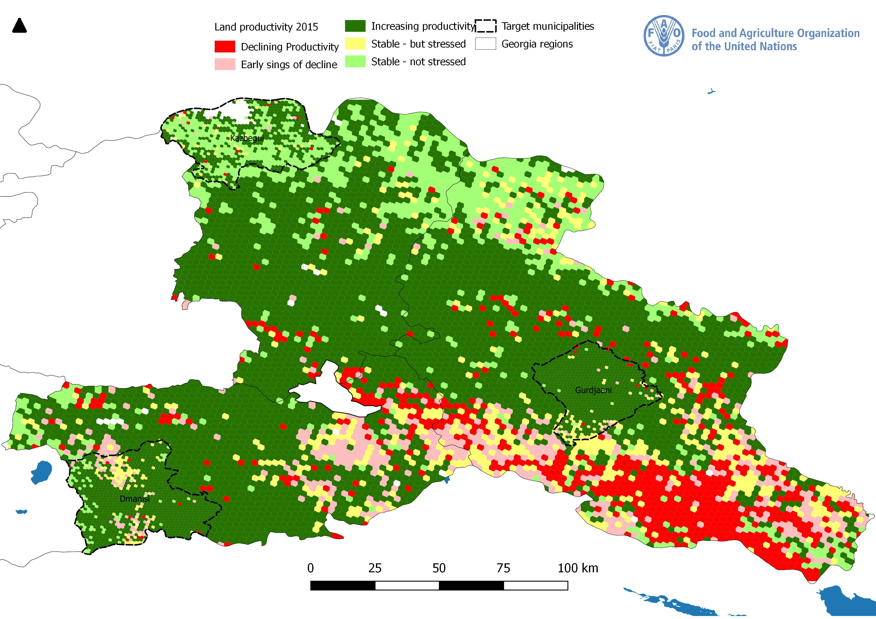

Annex F: GEF TF / LDCF/ SCCF Core Indicator Worksheet
Use this Worksheet to compute those indicator values as required in Part I, Table F to the extent applicable to your proposed project. Progress in programming against these targets for the program will be aggregated and reported at anytime during the replenishment period. LDCF and SCCF should complete, instead, the below CCA core indicator and built them into the results framework.

Annex G: GEF Project Taxonomy Worksheet
Use this Worksheet to list down the taxonomic information required under Part I, item G by ticking the most relevant keywords/ topics/themes that best describe this project.



Annex H: Work Plan (indicative)

Output | Main Activities | Responsible | Year 1 |  |  |  | Year 2 |  |  |  | Year 3
Output | Main Activities | Responsible | Q1 | Q2 | Q3 | Q4 | Q1 | Q2 | Q3 | Q4 | Q1 | Q2 | Q3 | Q4
Component 1: Strengthening the regulatory and institutional framework for sustainable management of pasturelands in Georgia
1.1.1: Multi-stakeholder coordination mechanism on pastureland management created enhanced at national level | Activity 1: Establishment of a national inter-sectoral multi-level LDN Working group (co-funded by MEPA) | MEPA |  | X | X
 | Activity 2: Enhancement of a national pasture platform integrating LDN principles | MEPA |  |  |  | X
1.1.2: Pastureland management law and supplementary sub-laws drafted | Activity 1: Identification of needs for new legislation and/or revisions of existing legislation based on agreed national pastureland policy and pastureland management law drafted | REC Caucasus |  |  |  | X | X | X
 | Activity 2: Regulatory Impact Assessment (RIA) + of draft law | REC Caucasus |  |  |  |  |  | X | X | X
 | Activity 3: Pastureland management law presented to the national stakeholder platform | REC Caucasus |  |  |  |  |  |  |  | X
 | Activity 4: Stakeholder consultations of draft pastureland law (with RIA) for wider review and arrangement of regional public hearing meetings and submission of final draft law to the Government for further formal governmental review procedure | REC Caucasus |  |  |  |  |  |  |  | X | X | X | X | X
 | Activity 5: Establishment of the Land Management Agency responsible for the pastureland management (co-funded by MEPA) | MEPA |  |  |  | X
Output 1.1.3: A national pastureland management policy contributing to implementation of LDN principles, designed and agreed with key stakeholders | Activity 1: A national pastureland policy integrating LDN principles drafted in participatory manner through series of roundtables, workshops, discussions under the national multi-stakeholder platform | REC Caucasus | X | X | X | X
 | Activity 2: National Pastureland/LDN stakeholder consultation to discuss and agree on of the national pastureland management policy | REC Caucasus |  |  | X | X | X | X
 | Activity 3: Dissemination of national pastureland policy document for wider public review and facilitation of at national and local levels for governmental approval | REC Caucasus |  |  |  | X | X | X
1.1.4: Multi-stakeholder pasture management groups are established in three target municipalities | Activity 1. Establishment of pasture management groups at municipal level in communities integrating LDN principles in at least three target municipalities | REC Caucasus |  |  |  | X | X
 | Activity 2. Development of a coordination mechanism between the croppers, food processors and livestock keepers to ensure wise use of resources (e.g. use of post-harvest residues for feeding) and prevent damage of crops by the animals | REC Caucasus |  |  |  |  | X | X | X
1.1.5. Decision Support System (DSS) for LDN integrated and tested | Activity 1: Identification/validation metrics for Land Cover (based on Collect Earth-PPG work) | REC Caucasus |  |  | X | X
 | Activity 2: Identification/ validation metrics for Soil Organic Carbon (co-funded by FAO) | FAO/MEPA |  |  |  | X | X
 | Activity 3: Identification/calibration metrics for Land Productivity (based on Collect Earth +PRAGA -PPG work) | REC Caucasus |  |  |  | X | X
 | Activity 4: Piloting of DSS for 3 LDN indicators and integration into existing processes (based on LADA-PPG work) | REC Caucasus |  |  |  |  |  | X | X
 | Activity 5: Integration and mapping land cover, land productivity, and Soil Organic Carbon for SOC monitoring | REC Caucasus |  |  |  |  |  |  | X | X
 | Activity 6: Facilitate access of stakeholders to the labs for checking quality of the soils | REC Caucasus |  |  |  | X | X
Component 2: Demonstration of sustainable pastureland management practices and scaling up successful approaches
2.1.1: A detailed inventory and multi-factor assessments of pastures are conducted in the three target municipalities | Activity 1. Inventory system/methodology with parameters (quantitative, qualitative) is agreed through the coordination mechanism and developed in at least one municipality based on Collect Earth | REC Caucasus |  |  | X | X | X
 | Activity 2. Nationally appropriate pasture grazing capacity methodology developed, tested and promoted, with transparent, well documented analysis of operational costs of proposed livestock production system. | REC Caucasus |  |  |  |  | X | X | X | X
2.1.2: Pasture management plans (strategic and operational) are developed in participatory manner and implemented in three target municipalities | Activity 1: Elaboration of State-owned pastureland management plans (strategic and operational) in participatory manner for three target municipalities (in total 20,000 ha) | REC Caucasus |  |  |  | X | X | X
 | Activity 2. Implementation of sustainable participatory pasture management practices (grazing management, weed control, breeding program with local stock, fertilization, terracing, gully prevention, mobile livestock water points, water harvesting, mobile fencing, mobile shade structures, etc.) (in total 747 ha) | REC Caucasus |  |  |  |  |  | X | X | X
 | Activity 3: Pastureland management municipal group discussions and community consultations | REC Caucasus |  |  |  |  |  |  | X | X | X
2.1.3: Business models to encourage investments in pastureland management to implement SLM and achieve LDN are elaborated in 3 target municipalities | Activity 1: Development of 5 differing business models for pasturelands under different land tenure systems in 3 target municipalities mainstreaming LDN principles based on the cost-benefit analysis | REC Caucasus |  |  |  |  |  |  |  | X | X
 | Activity 2: Livestock value chain strengthening in three target regions | REC Caucasus |  |  |  |  |  |  |  | X | X | X
 | Activity 3: Development of at least one bankable project for the LDN fund | REC Caucasus |  |  |  |  | X | X | X
 | Activity 4: A pilot solar-powered water well on a remote pasture to demonstrate potential RoI from the pastures | REC Caucasus |  |  |  |  | X | X | X
Component 3: Capacity building of the key stakeholders on sustainable management of pasturelands and achieving land degradation neutrality
3.1.1: National Capacity building program focused on the application of the SLM/LDN in pastureland management with gender mainstreaming consideration elaborated | Activity 1: Capacity Needs Assessment at the national, regional, and local levels | CENN |  | X | X | X
 | Activity 2: Farmer trainings via ICC/extension (at least 30% of participants are women) in three target municipalities | CENN |  |  |  |  | X | X | X | X | X | X | X
 | Activity 3. Farmer Field Schools on sustainable intensification of production by making the livestock feeding diets more efficient and climate-friendly, which would lead to decreased load on the pastures | CENN |  |  |  |  | X | X | X | X | X | X | X
 | Activity 4. Farmer Field Schools on creation and management of silvopastoral systems (considering expansion of goat production) on the currently degraded pastures (bringing the forest to the pasture, not livestock to the forest) | CENN |  |  |  |  | X | X | X | X | X | X | X
 | Activity 5. The livestock keepers will be educated on choosing right AnGR for the local environment and the importance of right breeds will be demonstrated by providing the parent stock and applying the passing on the gift approach | CENN |  |  |  |  | X | X | X | X | X | X | X
 | Activity 6. Training of Trainers in 3 target municipalities (through Extension, FFS) | CENN |  |  |  |  |  |  | X | X | X
 | Activity 7. Group organizations (field demonstrations/farmers meetings/exhibitions/competitions/ field days, etc.) in three target municipalities | CENN |  |  |  |  |  |  |  |  |  | X | X
 | Activity 8. Training for investment access to the farmers (FAO Rural Invest or others) | CENN |  |  |  |  | X | X | X | X
3.1.2: Knowledge materials on SLM and LDN are developed and disseminated to a wide range of relevant stakeholders | Activity 1: Preparation of knowledge brochures, manuals for pastureland management | CENN |  |  |  |  | X | X | X | X | X | X | X
 | Activity 2: Preparation of knowledge brochures, manuals on sustainable intensification and use of traditional local breeds | CENN |  |  |  |  | X | X | X | X | X | X | X
3.1.3: Training provided to national and local decision makers, workers of governmental extension services, women groups and farmers | Activity 1: Technical workshops and knowledge sharing activities on LDN oriented sustainable pastureland management | CENN |  |  |  |  |  |  | X
 | Activity 2: International technical study tours for examining the best SLM applications related to LDN on pasturelands (co-funded by Turkey) | FAO |  |  |  |  | X |  |  |  | X
3.1.4: Knowledge-sharing with other municipalities, regions and countries and dissemination of verifiable data and tested methodologies | Activity 1: Media campaigns on sustainable pasture management | CENN |  |  |  | X | X | X | X | X | X | X | X | X
 | Activity 3: Promotion of animal sourced foods, produced on sustainably managed pastures | CENN |  |  |  |  |  |  |  |  |  | X | X
Component 4: Effective Knowledge Management through RBM, monitoring and evaluation
4.1.1: RBM system of the project promoted adaptive management through capturing key results of the project activities and peer-to-peer training | Activity 1: Sharing of the project results or lessons at the UNCCD | REC Caucasus |  |  |  |  |  |  |  | X | X
 | Activity 2: Sharing of the project results or lessons at the FAO Global Agenda for Sustainable Livestock (GASL), the Livestock Environmental Assessment and Performance (LEAP) Partnership, and Pastoralist Hub | FAO |  |  |  |  |  |  |  |  | X | X
 | Activity 3: Sharing of the project results or lessons with other municipalities in the country | MEPA, REC Caucasus, CENN, FAO |  |  |  |  |  |  |  |  |  | X | X
4.1.2: A Gender-Sensitive Project Monitoring & Evaluation Plan and a relevant system are in place | Activity 1: Design of grievance mechanism, designation of focal point and communication to stakeholders | REC Caucasus |  |  | X
 | Activity 2: Development and maintenance of an M&E tool | Monitoring and Evaluation Specialist based in REC Caucasus |  | X
 | Activity 3: Monthly meetings of the project team | PC | X | X | X | X | X | X | X | X | X | X | X | X
 | Activity 4: Meetings of the executive committee every four months | MEPA/FAO | X | X | X | X | X | X | X | X | X | X | X | X
 | Activity 5: Annual meeting of the advisory committee | MEPA |  |  |  | X |  |  |  | X |  |  |  | X
 | Activity 6: Preparation of annual workplan | PC | X |  |  | X |  |  |  | X |  |  |  | X
 | Activity 7: Preparation of six-monthly progress reports | PC |  | X |  | X |  | X |  | X |  | X |  | X
 | Activity 8: Inception workshop | PC | X
 | Activity 9: Final workshop | PC |  |  |  |  |  |  |  |  |  |  |  | X
 | Activity 10: Preparation of inception and final reports | PC | X |  |  |  |  |  |  |  |  |  |  | X
4.1.3: Communication Strategy and KM strategy are developed and implemented | Activity 1: Development of a communication strategy for the institutional communication | RE Caucasus |  | X
 | Activity 2: Development of a communication strategy for the communication with farmers | REC Caucasus |  | X
4.1.4: Project Mid-term review and Final Evaluation are conducted | Activity 1: Mid-term review | FAO BH |  |  |  |  |  |  | X
 | Activity 2: Final evaluation | FAO OED |  |  |  |  |  |  |  |  |  |  |  | X

Annex I1: Environmental and Social Risk Certification
Please copy here the Environmental and Social Risk Certification under generated by FPMIS under the repsonsability of the Lead Technical Officer.

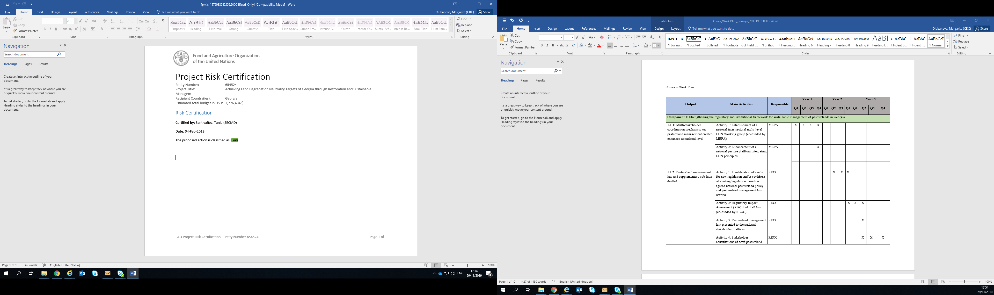

Annex I2: Stakeholder Engagement Matrix and Grievance Redress Mechanism

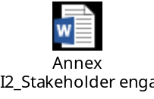

Grievance Redress Mechanism

Grievance Mechanism
Focal Point Information
Contact Details
Explain how the grievance mechanism will be/ has been communicated to stakeholders | At inception, a grievance mechanism will be defined, a focal point designated and communicated to the stakeholders to ensure that people affected by the project can file a complaints, in accordance with FAO operational procedures.

FAO is committed to ensuring that its programs are implemented in accordance with the Organization’s environmental and social obligations. In order to better achieve these goals, and to ensure that beneficiaries of FAO programs have access to an effective and timely mechanism to address their concerns about non-compliance with these obligations, the Organization, in order to supplement measures for receiving, reviewing and acting as appropriate on these concerns at the program management level, has entrusted the Office of the Inspector-General with the mandate to independently review the complaints that cannot be resolved at that level.
FAO will facilitate the resolution of concerns of beneficiaries of FAO programs regarding alleged or potential violations of FAO’s social and environmental commitments. For this purpose, concerns may be communicated in accordance with the eligibility criteria of the Guidelines for Compliance Reviews Following Complaints Related to the Organization’s Environmental and Social Standards, which applies to all FAO programs and projects.
Concerns must be addressed at the closest appropriate level, i.e. at the project management/technical level, and if necessary at the Regional Office level. If a concern or grievance cannot be resolved through consultations and measures at the project management level, a complaint requesting a Compliance Review may be filed with the Office of the Inspector-General (OIG) in accordance with the Guidelines. Program and project managers will have the responsibility to address concerns brought to the attention of the focal point.
The principles to be followed during the complaint resolution process include: impartiality, respect for human rights, including those pertaining to indigenous peoples, compliance of national norms, coherence with the norms, equality, transparency, honesty, and mutual respect.
Project-level grievance mechanism
The project will establish a grievance mechanism at field level to file complaints during project inception phase. Contact information and information on the process to file a complaint will be disclosed in all meetings, workshops and other related events throughout the life of the project. In addition, it is expected that all awareness raising material to be distributed will include the necessary information regarding the contacts and the process for filing grievances.
The project will also be responsible for documenting and reporting as part of the safeguards performance monitoring on any grievances received and how they were addressed.
The mechanism includes the following stages:
- In the instance in which the claimant has the means to directly file the claim, he/she has the right to do so, presenting it directly to the Project Coordination Unit (PCU). The process of filing a complaint will duly consider anonymity as well as any existing traditional or indigenous dispute resolution mechanisms and it will not interfere with the community’s self-governance system.
- The complainant files a complaint through one of the channels of the grievance mechanism. This will be sent to the Project Coordinator (PC) to assess whether the complaint is eligible. The confidentiality of the complaint must be preserved during the process.
- The PGC will be responsible for recording the grievance and how it has been addressed if a resolution was agreed.
- If the situation is too complex, or the complainer does not accept the resolution, the complaint must be sent to a higher level, until a solution or acceptance is reached.
- For every complaint received, a written proof will be sent within ten (10) working days; afterwards, a resolution proposal will be made within thirty (30) working days.
- In compliance with the resolution, the person in charge of dealing with the complaint, may interact with the complainant, or may call for interviews and meetings, to better understand the reasons.
- All complaint received, its response and resolutions, must be duly registered.

Internal process
1. Project Coordination Unit (PCU). The complaint could come in writing or orally to the PCU directly. At this level, received complaints will be registered, investigated and solved by the PCU.
2. If the complaint has not been solved and could not be solve in level 1, then the Project Coordinator (PC) elevates it to the FAO Representative of Georgia.
3. Project Steering Committee (PSC). The assistance of the PSC is requested if a resolution was not agreed in levels 1 and 2.
4. FAO Regional Office for Georgia. FAO Representative will request if necessary the advice of the Regional Office to resolve a grievance, or will transfer the resolution of the grievance entirely to the regional office, if the problem is highly complex.
5. The FAO Regional Representative will request only on very specific situations or complex problems the assistance on the FAO Inspector General who pursuits its own procedures to solve the problem.
Resolution
Upon acceptance a solution by the complainer, a document with the agreement should be signed with the agreement.
Project Coordination Unit (PCU) | Must respond within 5 working days.
FAO Representation in Georgia | Anyone in the FAO Representation may receive a complaint and must request proof of receipt. If the case is accepted, the FAO Representative must respond within 5 working days in consultation with FAO's Representation and Project Team.  FAO Representative: Raimund Jehle  e-mail: Raimund.Jehle@fao.org  Tel:___
Project Steering Committee (PSC) | If the case cannot be dealt by the FAO Representative, he/she must send the information to all PSC members and call for a meeting to find a solution. The response must be sent within 5 working days after the meeting of the PSC.
FAO Regional Office for Georgia | Must respond within 5 working days in consultation with FAO's Representation.  FAO Regional Representative: Raimund Jehle  e-mail:Raimund.Jehle@fao.org  Tel:__
Office of the Inspector General (OIG) | To report possible fraud and bad behavior by fax, confidential:  (+39) 06 570 55550  By e-mail: Investigations-hotline@fao.org  By confidential hotline: (+ 39) 06 570 52333

Annex J: Indigenous Peoples

There are no indigenous people in Georgia based on the FAO definitions and international consensus.

Annex K: FAO’S Roles in Internal Organization

FAO will be the GEF Implementing Agency of the project. As such, FAO has the project assurance role and will supervise and provide technical guidance for the overall implementation of the project, including:
- Monitor and oversee OP’s compliance with the OPA and project implementation in accordance with the project document, work plans, budgets, agreements with co-financiers and the rules and procedures of FAO and GEF;
- Commence and completing the responsibilities allocated to it in the Project Document in a timely manner, provided that all necessary reports and other documents are available;
- Making transfers of funds, supplies and equipment, as applicable, in accordance with the provisions of the OPA;
- Administrate the portion of project GEF funds that has been agreed with the OP to remain for FAO direct implementation. These funds will be managed in accordance with the rules and procedures of FAO;
- organizing and completing monitoring, assessment, assurance activities and evaluation of the Project;
- Review, discuss with the OP, and approve the project progress and financial reports, as detailed in the OPA and its annexes. undertaking and completing monitoring, assessment, assurance activities, evaluation and oversight of the project;
- Liaising on an ongoing basis, as needed, with the Government (as applicable), other members of the United Nations Country Team, Resource Partner, and other stakeholders;
- Providing overall guidance, oversight, technical assistance and leadership, as appropriate, for the Project;
- Provide financial and audit services to the project including budget release, budget revisions and administration of funds from GEF in accordance with rules and procedures of FAO;

- oversee financial expenditures against project budgets;

- ensure that all activities, including procurement and financial services are carried out in strict compliance with FAO and GEF relevant procedures and agreements;
- Initiating joint review meetings with the OP to agree on the resolution of findings and to document the lessons learned;
- Report to the GEF Secretariat and Evaluation Office, through the annual Project Implementation Review, on project progress and provide consolidated financial reports to the GEF Trustee;
- Conduct at least one supervision mission per year
- Lead the Mid-Term Review and Final Evaluation;
- Monitor implementation of the plan for social and environmental safeguards, in accordance with the FAO Environmental and Social Safeguards.
- trigger additional reviews, audits and/or evaluations, as necessary;

In collaboration with the Project Management Unit (PMU) and under the overall guidance of the the Project Steering Committee, FAO will participate in the planning of contracting and technical selection processes. FAO will process fund transfers to the OP as per provsions, terms and conditions of the signed OPA.
The FAO Representative in Georgia will be the Budget Holder (BH) and will be responsible for timely operational, and financial management of GEF resources implemented. The budget holder will be also responsible for i) managing OPIM for results, including monitoring of risks and overall compliance with the OPA provisions; ii)review and clear financial and progress reports received from the OP and certify request for funds iii) review and clear budget revisions and annual work plan and budgets; iv) ensure implementation of the Risk Mitigation and Assurance Plan v) follow up and ensure that the OP implements all actions and recommendations agreed upon during Assurance Activities.
As a first step in the implementation of the project, the FAO Representation will establish an interdisciplinary Project Task Force (PTF) within FAO, to guide the implementation of the project. The PTF is a management and consultative body that integrate the necessary technical qualifications from the FAO relevant units to support the project. The PTF is composed of a Budget Holder, a Lead Technical Officer (LTO), the Funding Liaison Officer (FLO) and one or more technical officers based on FAO Headquarters (HQ Technical Officer).
The FAO Representative, in accordance with the PTF, will give its non-objection to the AWP/Bs submitted by the PCU as well as the Project Progress Reports (PPRs). PPRs may be commented by the PTF and should be approved by the LTO before being uploaded by the BH in FPMIS.
The Lead Technical Officer (LTO) for the project will be Climate, Biodiversity, Land and Water division. The role of the LTO is central to FAO’s comparative advantage for projects. The LTO will oversee and carry out technical backstopping to the project implementation. The LTO will support the BH in the implementation and monitoring of the AWP/Bs, including work plan and budget revisions. The LTO is responsible and accountable for providing or obtaining technical clearance of technical inputs and services procured by the Organization.
In addition, the LTO will provide technical backstopping to the PMU to ensure the delivery of quality technical outputs. The LTO will coordinate the provision of appropriate technical support from PTF to respond to requests from the PSC. The LTO will be responsible for:
- Assess the technical expertise required for project implementation and identify the need for technical support and capacity development of the OP.
- Provide technical guidance to the OP on technical aspects and implementation.
- Review and give no-objection to TORs for consultancies and contracts to be performed under the project, and to CVs and technical proposals short-listed by the PCU for key project positions and services to be financed by GEF resources;
- Review and give clearance for the OP’s procurement plans;
- Supported by the FAO Representation, review and clear final technical products delivered by consultants and contract holders financed by GEF resources;
- Assist with review and provision of technical comments to draft technical products/reports during project implementation;
- Review and approve project progress reports submitted by the National Program Director (NPD), in cooperation with the BH;
- Support the FAO Representative in examining, reviewing and giving no-objection to AWP/B submitted by the NPD, for their approval by the Project Steering Committee;
- Ensure the technical quality of the six-monthly Project Progress Reports (PPRs). The PPRs will be prepared by the NPD, with inputs from the PCU. The BH will submit the PPR to the FAO/GEF Coordination Unit for comments, and the LTO for technical clearance. The PPRs will be submitted to the PSC for approval twice a year. The FLO will upload the approved PPR to FPMIS.
- Supervise the preparation and ensure the technical quality of the annual PIR. The PIR will be drafted by the NPD, with inputs from the PT. The PIR will be submitted to the BH and the FAO-GEF Coordination Unit for approval and finalization. The FAO/GEF Coordination Unit will submit the PIRs to the GEF Secretariat and the GEF Evaluation Office, as part of the Annual Monitoring Review report of the FAO-GEF portfolio. The LTO must ensure that the NPD and the PCU have provided information on the co-financing provided during the year for inclusion in the PIR;
- Conduct annual supervision missions;
- Provide comments to the TORs for the mid-term and final evaluation; provide information and share all relevant background documentation with the evaluation team; participate in the mid-term workshop with all key project stakeholders, development of an eventual agreed adjustment plan in project execution approach, and supervise its implementation; participate in the final workshop with all key project stakeholders, as relevant. Contribute to the follow-up to recommendations on how to insure sustainability of project outputs and results after the end of the project.
- Monitor implementation of the Risk Mitigation Plan, in accordance with the FAO Environmental and Social Safeguards.
The HQ Technical Officer is a member of the PTF, as a mandatory requirement of the FAO Guide to the Project Cycle. The HQ Technical Officer has most relevant technical expertise - within FAO technical departments - related to the thematic of the project. The HQ Technical Officer will provide effective functional advice to the LTO to ensure adherence to FAO corporate technical standards during project implementation, in particular:
- Supports the LTO in monitoring and reporting on implementation of environmental and social commitment plans for moderate risk projects. In this project, the HQ officer will support the LTO in monitoring and reporting the identified risks and mitigation measures (Appendix H2) in close coordination with the OP.
- Provides technical backstopping for the project work plan.
- Clears technical reports, contributes to and oversees the quality of Project Progress Report(s).
- May be requested to support the LTO and PTF for implementation and monitoring.
- Contribute to the overall ToR of the Mid-term and Final Evaluation, review the composition of the evaluation team and support the evaluation function.
The FAO-GEF Coordination Unit will provide Funding Liaison Officer (FLO) functions. This FAO/GEF Coordination Unit will review and provide a rating in the annual PIR(s) and will undertake supervision missions as necessary. The PIRs will be included in the FAO GEF Annual Monitoring Review submitted to GEF by the FAO GEF Coordination Unit. The FAO GEF Coordination Unit may also participate or lead the mid-term evaluation, and in the development of corrective actions in the project implementation strategy if needed to mitigate eventual risks affecting the timely and effective implementation of the project. The FAO GEF Coordination Unit will in collaboration with the FAO Finance Division to request transfer of project funds from the GEF Trustee based on six-monthly projections of funds needed.
The FAO Financial Division will provide annual Financial Reports to the GEF Trustee and, in collaboration with the FAO-GEF Coordination Unit, request project funds on a six-monthly basis to the GEF Trustee.
Financial management

Financial management in relation to the GEF resources directly managed by FAO will be carried out in accordance with FAO’s rules and procedures as outlined below. The OP is accountable to FAO for achieving the agreed project results and for the effective use of resources made available by FAO. Financial management and reporting for the funds transferred to the OP will be done by the OP in accordance with terms, conditions, formats and requirements of FAO and the provisions of the signed Operational Partners Agreement (OPA). The administration by the OP of the funds received from FAO shall be carried out under its own financial regulations, rules and procedures, which shall provide adequate controls to ensure that the funds received, are properly administered and expended. The Operational Partner shall maintain the account in accordance with generally accepted accounting standards.
Financial Records. FAO shall maintain a separate account in United States dollars for the project’s GEF resources showing all income and expenditures. FAO shall administer the project in accordance with its regulations, rules and directives. The OP shall maintain books and records that are accurate, complete and up-to-date. The OP’s books and records will clearly identify all Fund Transfers received by the OP as well as disbursements made by the OP under the OPA, including the amount of any unspent funds and interest accrued.

Financial Reports. The BH shall prepare quarterly project expenditure accounts and final accounts for the project, showing amount budgeted for the year, amount expended since the beginning of the year, and separately, the un-liquidated obligations as follows: i) Details of project expenditures on outcome-by-outcome basis, reported in line with Project Budget as at 30 June and 31 December each year; ii) Final accounts on completion of the Project on a component-by-component and outcome-by-outcome basis, reported in line with the Project Budget; iii) A final statement of account in line with FAO Oracle Project budget codes, reflecting actual final expenditures under the Project, when all obligations have been liquidated.
The OP will prepare the financial reports in accordance with terms, conditions, formats and requirements of FAO and the provisions of the signed OPA. The BH will review and approve request for funds and financial reports of the OP. The subsequent instalments can be released only based on the BH confirmation that all expenditures are eligible and all OPA requirements are fulfilled to the satisfaction of FAO. The BH will withhold any payment due to the OP in case of non-compliance with the reporting obligations detailed in the OPA.
Financial reports for submission to the donor (GEF) will include both FAO- and OP-managed resources, will be prepared in accordance with the provisions in the GEF Financial Procedures Agreement and submitted by the FAO Finance Division.

Responsibility for Cost Overruns. As regards resources directly managed by FAO, the BH shall utilize the GEF project funds in strict compliance with the Project Budget (Appendix A2) and the approved AWP/Bs. The BH can make variations provided that the total allocated for each budgeted project component is not exceeded and the reallocation of funds does not impact the achievement of any project output as per the project Results Framework (Appendix A1). At least once a year, the BH will submit a budget revision for approval of the LTO and the FAO/GEF Coordination Unit through FPMIS. Cost overruns shall be the sole responsibility of the BH.
As regards resources managed by the OP, the OP shall utilize the funds received from FAO in strict compliance with provisions of the signed OPA and its Annexes, including approved work plan and budget. The OP can make variations not exceeding 10 percent on any budget heading. Any variations above 10 percent on any budget heading that may be necessary will be subject to prior consultations with and approval by FAO.
Under no circumstances can expenditures exceed the approved total project budget or be approved beyond the NTE date of the OPA and/or the project. Any over-expenditure is the responsibility of the BH.
Audit. The project shall be subject to the internal and external auditing procedures provided for in FAO financial regulations, rules and directives and in keeping with the Financial Procedures Agreement between the GEF Trustee and FAO.

The audit regime at FAO consists of an external audit provided by the Auditor-General (or persons exercising an equivalent function) of a member nation appointed by the Governing Bodies of the Organization and reporting directly to them, and an internal audit function headed by the FAO Inspector-General who reports directly to the Director-General. This function operates as an integral part of the Organization under policies established by senior management, and furthermore has a reporting line to the governing bodies. Both functions are required under the Basic Texts of FAO which establish a framework for the terms of reference of each. Internal audits of imprest accounts, records, bank reconciliation and asset verification take place at FAO field and liaison offices on a cyclical basis. Specific provision for auditing the OP managed funds are included in the signed Operational Partners Agreement (OPA). During implementation, assurance activities are organized by FAO to determine whether the progress has been made and whether funds transferred to Operational Partners were used for their intended purpose, in accordance with the work plan and relevant rules and regulations. This may include, but is not limited to, monitoring missions, spot checks, quarterly progress and annual implementation reviews, and audits on the resources received from FAO.

Procurement. Careful procurement planning is necessary for securing goods, services and works in a timely manner, on a “Best Value for Money” basis. It requires analysis of needs and constraints, including forecast of the reasonable timeframe required to execute the procurement process. Procurement and delivery of inputs in technical cooperation projects will follow FAO’s rules and regulations for the procurement of supplies, equipment and services (i.e. Manual Sections 502 and 507). Manual Section 502: “Procurement of Goods, Works and Services” establishes the principles and procedures that apply to procurement of all goods, works and services on behalf of the Organization, in all offices and in all locations, with the exception of the procurement actions described in Procurement Not Governed by Manual Section 502. Manual Section 507 establishes the principles and rules that govern the use of Letters of Agreement (LoA) by FAO for the timely acquisition of services from eligible entities in a transparent and impartial manner, taking into consideration economy and efficiency to achieve an optimum combination of expected whole life costs and benefits. As per the guidance in FAO’s Project Cycle Guide, the BH will draw up an annual procurement plan for major items, which will be the basis of requests for procurement actions during implementation. The first procurement plan will be prepared at the time of project start-up, if not sooner, in close consultation with the PC and LTO. The plan will include a description of the goods, works, or services to be procured, estimated budget and source of funding, schedule of procurement activities and proposed method of procurement. In situations where exact information is not yet available, the procurement plan should at least contain reasonable projections that will be corrected as information becomes available.

Procurement will follow OP rules and regulations for the procurement of supplies, equipment and services. The OP will draw up a procurement plan as part of the supporting documentation to each request for funds submitted to FAO. The plan will include a description of the goods, works, or services to be procured, estimated budget and source of funding, schedule of procurement activities and proposed method of procurement. In situations where exact information is not yet available, the procurement plan should at least contain reasonable projections that will be corrected as information becomes available.
The procurement plan shall be updated every quarter and submitted to FAO BH and LTO for clearance.

Annex L: FAO and Government Obligations

(a) This Annex sets out the basic conditions under which FAO will assist the Government in the implementation of the Project described in the attached Project Document.
(b)The achievement of the objectives set by the Project shall be the joint responsibility of the Government and FAO.
FAO OBLIGATIONS
1. FAO will be responsible for the provision, with due diligence and efficiency, of assistance as provided in the Project Document. FAO and the Government will consult closely with respect to all aspects of the Project.
2. Assistance under the Project will be made available to the Government, or to such entity as provided in the Project, and will be furnished and received (i) in accordance with relevant decisions of the Governing Bodies of FAO, and with its constitutional and budgetary provisions, and (ii) subject to the receipt by FAO of the necessary contribution from the Resource Partner. FAO will disburse the funds received from the Resource Partner in accordance with its regulations, rules and policies. All financial accounts and statements will be expressed in United States Dollars and will be subject exclusively to the internal and external auditing procedures laid down in the financial regulations, rules and directives of FAO.
3. FAO’s responsibilities regarding financial management and execution of the Project will be as stipulated in the Project Document. FAO may, in consultation with the Government, implement Project components through partners identified in accordance with FAO procedures. Such partners will have primary responsibility for delivering specific project outputs and activities to the Project in accordance with the partner’s rules and regulations, and subject to monitoring and oversight, including audit, by FAO.
4. Assistance under the Project provided directly by FAO, including technical assistance services and/or oversight and monitoring services, will be carried out in accordance with FAO regulations, rules and policies, including on recruitment, travel, salaries, and emoluments of national and international personnel recruited by FAO, procurement of services, supplies and equipment, and subcontracting. The candidacies of senior international technical staff for recruitment by FAO will be submitted to the Government for clearance following FAO procedures.
5. Equipment procured by FAO will remain the property of FAO for the duration of the Project. The Government will provide safe custody of such equipment, which is entrusted to it prior to the end of the Project. The ultimate destination of equipment procured under this Project will be decided by FAO in consultation with the Government and the Resource Partner.
GOVERNMENT OBLIGATIONS
6. With a view to the rapid and efficient execution of the Project, the Government shall grant to FAO, its staff, and all other persons performing services on behalf of FAO, the necessary facilities including:
i) the prompt issuance, free of charge, of any visas or permits required;
ii) any permits necessary for the importation and, where appropriate, the subsequent exportation, of equipment, materials and supplies required for use in connection with the Project and exemption from the payment of all customs duties or other levies or charges relating to such importation or exportation;
iii) exemption from the payment of any sales or other tax on local purchases of equipment, materials and supplies for use in connection with the project;
iv) any permits necessary for the importation of property belonging to and intended for the personal use of FAO staff or of other persons performing services on behalf of FAO, and for the subsequent exportation of such property;
v) prompt customs clearance of the equipment, materials, supplies and property referred to in subparagraphs (ii) and (iv) above.
7. The Government will apply to FAO, its property, funds and assets, its officials and all the persons performing services on its behalf in connection with the Project: (i) the provisions of the Convention on Privileges and Immunities of the Specialized Agencies; and (ii) the United Nations currency exchange rate. The persons performing services on behalf of FAO will include any organization, firm or other entity, which FAO may designate to take part in the execution of the Project.
8. The Government will be responsible for dealing with any claims which may be brought by third parties against FAO, its personnel or other persons performing services on its behalf, in connection with the Project, and will hold them harmless in respect to any claim or liability arising in connection with the Project, except when it is agreed by FAO and the Government that such claims arise from gross negligence or wilful misconduct of such persons.
9. The Government will be responsible for the recruitment, salaries, emoluments and social security measures of its own national staff assigned to the project. The Government will also provide, as and when required for the Project, the facilities and supplies indicated in the Project Document. The Government will grant FAO staff, the Resource Partner and persons acting on their behalf, access to the Project offices and sites and to any material or documentation relating to the Project, and will provide any relevant information to such staff or persons.
REPORTING AND EVALUATION
10. FAO will report to the Government (and to the Resource Partner) as scheduled in the Project Document.
11. The Government will agree to the dissemination by FAO of information such as Project descriptions and objectives and results, for the purpose of informing or educating the public. Patent rights, copyright, and any other intellectual property rights over any material or discoveries resulting from FAO assistance under this Project will belong to FAO. FAO hereby grants to the Government a non-exclusive royalty-free license to use, publish, translate and distribute, privately or publicly, any such material or discoveries within the country for non-commercial purposes. In accordance with requirements of some Resource Partners, FAO reserves the right to place information and reports in the public domain.
12. The Project will be subject to independent evaluation according to the arrangements agreed between the Government, the Resource Partner and FAO. The evaluation report will be publicly accessible, in accordance with the applicable policies, along with the Management Response. FAO is authorized to prepare a brief summary of the report for the purpose of broad dissemination of its main findings, issues, lessons and recommendations as well as to make judicious use of the report as an input to evaluation synthesis studies.
FINAL PROVISIONS
13. Any dispute or controversy arising out of or in connection with the Project or this Agreement will be amicably settled through consultations, or through such other means as agreed between the Government and FAO.
14. Nothing in or related to any provision in this Agreement or document or activity of the Project shall be deemed (i) a waiver of the privileges and immunities of FAO; (ii) the acceptance by FAO of the applicability of the laws of any country to FAO, and: (iii) the acceptance by FAO of the jurisdiction of the courts of any country over disputes arising from assistance activities under the Project.
15. This Agreement may be amended or terminated by mutual written consent. Termination will take effect sixty days after receipt by either party of written notice from the other party. In the event of termination, the obligations assumed by the parties under this Agreement will survive its termination to the extent necessary to permit the orderly conclusion of activities, and the withdrawal of personnel, funds and property of FAO.
16. This Agreement will enter into force upon signature by the duly authorized representatives of both parties.

Annex M: Socio-economic analysis in three target Municipalities
For Annex M Please see a separate attachment.

Annex N-1: PRAGA baseline assessment
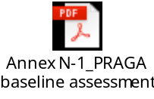

Annex N-2: PRAGA baseline field data
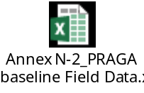

Annex O: LADA baseline report


Annex O-1: LADA baseline field data in Dmanisi Municipality
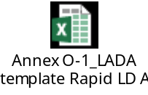

Annex O-2: LADA baseline field data in Gurjaani Municipality
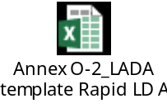

Annex O-3: LADA baseline field data in Kazbegi Municipality
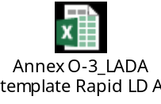

Annex P: Land Use distribution per municipalities based on Collect Earth assessment
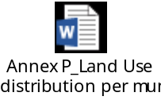

Annex Q: Gender Action Plan


https://www.rec-caucasus.org/storage/uploads/files/1574947976.pdf
Ostrom E. 2009. A general framework for analyzing sustainability of social-ecological systems. Science 325(5939)
agricultural census results, GeoStats
https://www.iucn.org/theme/ecosystem-management/our-work/global-drylands-initiative/gdi-projects/participatory-assessment-land-degradation-and-sustainable-land-management-grassland-and-pastoral-systems-praga
http://www.fao.org/land-water/land/land-governance/land-resources-planning-toolbox/category/details/en/c/1036360/
https://esdac.jrc.ec.europa.eu/projects/lucas
https://knowledge.unccd.int/sites/default/files/ldn_targets/2018-11/Georgia%20LDN%20Country%20Commitments.pdf
Gdrive folder where the final DB and the CE survey are available at https://drive.google.com/drive/folders/1mpHXHSiYGEseiZjFHo3xQjjkL1Eyu4HT?usp=sharing
http://www.fao.org/3/i8324en/i8324en.pdf
http://stapgef.org/sites/default/files/publications/Final_LDN%20guidelines_V5_October%202019.pdf
Cowie, A.L., Orr, B.J., Castillo Sanchez, V.M., Chasek, P., Crossman, N.D., Erlewein, A., Louwagie, G., Maron, M., Metternicht, G.I., Minelli, S., Tengberg, A.E., Walter, S., Welton, S. 2018. Land in balance: The scientific conceptual framework for Land Degradation Neutrality. Environmental Science & Policy. Vol.79: 25-35.
0.01 million hectares by 2030. Source: http://www.bonnchallenge.org/content/georgia
http://www.fao.org/3/I8655EN/i8655en.pdf
Definitions related to gender, including gender equality, gender-responsive refer to those given in the GEF Policy on Gender (2017).
European Union. 2015. “Gender Equality and Women’s Empowerment: Transforming the Lives of Girls and Women through EU External Relations 2016-2020” (the Action Plan or GAP II).
Committee on the Elimination of Discrimination against Women. 2014. Concluding observations on the combined fourth and fifth periodic reports of Georgia.
Available at https://www.unccd.int/actions/gender-action-plan accessed September 2019
Available at https://unfccc.int/resource/docs/2017/cop23/eng/11a01.pdf#page=13
Important guidelines are provided in FAO. 2013. Governing land for women and men. A technical guide to support the achievement of responsible gender-equitable governance of land tenure.
GEF. 2018. GEF-7 Land Degradation Focal Area Strategy.
Ibid.
The FAO gender assessment for Georgia (FAO. 2018. Gender, agriculture and rural development in Georgia) has a useful summary of these.
GoG. 2014. National Biodiversity Strategy and Action Plan of Georgia 2014 – 2020.
FAO. 2018. Gender, agriculture and rural development in Georgia.
National Statistics Office of Georgia. 2018. Men and Women in Georgia. Table “Number of respondents owning an asset in 2015”. Source: Geostat, pilot survey on measuring asset ownership and entrepreneurship from a gender perspective.
Generating Economic and Environmental Benefits from Sustainable Land Management for Vulnerable Rural Communities of Georgia” project implemented by UNEP (GEF ID 9730).
ENPARD : European Neighbourhood Programme for Agriculture and Rural Development.
Dairy Modernization and Market Access Project (DiMMA). See https://www.ifad.org/en/web/operations/project/id/2000001393
Please refer to GEF Gender Equality Guidelines, Guide to maistreaming gender in FAO's project cycle, GEF Gender Guidelines.
http://www.bonnchallenge.org/commitments
FAO’s Knowledge Management Strategy requires formulators and implementers to consider sound knowledge management practices throughout the project cycle.
Specific guidance on how FAO can promote the Four Pillars of Decent Work in rural areas is provided in the Quick reference for addressing decent rural employment (as well as in the full corresponding Guidance document). For more information on FAO’s work on decent rural employment and related guidance materials please consult the FAO thematic website at: http://www.fao.org/rural-employment/en/.
Please note that output based indicators are not mandatory as long as the targets for each output are well defined.
This section has to be adapted to each specific country.
Compliance Reviews following complaints related to the Organization’s environmental and social standards: http://www.fao.org/aud/42564-03173af392b352dc16b6cec72fa7ab27f.pdf

